
H.C.B-A2319
2 WAY AIR DUSTER

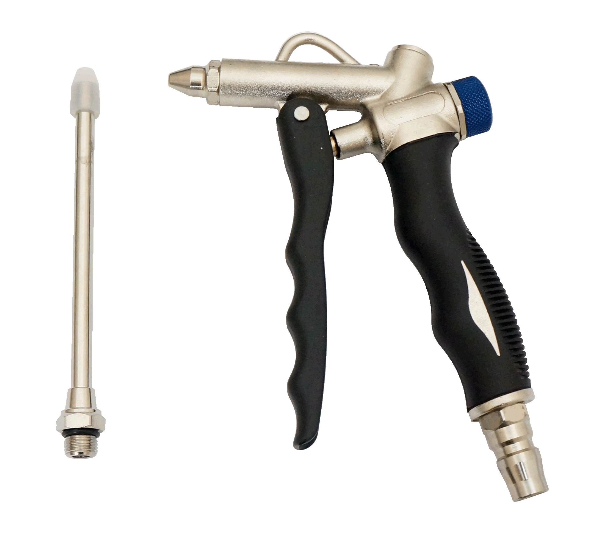

- Flow control knob to adjust air speed.
- Interchangeable short nozzle and 4-1/2" in. Long nozzle is optional.
- Nozzles can be used in standard pistol grip mode as well as from the top of the gun for access into fight spots.
- Ergonomic grip, lightweight.
H.C.B-A2319
2 WAY AIR DUSTER

- Flow control knob to adjust air speed.
- Interchangeable short nozzle and 4-1/2" in. Long nozzle is optional.
- Nozzles can be used in standard pistol grip mode as well as from the top of the gun for access into fight spots.
- Ergonomic grip, lightweight.

