
H.C.B-A2282
TRUCK BRAKE SPOONS (2 PCS)
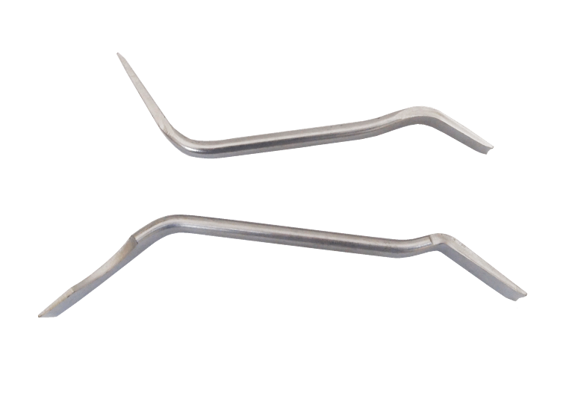

- 16*200mm,18*200mm
- Designed to adjust brakes on most cars and light trucks.
- Universal angle design for most cars.
- This universal offset brake spoon is what you need to adjust star-adjuster and screw-adjuster type brakes quickly and easily. Blades are angles to easily reach confined areas. Constructed of drop-forged steel and chrome plated to resist corrosion.
- This 7in. brake spoon is designed with angled blades to work better in confined areas. Adjusts star-adjuster and screw-adjuster type brakes quickly and easily. Made of durable drop-forged steel with corrosion-resistant chrome plating.

H.C.B-A2282
TRUCK BRAKE SPOONS (2 PCS)

- Full length: 16/18*200mm,18*200mm
- Designed to adjust brakes on most cars and light trucks.
- Universal angle design for most cars.
- This universal offset brake spoon is what you need to adjust star-adjuster and screw-adjuster type brakes quickly and easily. Blades are angles to easily reach confined areas. Constructed of drop-forged steel and chrome plated to resist corrosion.
- This 7in. brake spoon is designed with angled blades to work better in confined areas. Adjusts star-adjuster and screw-adjuster type brakes quickly and easily. Made of durable drop-forged steel with corrosion-resistant chrome plating.

