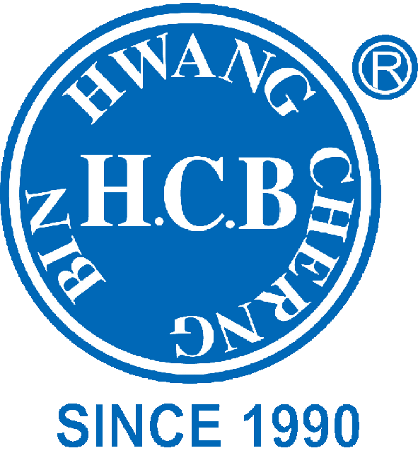
H.C.B-A2280
UNIVERSAL JOINT (Dr. 1")

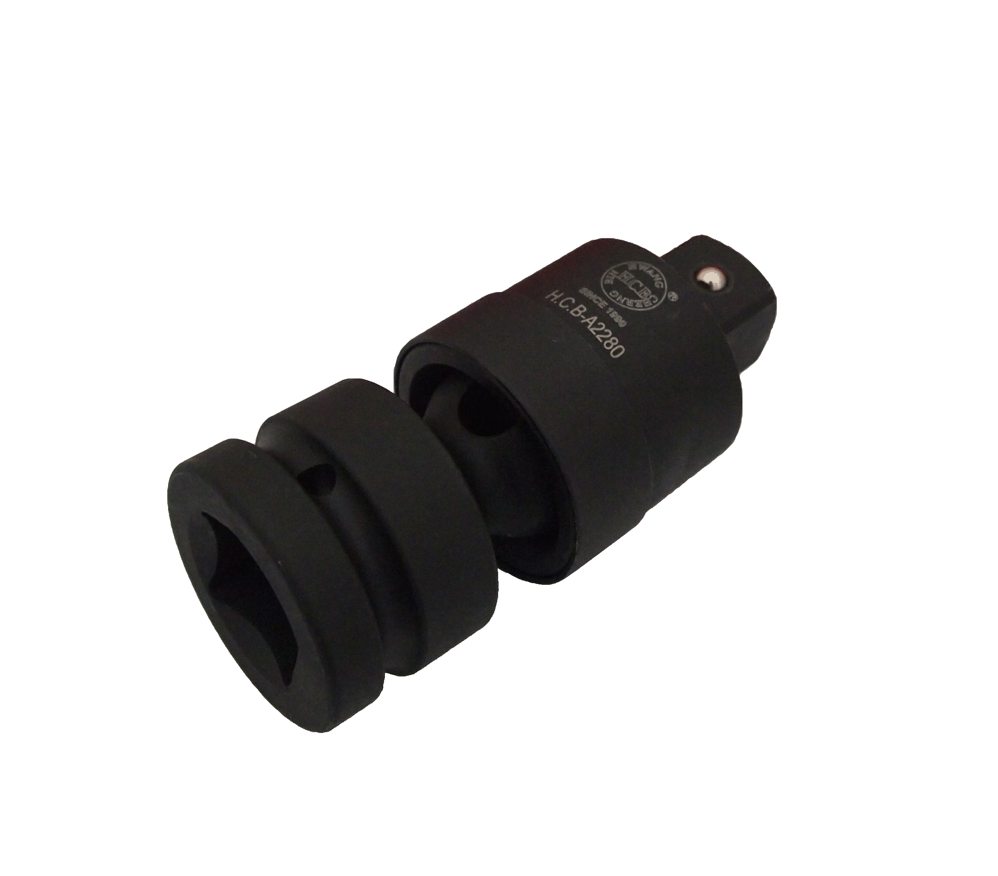

- Drop-forged steel universal joint.
- Suitable for use on all types of air impact tool.
- Chrome Molybdenum steel with phosphate finish for added corrosion resistance.
- Spring-ball socket retainer and drilled head to accept retaining pin.

H.C.B-A2280
UNIVERSAL JOINT (Dr. 1")

- Drop-forged steel universal joint.
- Suitable for use on all types of air impact tool.
- Chrome Molybdenum steel with phosphate finish for added corrosion resistance.
- Spring-ball socket retainer and drilled head to accept retaining pin.

