
H.C.B-A2230
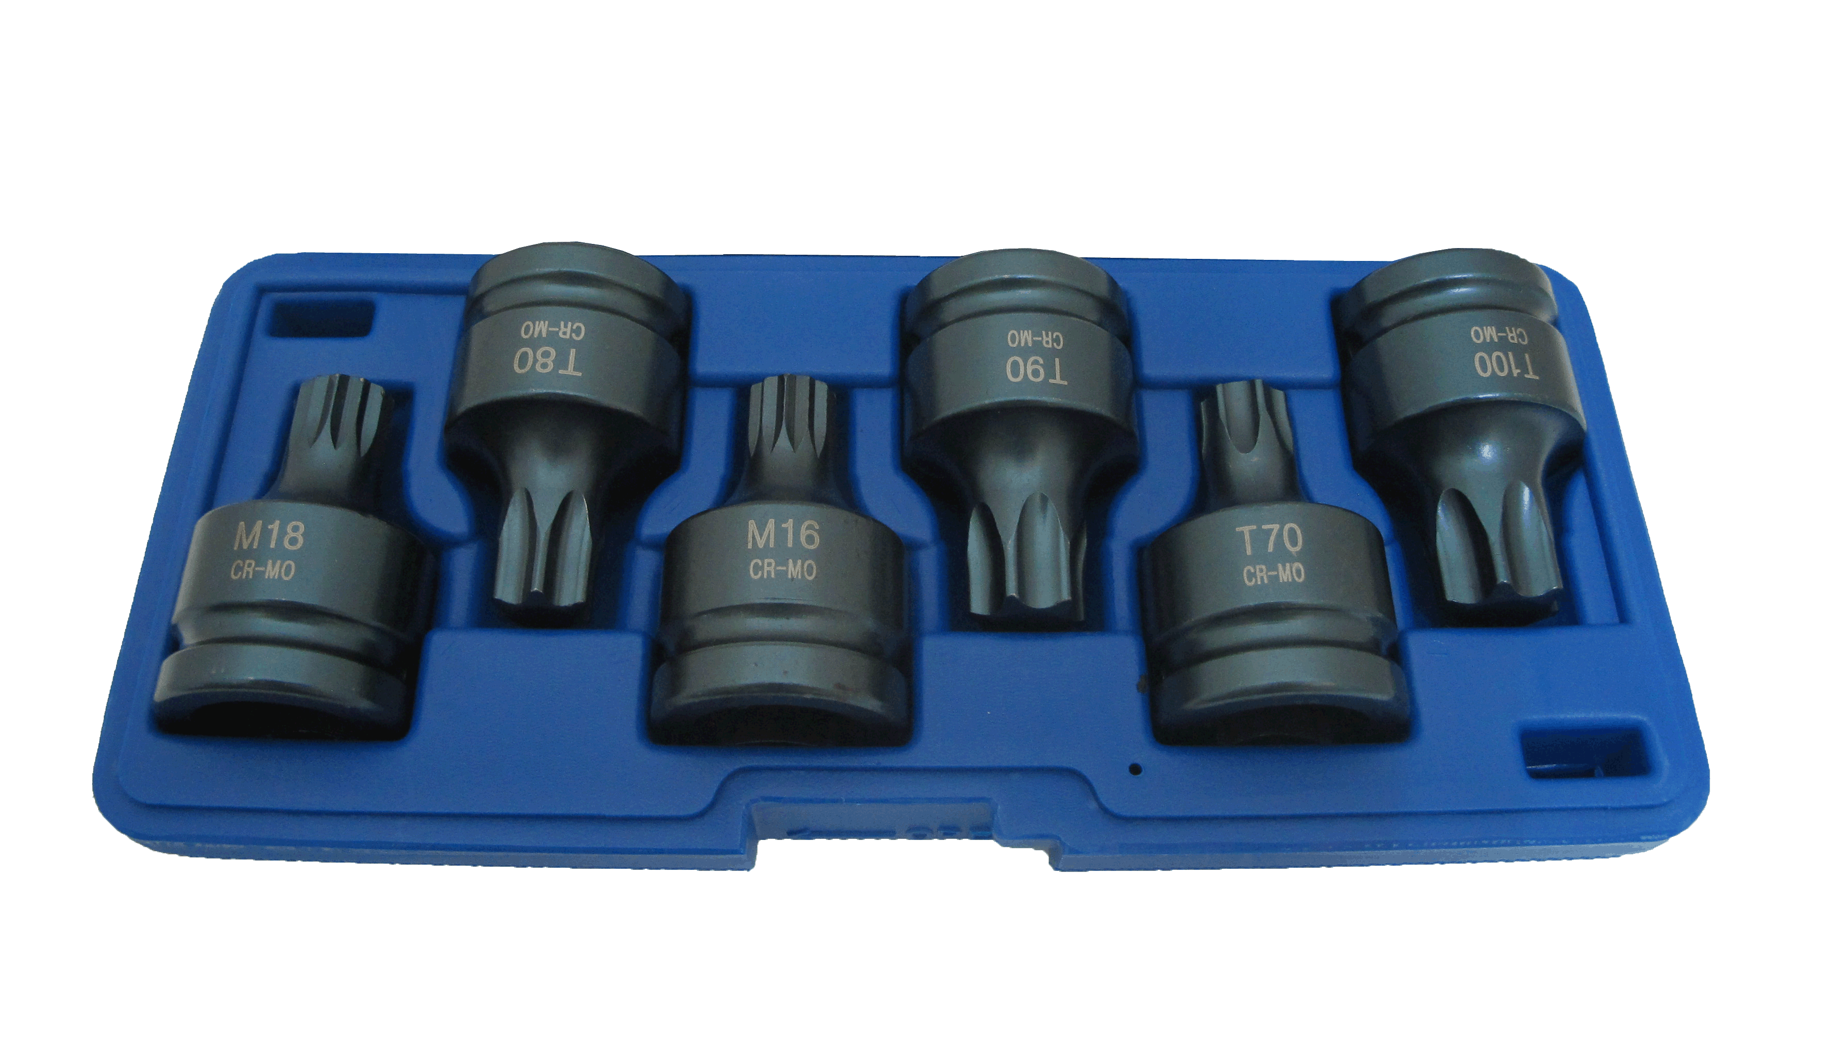
Dr. 3/4” TX-STAR & SPLINE IMPACT BIT SOCKET KIT (6 PCS) (61mm) (T70/T80/T90/T100/M16/M18)

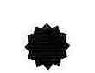
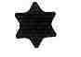
TRX-Star：T70, T80, T90, T100
Spline： M16, M18
Length:61mm
Material: CR-MO

M16 Application:
· Touareg Phaeton from 2003
- braking system
- Camshaft drive gear
- Caliper, rear
• M18 Application:
Touran 2004 · Audi A3 from 2004
- Landing gear assembly and disassembly,
Wheel bearing / hub unit

H.C.B-A2230
Dr. 3/4” TX-STAR & SPLINE IMPACT BIT SOCKET KIT (6 PCS) (61mm) (T70/T80/T90/T100/M16/M18)

TRX-Star：T70, T80, T90, T100
Spline： M16, M18
Length:61mm
Material: CR-MO

M16 Application:
· Touareg Phaeton from 2003
- braking system
- Camshaft drive gear
- Caliper, rear
• M18 Application:
Touran 2004 · Audi A3 from 2004
- Landing gear assembly and disassembly,
Wheel bearing / hub unit

