
H.C.B-A2170
DIESEL ENGINE COMPRESSION TESTER KIT
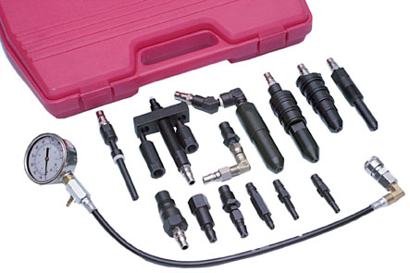

ITEM NO. | APPLICATION | ENGINE | TESTING PORT | THREAD
H.C.B-A2170-02 | Ford/Navistar | 6.9 and 7.3 liter | glow plug | 10mm -1.00
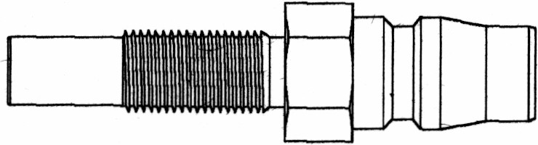 | General Motors | 4.3 & 5.7 liter | glow plug | 10mm -1.00
 | Navistar | 6.9 & 7.3 liter | glow plug | 10mm -1.00
H.C.B-A2170-03 | Audi | all | fuel injector | 24mm - 2.00
 | Cummins | 6 BT, 4.02" bore, 5.9 liter | fuel injector | 24mm - 2.00
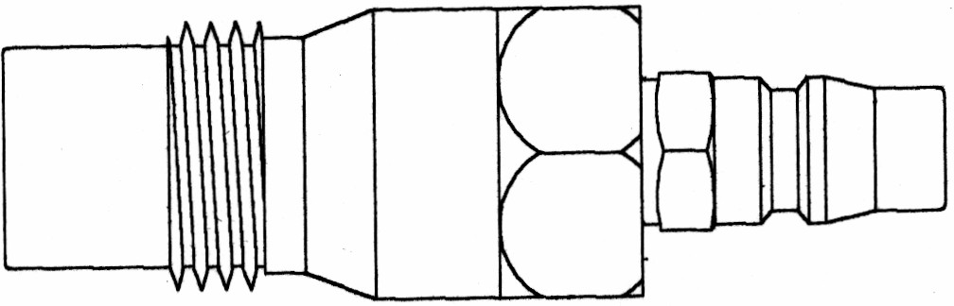 | Mercedes Benz | cars & trucks with | fuel injector | 24mm - 2.00
 |  | 24mm ports
 | Volkswagen | all cars and trucks | fuel injector | 24mm - 2.00
 | Volvo | all cars and trucks | fuel injector | 24mm - 2.00
H.C.B-A2170-04  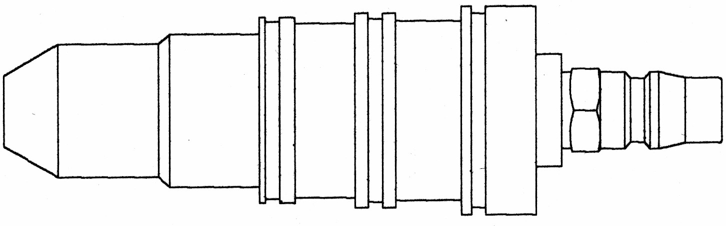 | Cummins | V-185, V-210, V-225, | fuel injector
 |  | V-555, VT-255, VT-555
H.C.B-A2170-05 | Bacharach | Allow a Bacharach
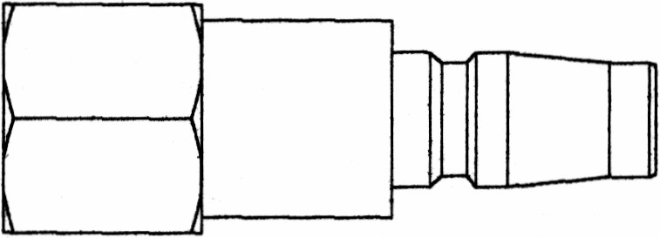 |  | brand apapter to be
 |  | used with our tester,
 |  | No. H.C.B-A2170-01.
H.C.B-A2170-06 | Mercedes | 12mm is for Model 300 | glow plug | 12mm - 1.25
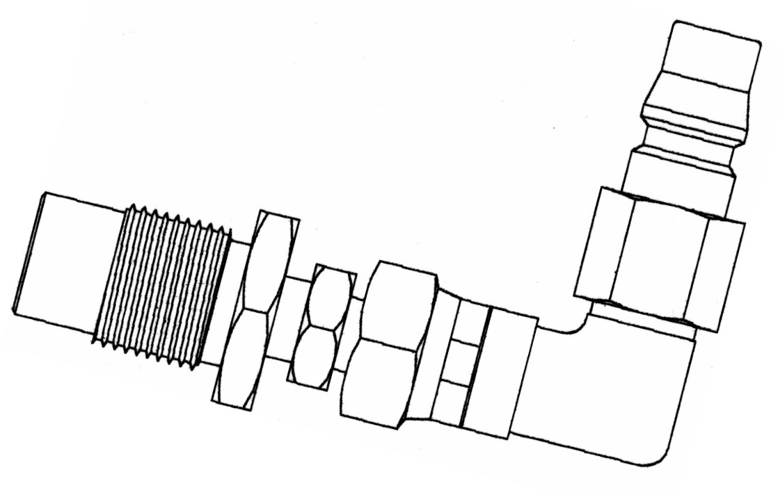 | Benz | & 300 Turbo diesel from |  | and
 |  | 1978 and the 250 & 350 |  | 18mm - 1.50
 |  | Turbo models.
 |  | 18mm is for all regular
 |  | Mercedes Benz engines
 |  | & model 300 prior to
 |  | 1978
H.C.B-A2170-07 | Allis Chalmers | 6000, 7000, 10000, 11000 | fuel injector
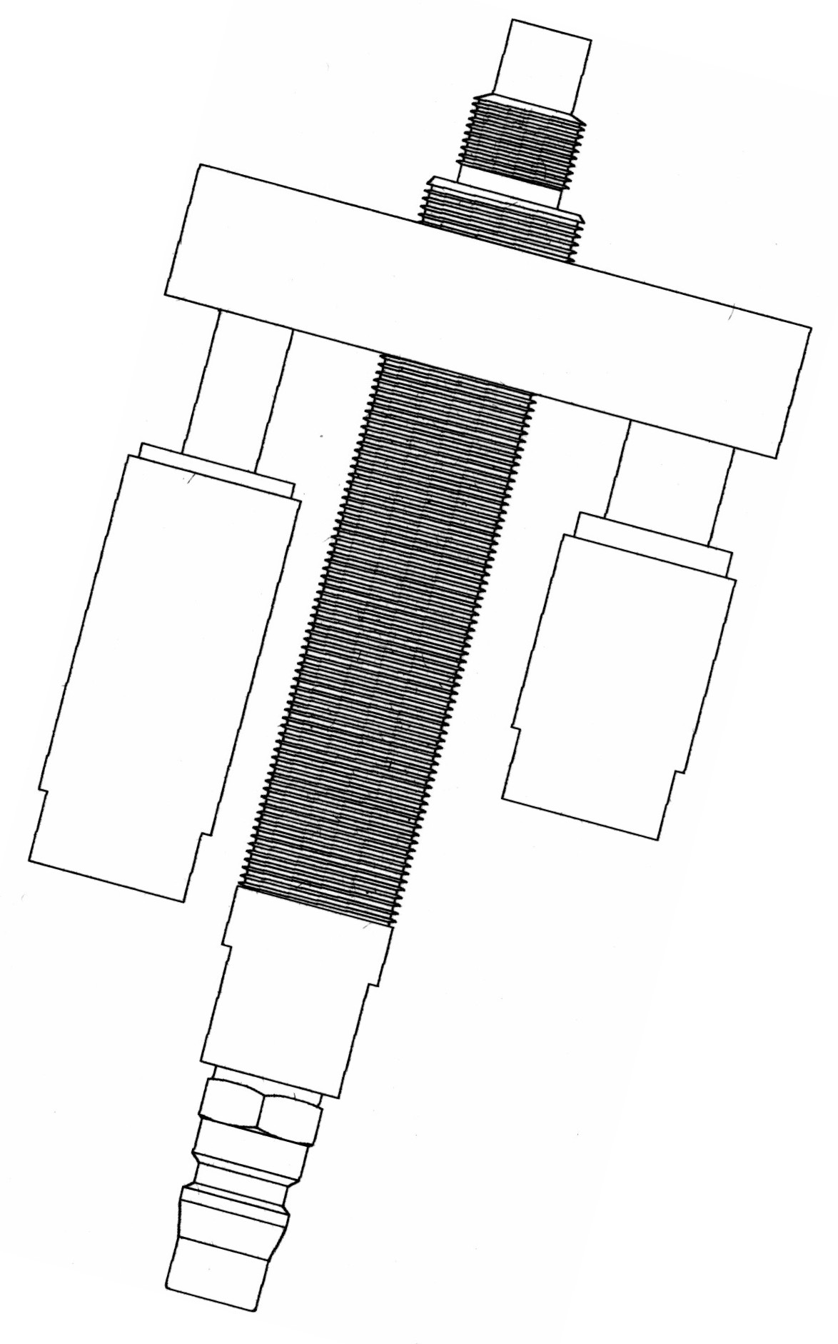 | Bedford | 200, 220, 300, 330, 466 | fuel injector
 | Case, J.I. | all models not using | fuel injector
 |  | pencil nozzle
 | Deere, John | 404, 466, 531, 619 | fuel injector
 | Fiat Allis | 8035-02-300, 8035-02-301, | fuel injector
 |  | 8035-02-302, 8045-02,
 |  | 8045-03
 | Ford Tractor | all | fuel injector
 | International | D/DT 361, D/DT 429, | fuel injector
 | Harvester | DV462, DV/DVT 550,
 |  | DT/DV/DVT 573, 361, 407
 | Mack Truck | END 405, 457, 475, 510, | fuel injector
 |  | 519, 605, 672, 673, 674,
H.C.B-A2170-07 |  | 711, 864, ENDT-673,
 |  | 675, 676, 865, 866
 | Onan | DSL, MDSL | fuel injector
 | Waukesha | 180DLC,190D,195D,197D | fuel injector
H.C.B-A2170-08 | Cummins | These 5.5" bore engines: | fuel injector
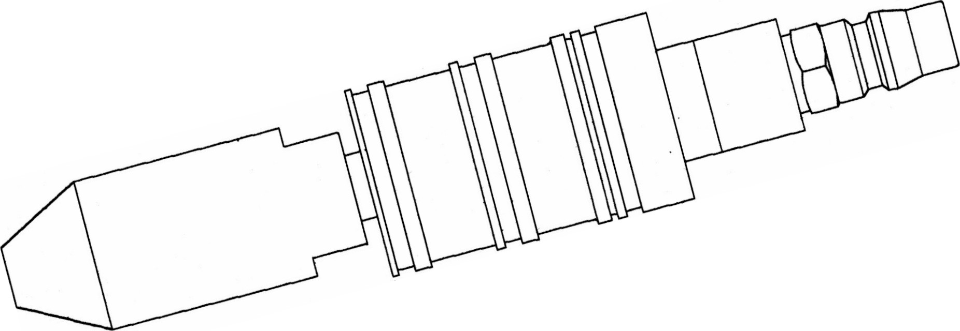 |  | NH(855 cubic inches),
 |  | V-6, V-8, V-12 &
 |  | 903 V-8 Cylindrical PTB
H.C.B-A2170-09 | BMW | 2.4 liter | glow plug | 12mm - 1.25
 | Lincoln Continental | 1984 and 1985 car | glow plug | 12mm - 1.25
 | Mark Ⅶ | models
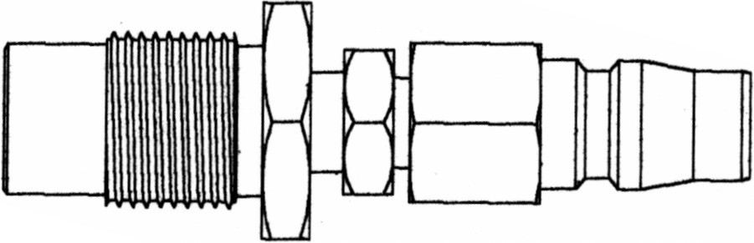 | Peugeot | For Peugeot diesel | glow plug | 12mm - 1.25
 |  | passenger cars having |  | and
 |  | either 12mm -1.25 or |  | 18mm - 1.50
 |  | 18mm -1.50mm glow
 |  | plug port holes
H.C.B-A2170-10 | Chevy Luv | 1.8 and 2.2 liter | glow plug | 10mm - 1.25
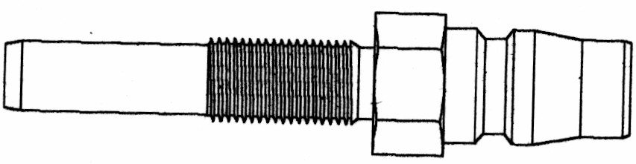 | Isuzu | 1.8 and 2.2 liter | glow plug | 10mm - 1.25
 | Toyota | 1.8 liter | glow plug | 10mm - 1.25
H.C.B-A2170-11 | General Motors | 4.3, 5.7,6.2 liter, 6.5 liter | glow plug | 10mm - 1.25
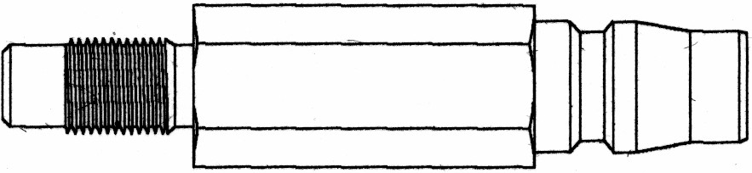 |  | Turbo
H.C.B-A2170-12 | Detroit Diesel | 53, 71, 92, 110, 149, V53, | fuel injector
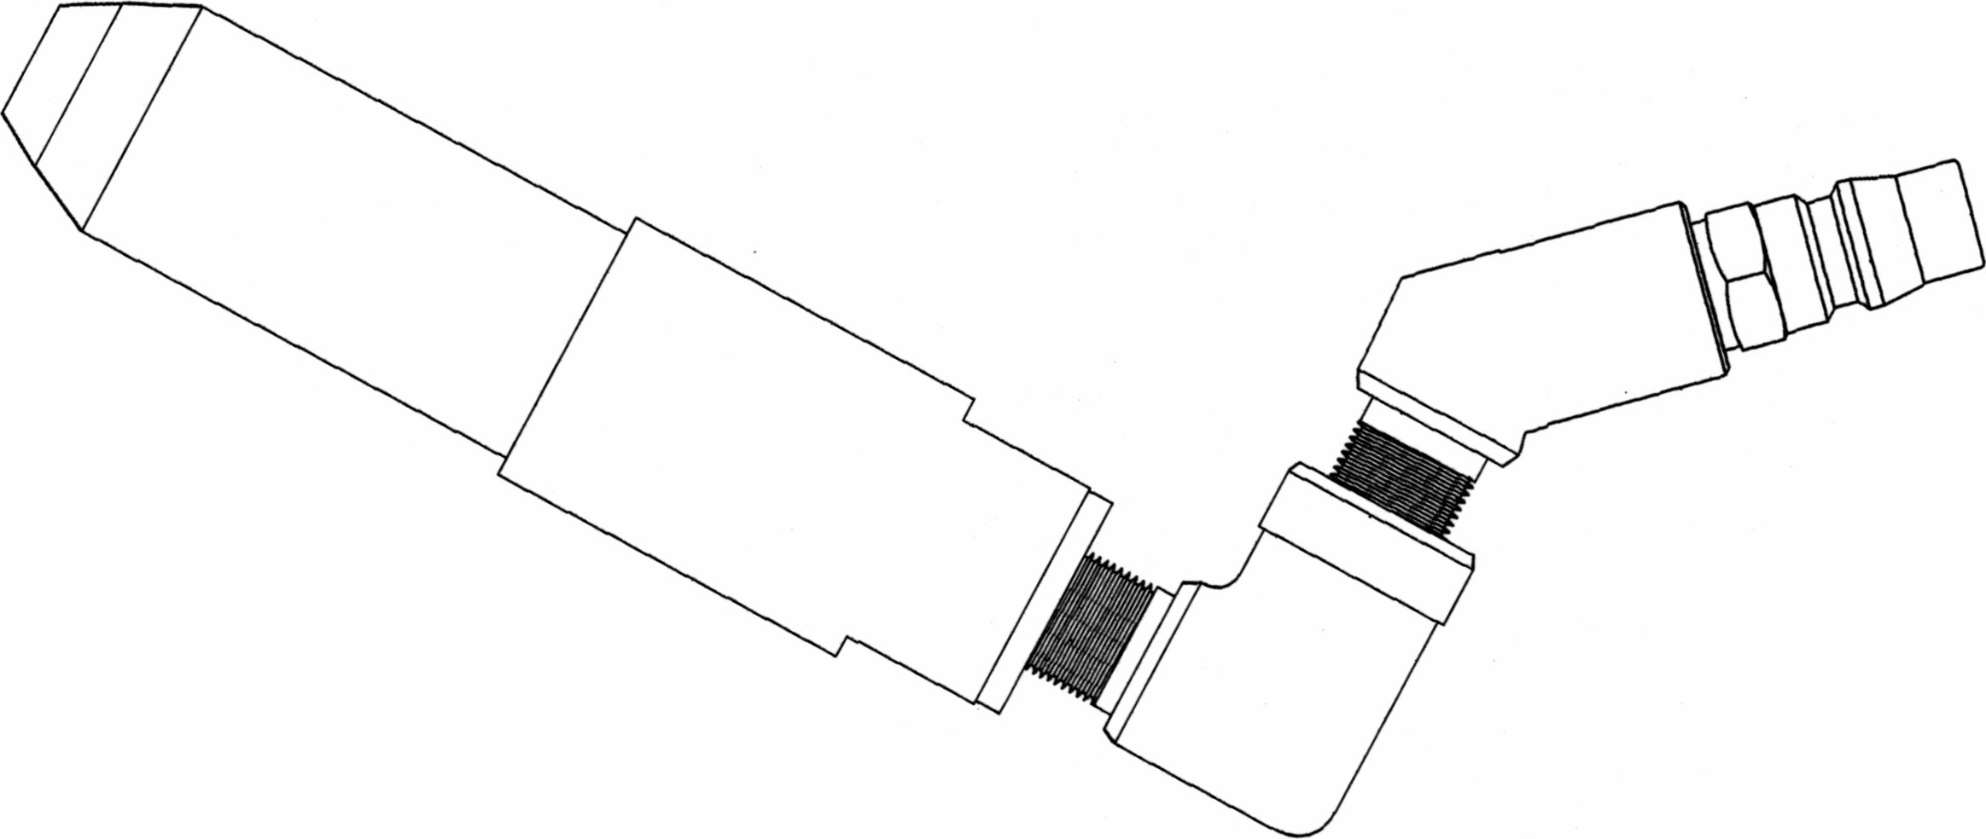 |  | V71 with low or high
 |  | clamp injector hold
 |  | down
H.C.B-A2170-13 | Caterpillar | "Capsule" type nozzles | fuel injector
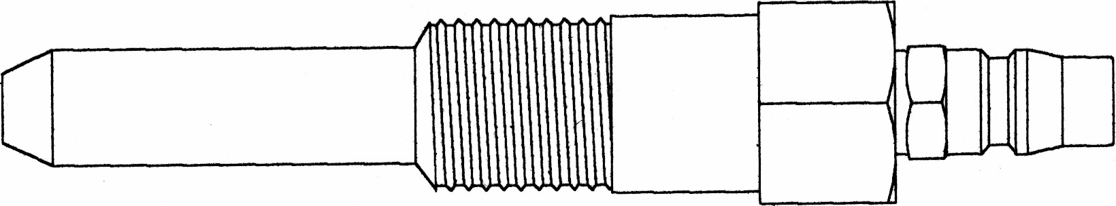 |  | including models
 |  | D-336,1674, 1676, 3406,
 |  | 3408 and 3412
H.C.B-A2170-14 | Case, J.I. | 70 series, 188 & 207 C.I.D. | fuel injector
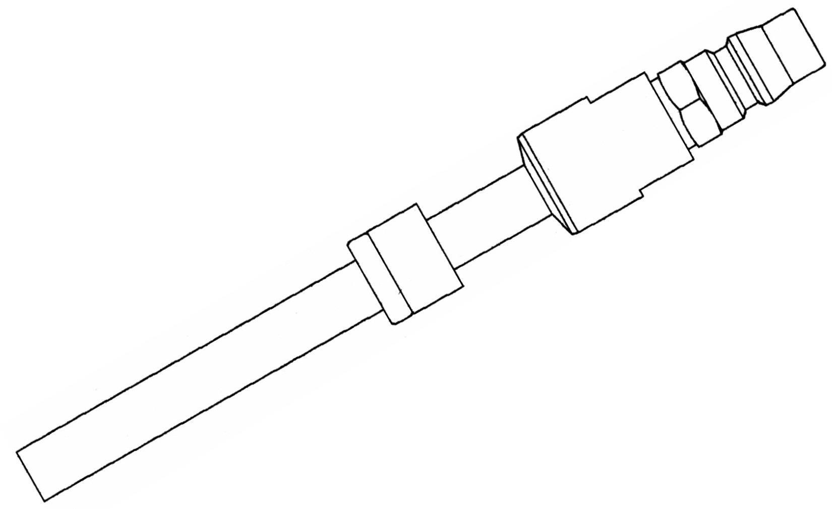 |  | pencil nozzle
 | Caterpillar | 1100 and 3208 series | fuel injector
 | Deere, John | early 300, 400 and 500 | fuel injector
 |  | series, 276, 404, and 531
 |  | C.I.D.
 | Waukesha | D155D | fuel injector

