
H.C.B-A2082
MULTIPLE WINDOW SCALE DIGITAL ADJUSTABLE TORQUE WRENCHES WITH LIGHT (DR. 1/2”)

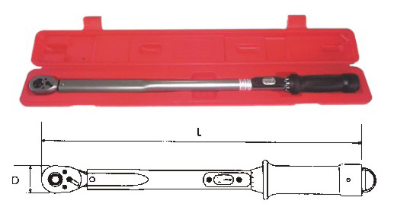

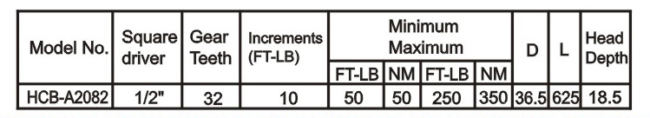
H.C.B-A2082
MULTIPLE WINDOW SCALE DIGITAL ADJUSTABLE TORQUE WRENCHES WITH LIGHT (DR. 1/2”)

