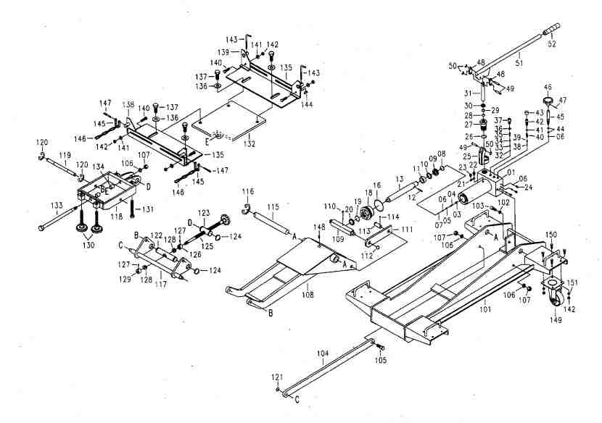

H.C.B-A2045
1.5 TONS TRUCK TRANSMISSION JACK

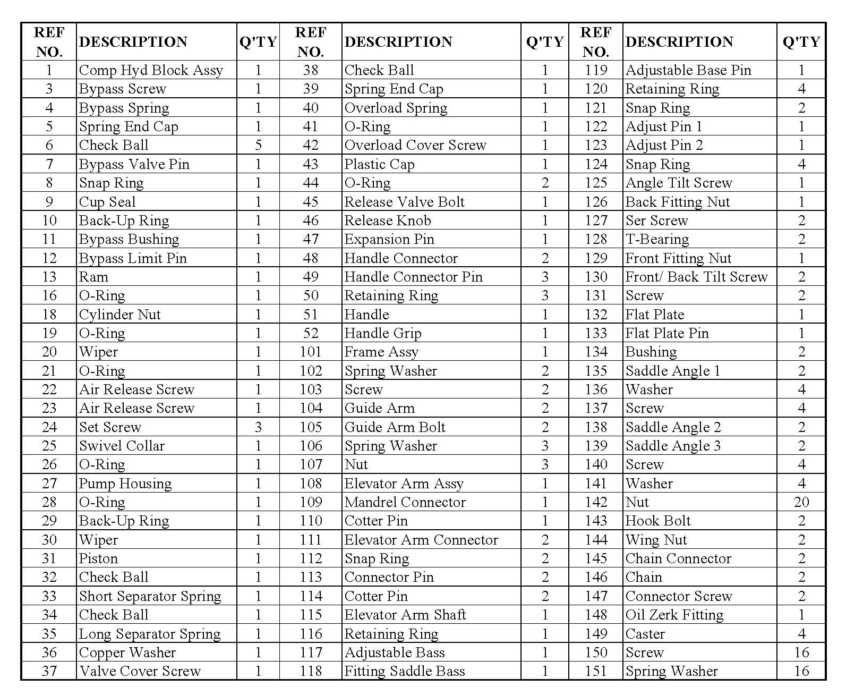
H.C.B-A2045
1.5 TONS TRUCK TRANSMISSION JACK
- Best tool for removing /installing transmission or differential of auto and light trucks.
- This set contains adjustable saddle brackets and chain, and is suitable for every size of transmission clutches and differential.
- Safe overload and bypass system prevent cylinder from damaging.
- Rust-proof with flashing chromed ram inside the hydraulic system. 360∘rotary handle. Easy to use.
- Four swivel caster wheels are easy to move under the vehicles.
- Releasing the valve to lower this tool.
- Capacity : 1.5 tons
