
H.C.B-A2018-7
RENAULT OIL FILTER WRENCH
(Dr. 1/2", 6 RIBS, 66 mm)

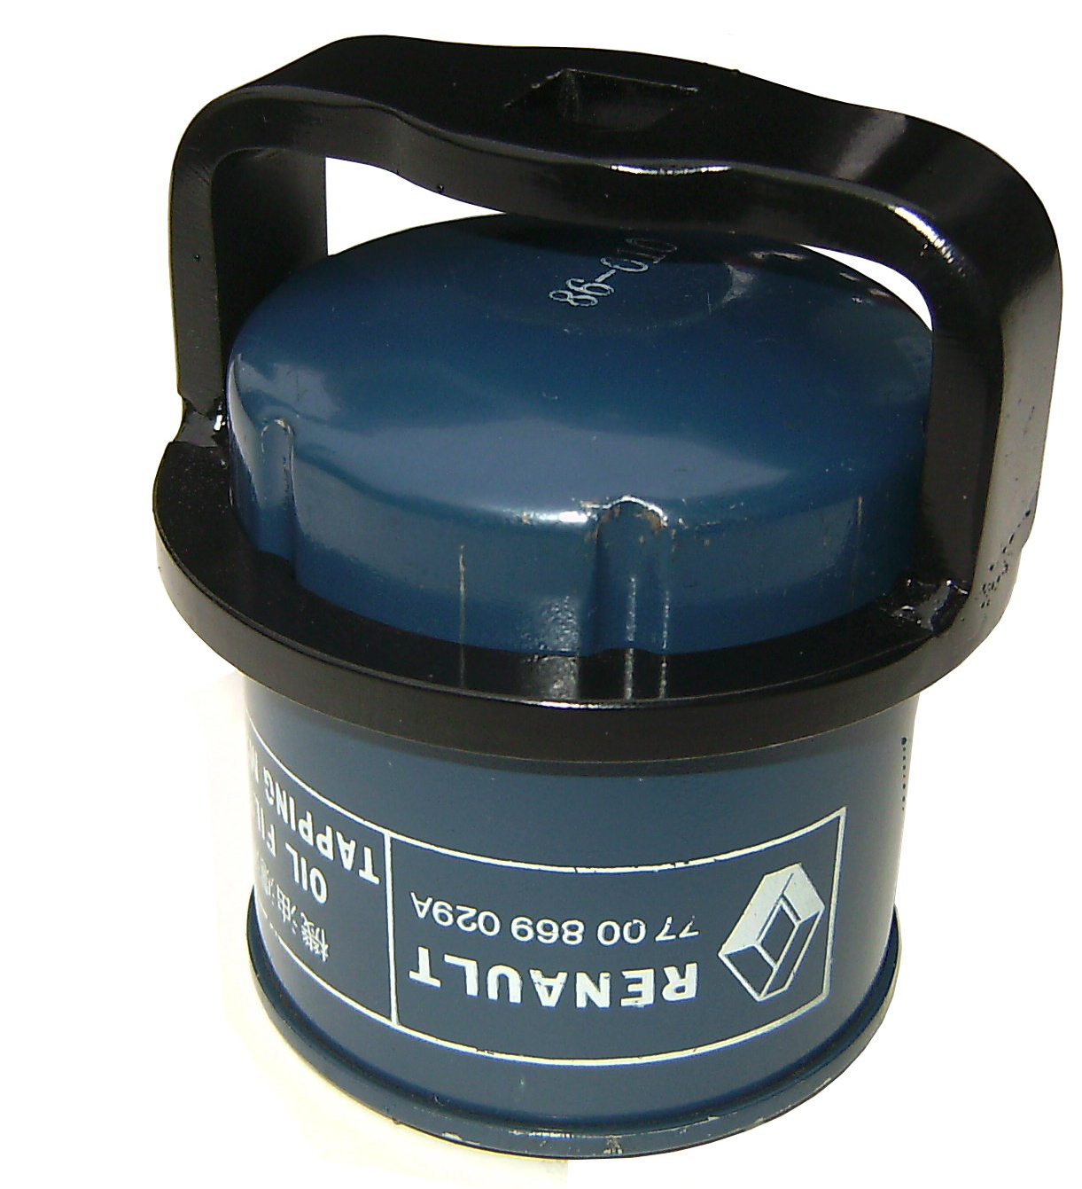
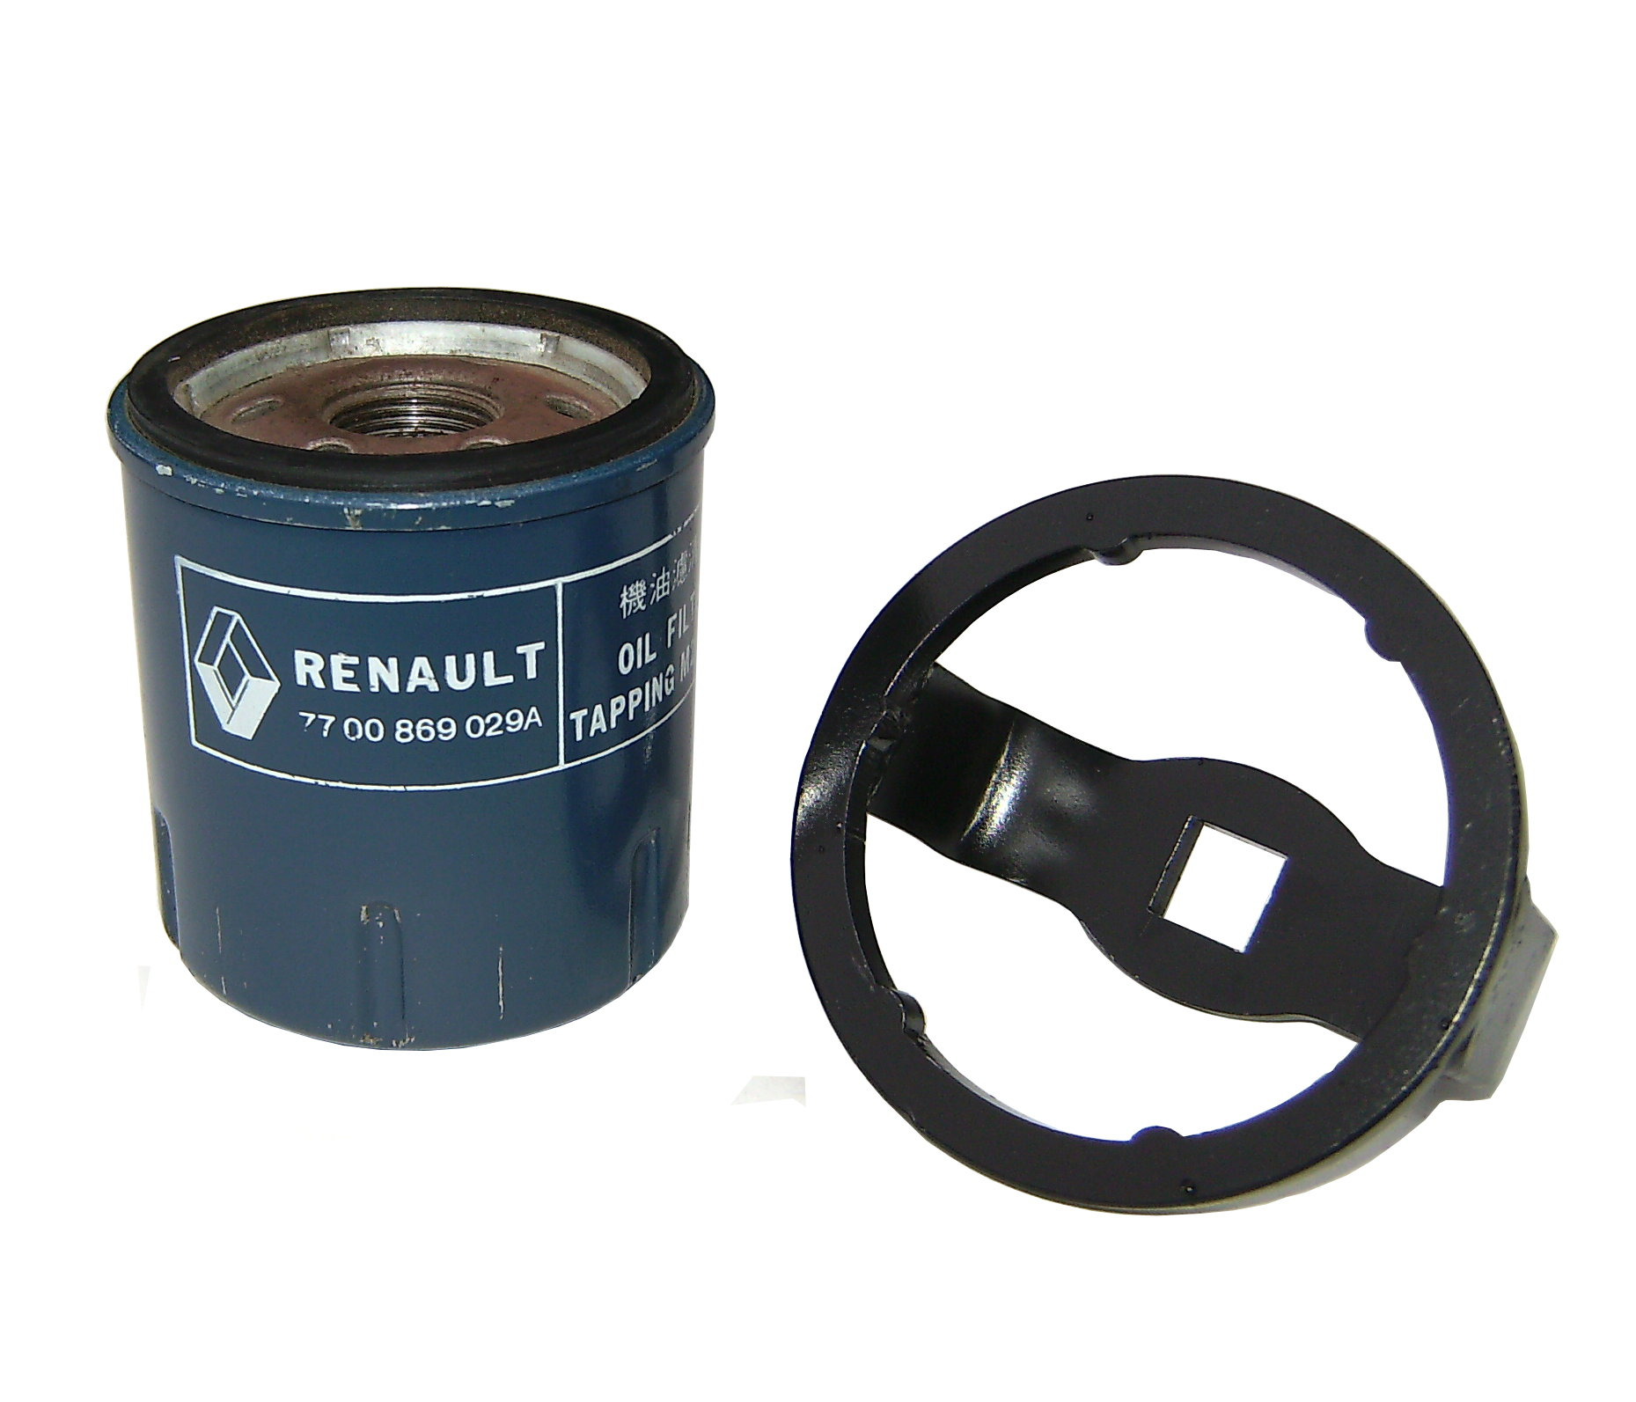

■ Size: 66mm
■ N.W.: 0.202KG

H.C.B-A2018-7
RENAULT OIL FILTER WRENCH
(Dr. 1/2", 6 RIBS, 66 mm)

■ Size: 66mm
■ N.W.: 0.202KG

