**H.C.B-A2018-41**

**DAF CF(85) OIL MIST SEPARATOR WRENCH (Dr.1/2",14RIBS,75mm)**

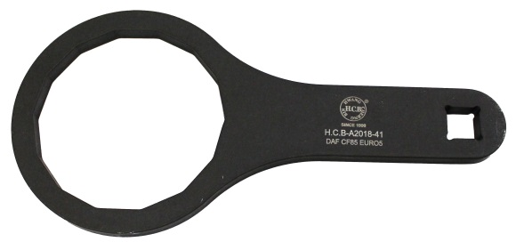

* **Application:** DAF CF85 EURO4~5
* **Oil mist separator No ref.**:1433649

**H.C.B-A2018-41**

**DAF CF(85) OIL MIST SEPARATOR WRENCH (Dr.1/2",14RIBS,107mm)**



* **Application:** DAF CF85 EURO4~5
* **Oil mist separator No ref.**:1433649