**H.C.B-A2018-32**

**RENAULT OIL FILTER WRENCH**

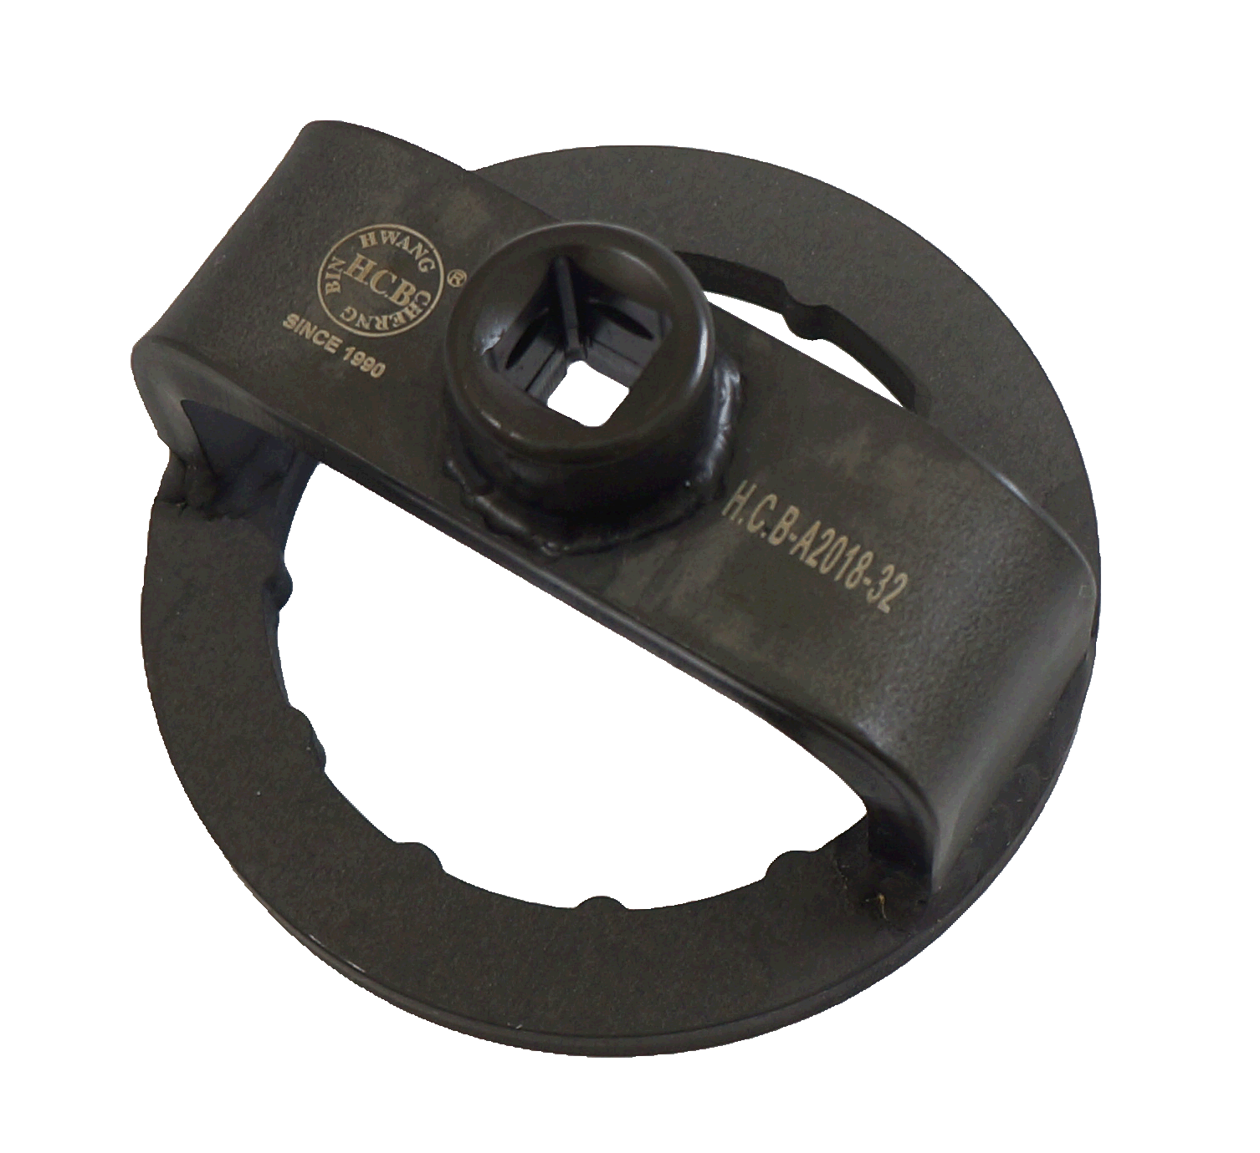**(Dr. 1/2”, 12 RIBS, 76 mm)**

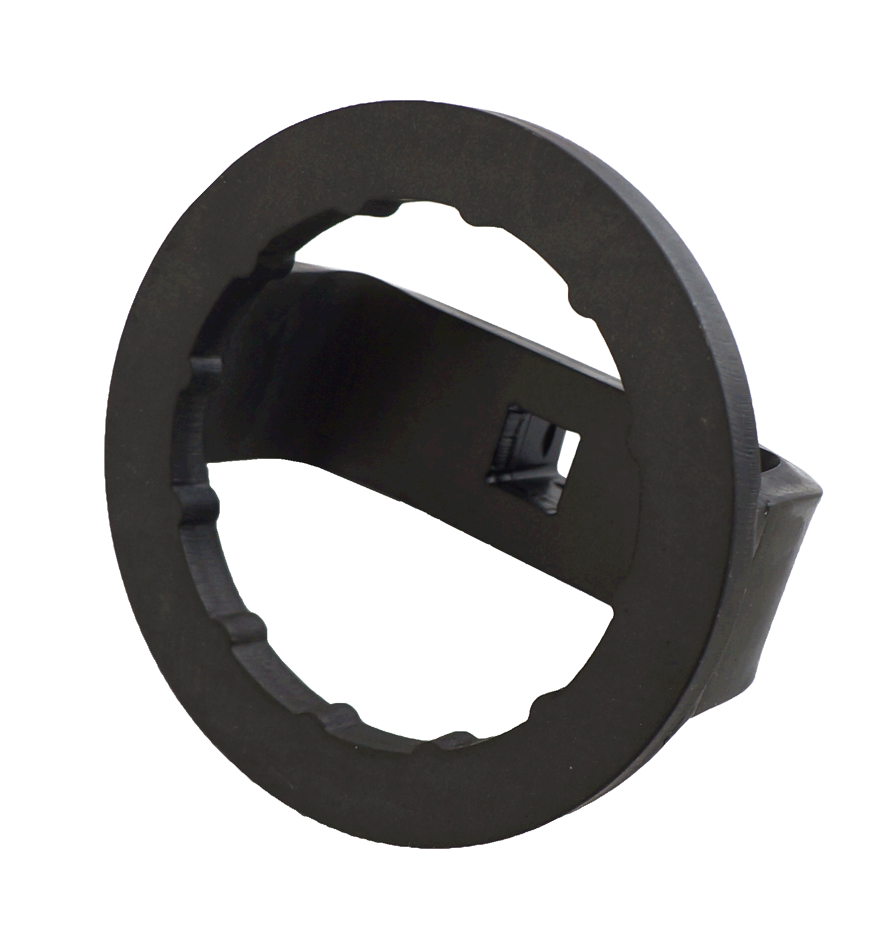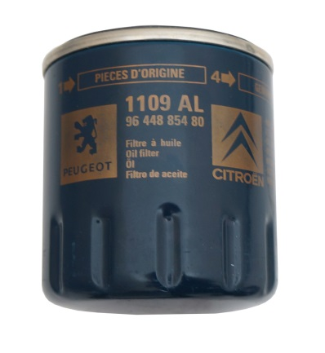

* With a 1/2” torque wrench, oil filters can be easily loosened or tightened to designed torque.
* Application:

-BMW R Hexhead, R1200GS, R, RT, S, ST, R900RT, K1200R, S, HP2, F650, F800……, etc.

-Renault with EF34 oil filters

Renault Twingo R5, Rapid sedan with C, Clio, Kangoo petrol-R12 Espace III, Laguna sedan with F, Megan Kangoo with K Gasoline engines, R21 Espace I + III F Gasoline engines and Traffic with J gasoline engines

- Ford Diesel 1.8 Motorcraft filter and EFL344

- Peugeot with Purflux Filter

**H.C.B-A2018-32**

**RENAULT OIL FILTER WRENCH**

**(Dr. 1/2”, 12 RIBS, 76 mm)**



* With a 1/2” torque wrench, oil filters can be easily loosened or tightened to designed torque.
* Application:

-BMW R Hexhead, R1200GS, R, RT, S, ST, R900RT, K1200R, S, HP2, F650, F800……, etc.

-Renault with EF34 oil filters

Renault Twingo R5, Rapid sedan with C, Clio, Kangoo petrol-R12 Espace III, Laguna sedan with F, Megan Kangoo with K Gasoline engines, R21 Espace I + III F Gasoline engines and Traffic with J gasoline engines

- Ford Diesel 1.8 Motorcraft filter and EFL344

- Peugeot with Purflux Filter