
H.C.B-A1995
DETROIT DIESEL 60 SERIES HEAD GUIDE STUDS

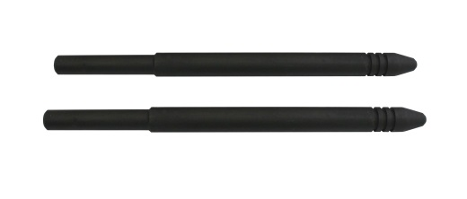

■ It is used to assist in placing the cylinder head onto the engine block of Detroit Diesel Series 60, DD15, and DD16 applications.

