**Sheppard M100 Pitman Arm Puller**

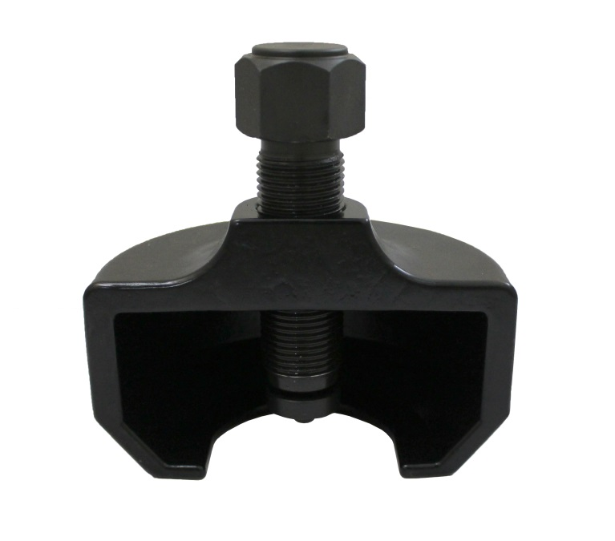

Easily remove even the most stubborn pitman arms on Sheppard M100 gear boxes.

* Eliminates dangerous hammering and cutting torch methods.
* May be used with up to a 3/4″ impact tool.
* High strength steel casting designed for high capacity pulling.
* Simple to slip on for instant results.