
H.C.B-A1966
FUEL INJECTOR NOZZLE PULLER

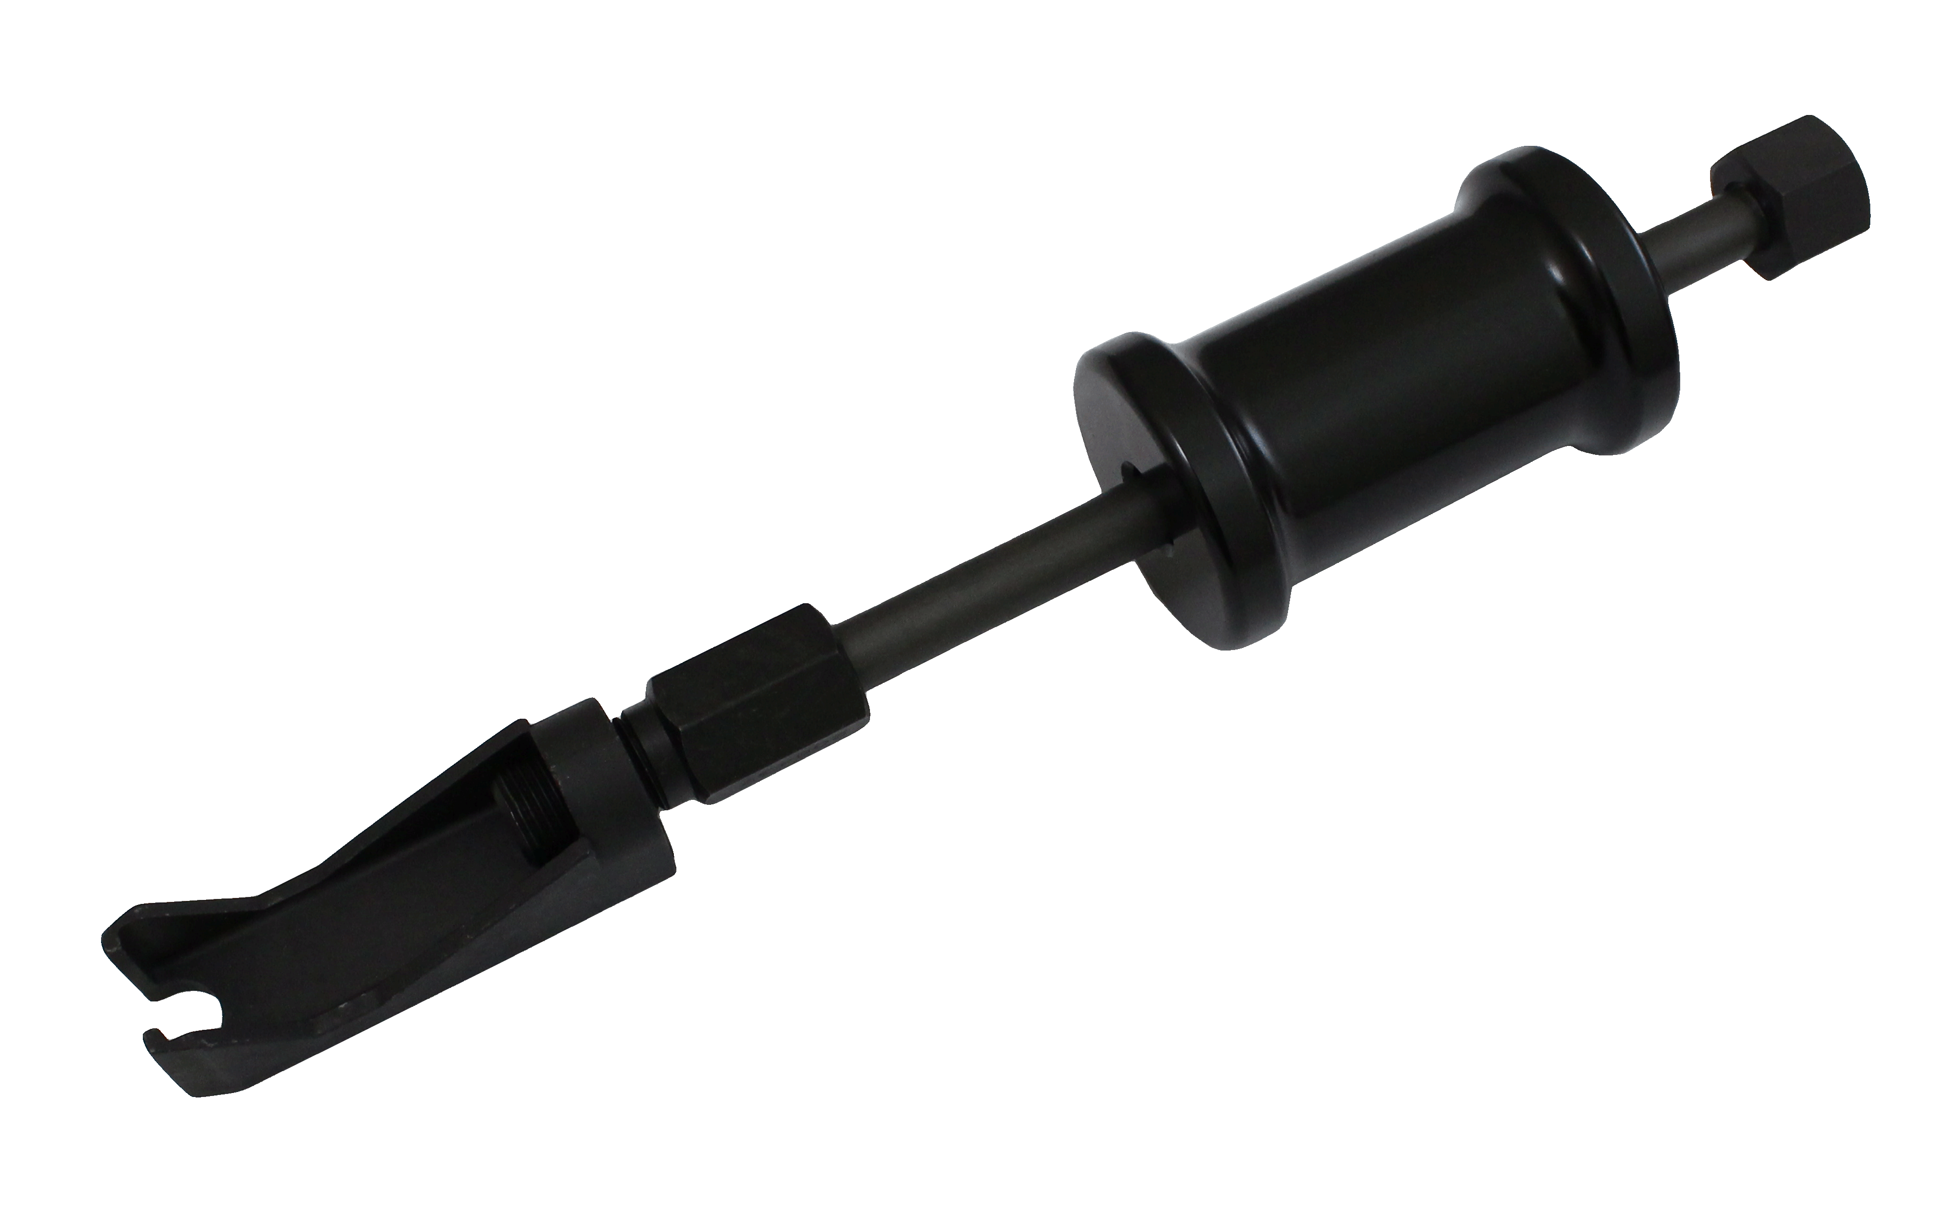

- Designed for removing pencil-type fuel injector nozzles from 5.7 liter GM diesel engines, and nozzles in Caterpillar, John Deere, Waukesha, Case, and White FArm Equipment diesels used in construction and agricultural vehicles.
- The slide hammer action gives an even, straight pull.
- It prevents damage to the nozzle or fuel line during removal.

