
H.C.B-A1930
HYUNDAI / KIA HIGH PRESSURE DIESEL PUMP SPROCKET TOOL (2.5)
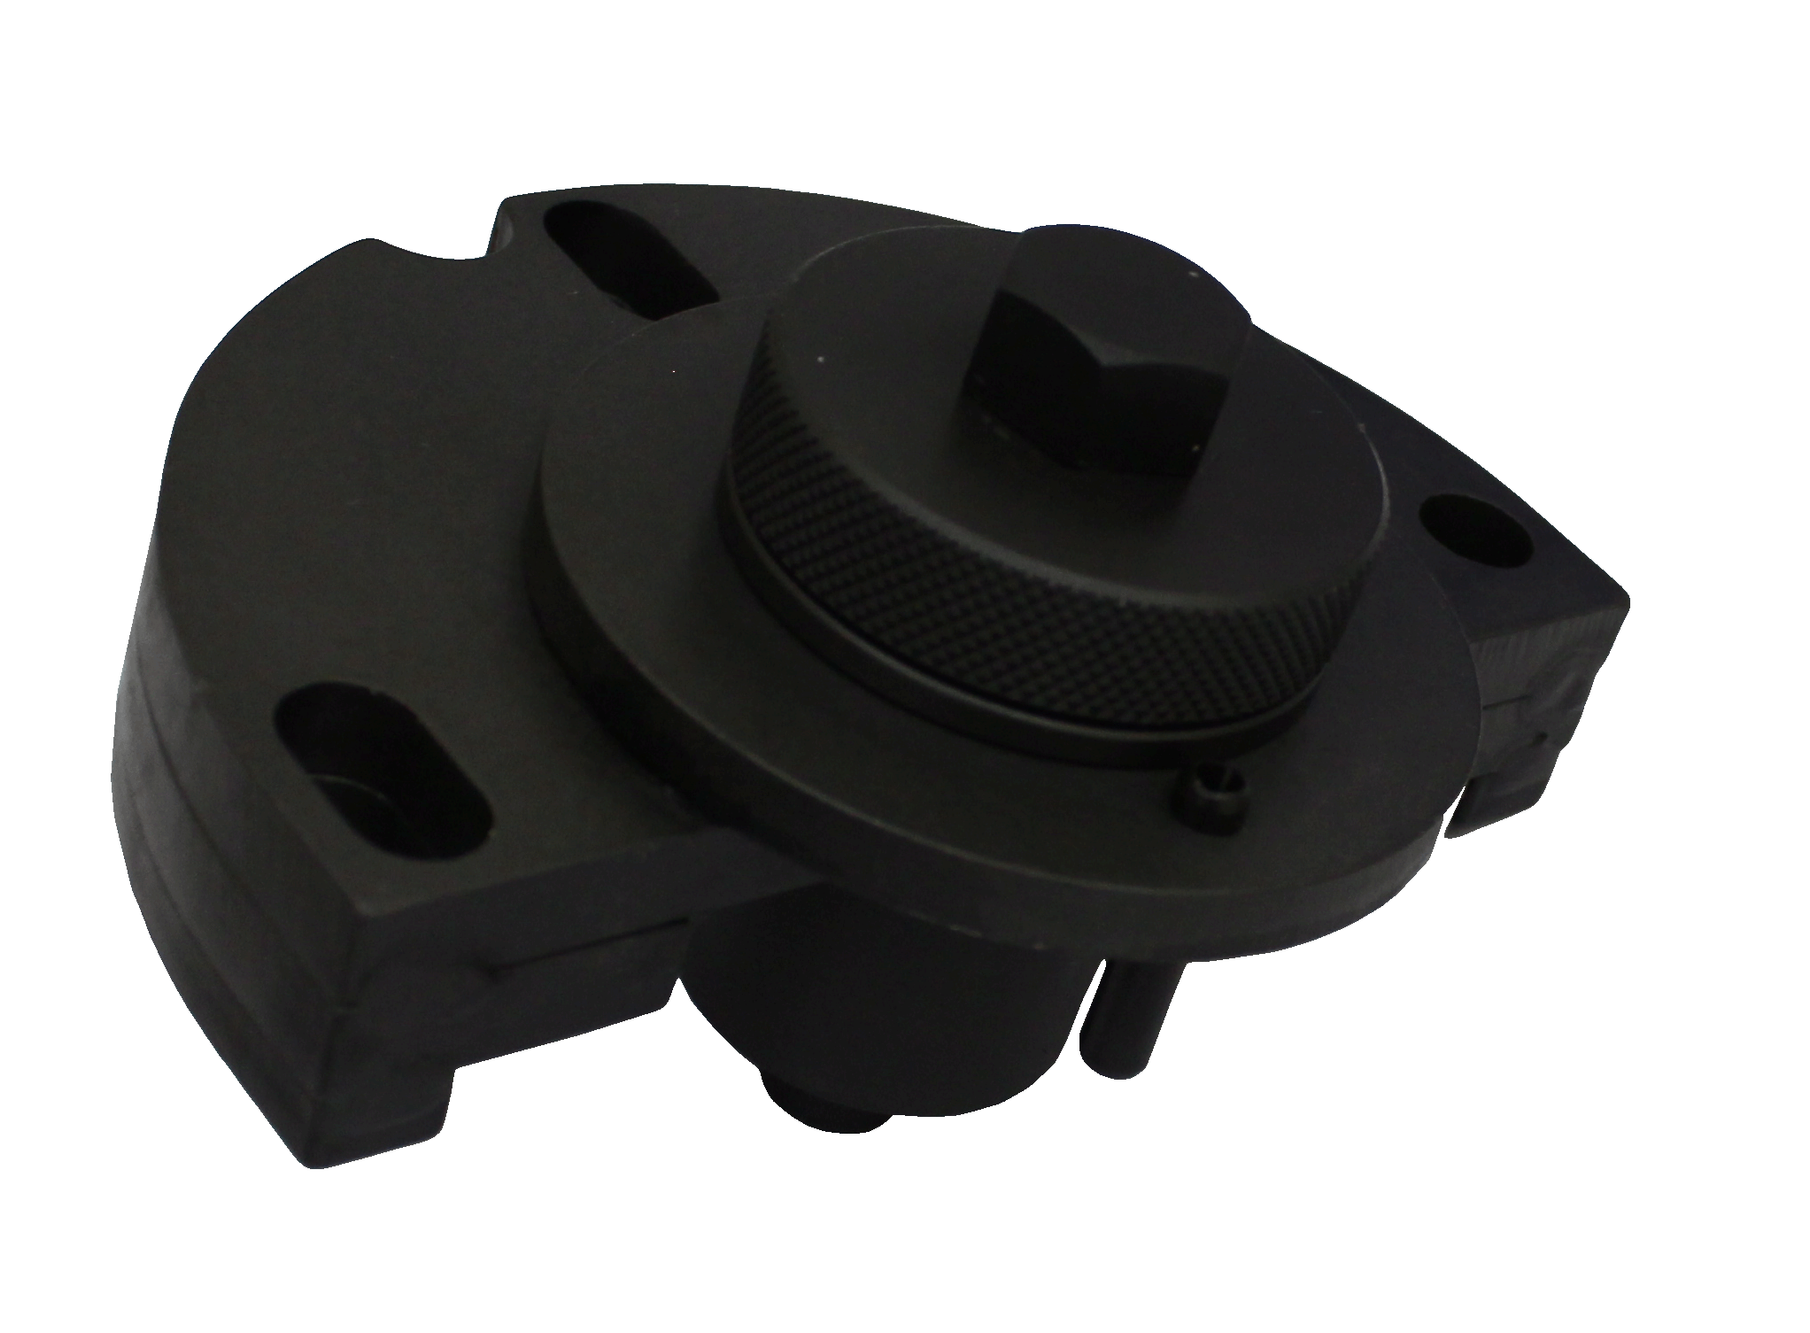

- For removal and replacement of the high pressure fuel pump.
- Designed for separate the diesel pump sprocket from the high pressure diesel pump on the 2.5 common rail diesel engines used across the Hyundai and Kia ranges from 2002.
- Application:
- Models:
Kia: Sorento BL (2002-2010)
Hyundai: H1, H200, H300/ iLoad (TQ; 2007-present)
Montana 2002 to 2017 CRDi,
H350 2015 to 2017 CRDi VGT i800,
- Engines:
Kia: D 2.5 VGT / D 2.5 WGT
Hyundai: D 2.5 TCI-A / D 2.5 TCI-A2
- OEM no.ref.: 09331-4A000 (093314A0000)

H.C.B-A1930
HYUNDAI / KIA HIGH PRESSURE DIESEL PUMP SPROCKET TOOL (2.5)

- For removal and replacement of the high pressure fuel pump.
- Designed for separate the diesel pump sprocket from the high pressure diesel pump on the 2.5 common rail diesel engines used across the Hyundai and Kia ranges from 2002.
- Application:
- Models:
Kia: Sorento BL (2002-2010)
Hyundai: H1, H200, H300/ iLoad (TQ; 2007-present)
Montana 2002 to 2017 CRDi,
H350 2015 to 2017 CRDi VGT i800,
- Engines:
Kia: D 2.5 VGT / D 2.5 WGT
Hyundai: D 2.5 TCI-A / D 2.5 TCI-A2
- OEM no.ref.: 09331-4A000 (093314A0000)

