
H.C.B-A1924
DAF TRUCK FLYWHEEL ROTATOR
(EURO 5&6)

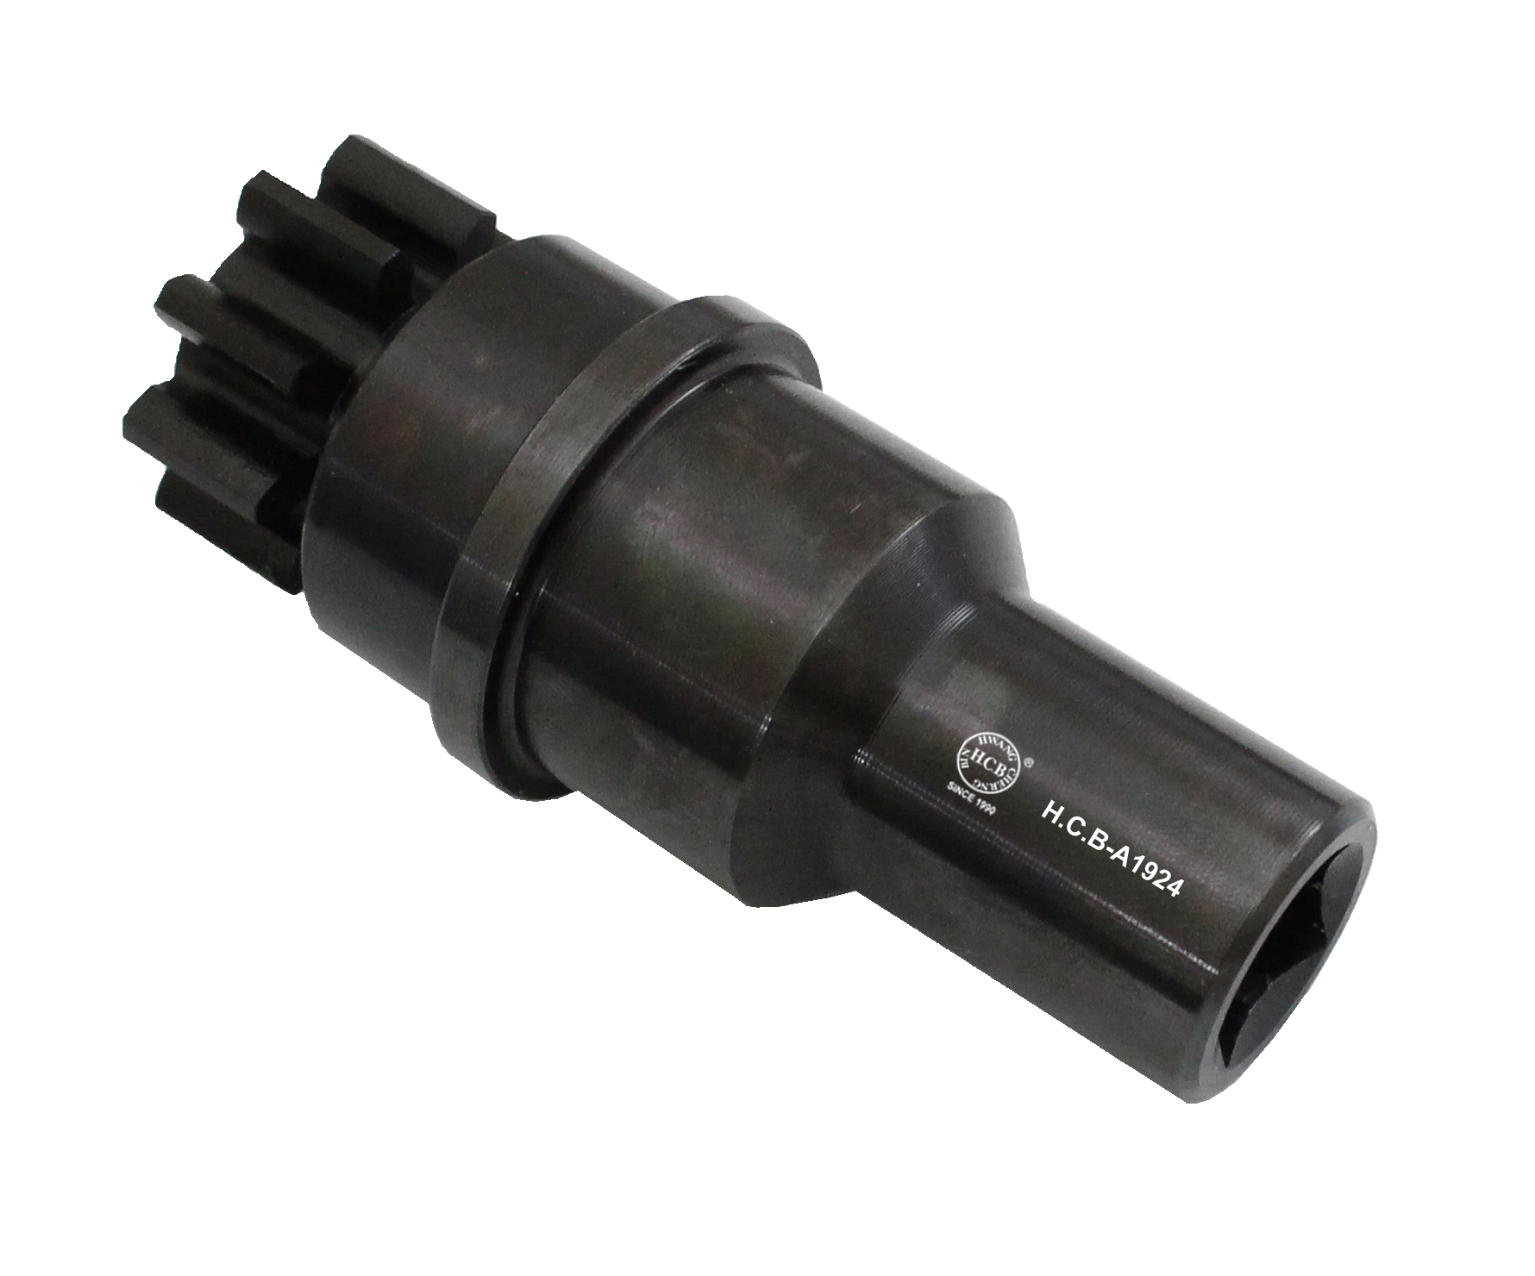

- Application:
DAF lorries equipped with a 6-cylinder (EURO 5&6) engine.
DAF XF 105 (EURO 5)
- Engine code: MX300/MX 340/MX375

H.C.B-A1924
DAF TRUCK FLYWHEEL ROTATOR
(EURO 5&6)

- Application:
DAF lorries equipped with a 6-cylinder (EURO 5&6) engine.
DAF XF 105 (EURO 5)
- Engine code: MX300/MX 340/MX375

