
H.C.B-A1922
BENZ REAR AXLE NUT SOCKET
(Dr.3/4", 101.5mm, 12 POINTS)

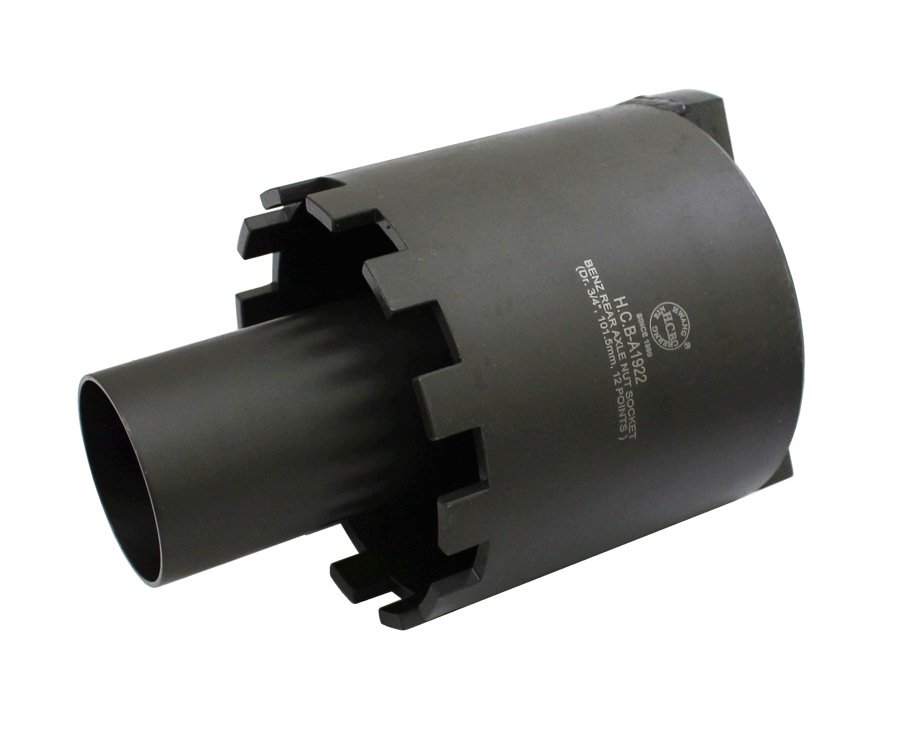

- Fix bearing while removing and installing real axle nut.
- It can be used with torque wrench for installing and removing.
- Material: SCM440.
- Size: Inner 101.5 mm, Outer110mm
- Application:Mercedes Benz Truck
- BENZ OEM no.ref.: 740589000700

