
H.C.B-A1911
DETROIT 60 SERIES DIESEL CRANKSHAFT ALIGNMENT TOOL

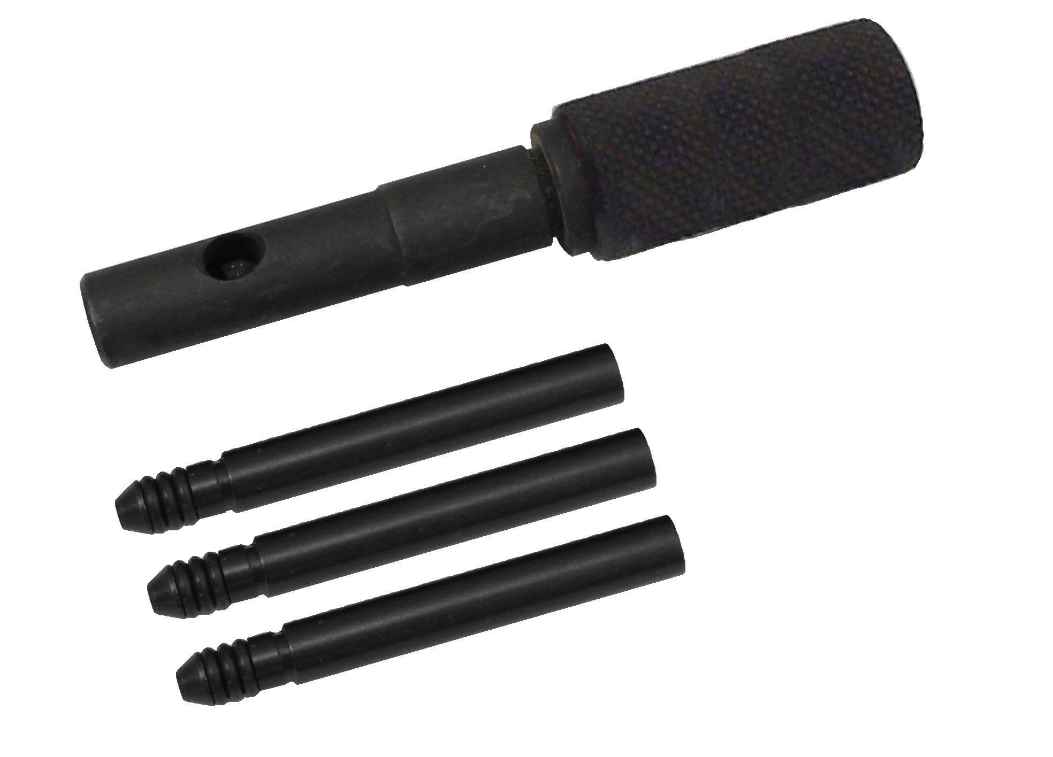

- This tool is used to ensure proper crankshaft alignment
- Application: SERIES 60 includes one holder and three pins.

H.C.B-A1911
DETROIT 60 SERIES DIESEL CRANKSHAFT ALIGNMENT TOOL

- This tool is used to ensure proper crankshaft alignment
- Application: SERIES 60 includes one holder and three pins.

