
H.C.B-A1910
VOLVO/ MACK LEAF SPRING PIN SOCKET
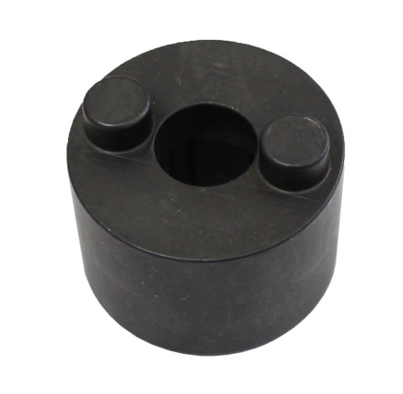

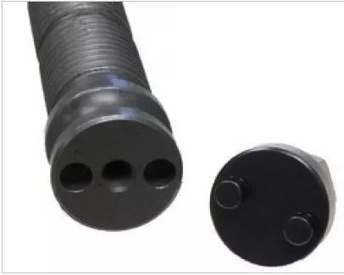

- Remove and install even the most stubborn threaded leaf spring and shackle pins on Volvo and Mack suspensions. Refer to dimensions to ensure compatibility.
- Applications :Volvo and Mack.
- VOLVO OEM no.ref.: 9996791

H.C.B-A1910
VOLVO/ MACK LEAF SPRING PIN SOCKET

- Remove and install even the most stubborn threaded leaf spring and shackle pins on Volvo and Mack suspensions. Refer to dimensions to ensure compatibility.
- Applications :Volvo and Mack.
- VOLVO OEM no.ref.: 9996791

