
H.C.B-A1908
DETROIT DIESEL INJECTOR NOZZLE/ CUP/ SLEEVE/ TUBE REMOVER & INSTALLER

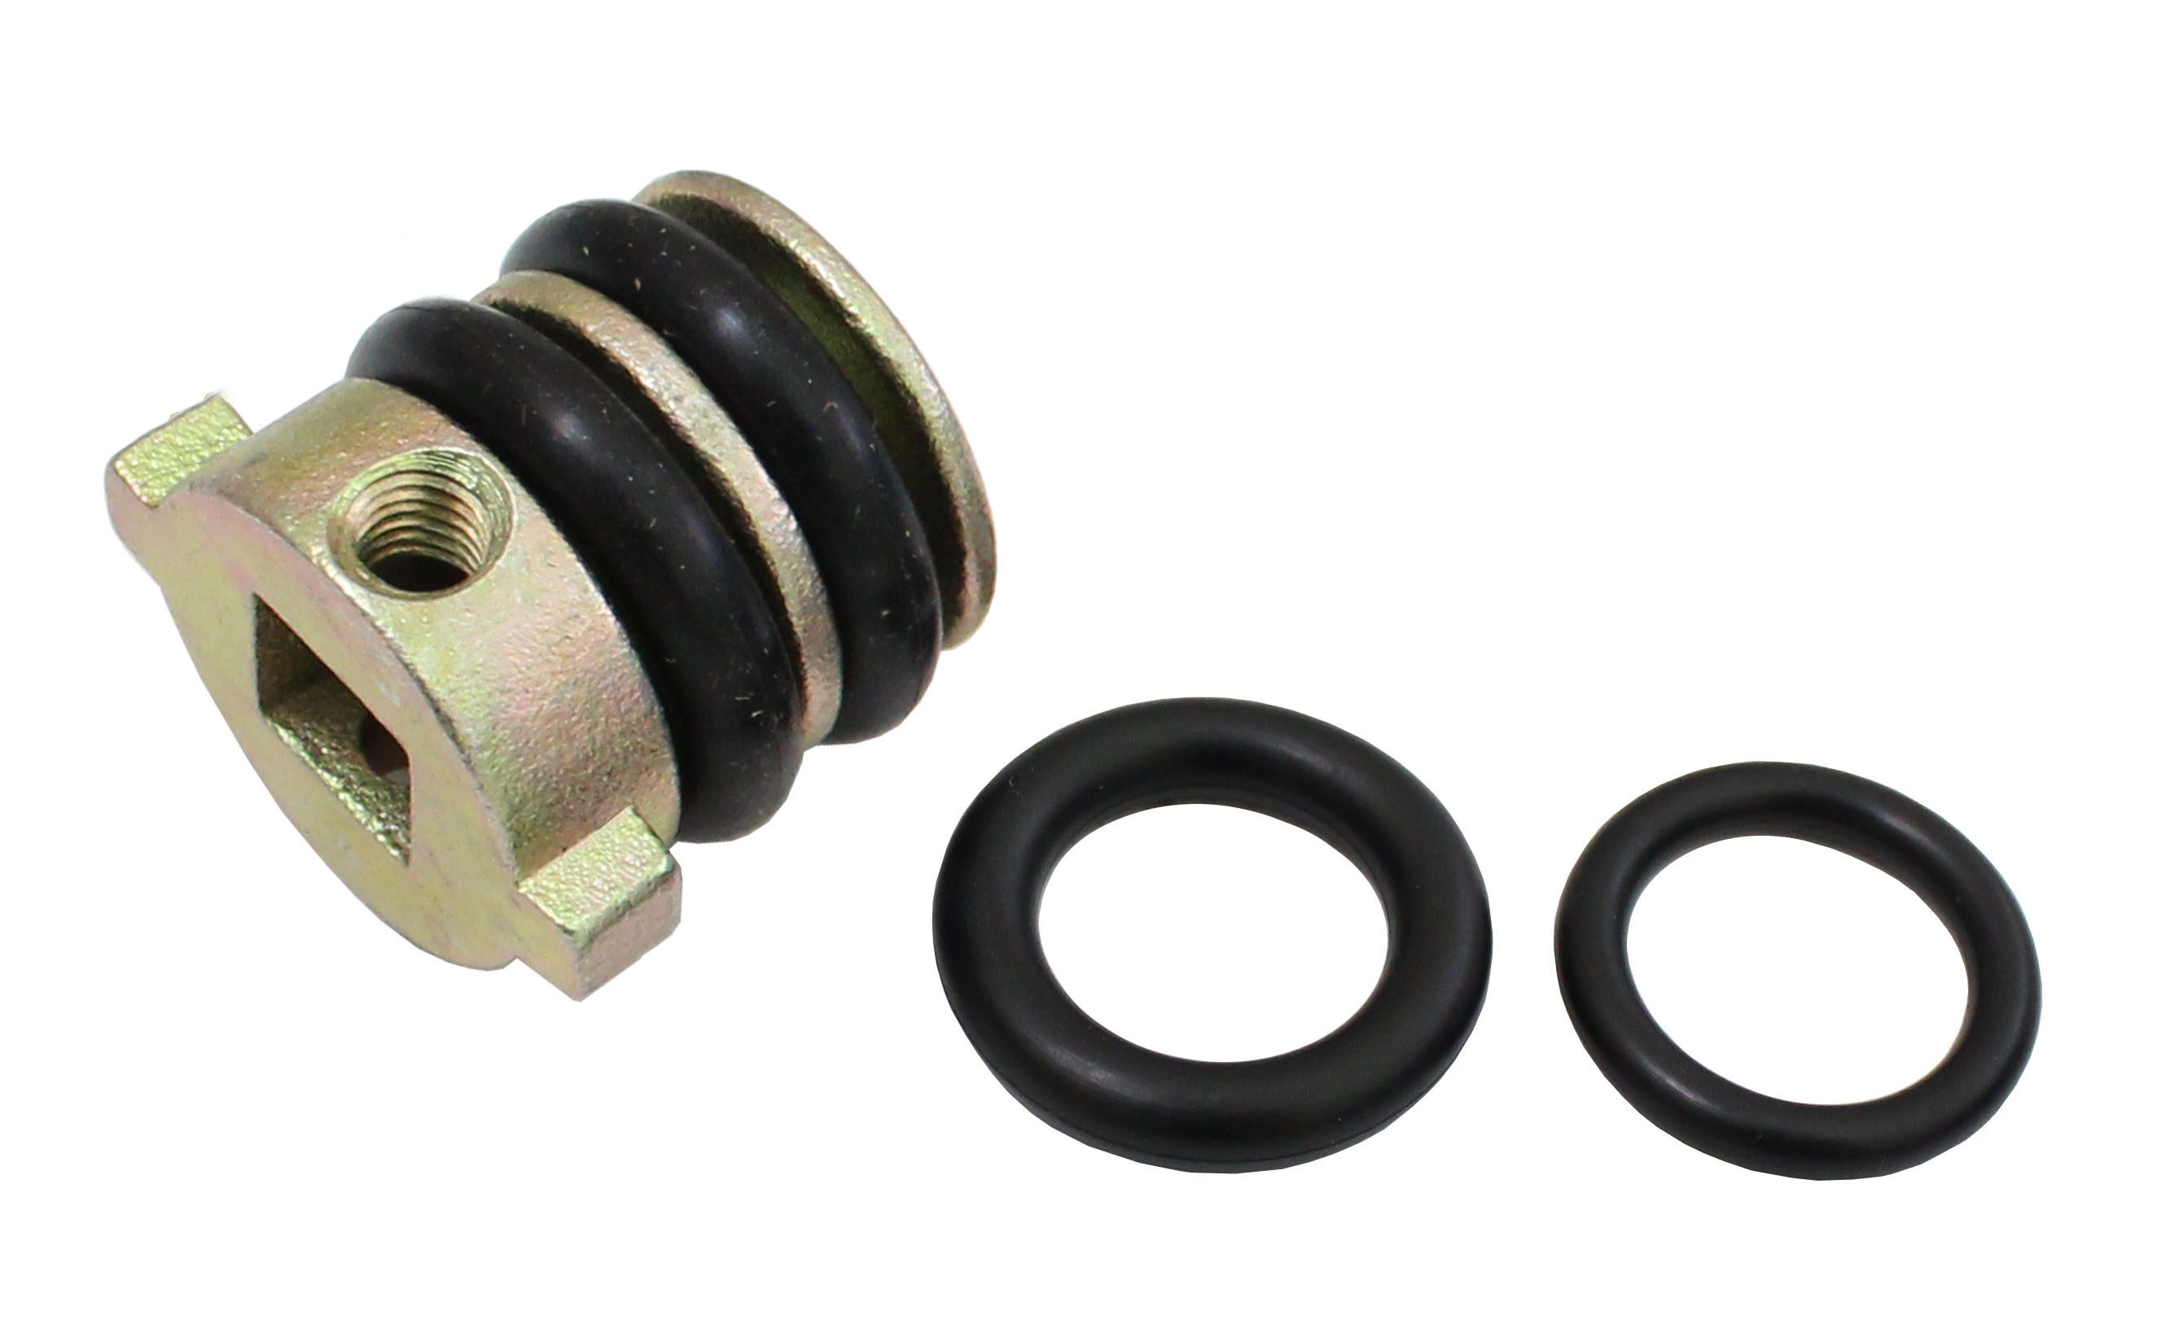

- This tool is used to remove and replace the injector cups.
- Applications: SERIES 60, Detroit Diesel

