
H.C.B-A1907
DETROIT DIESEL 60 SERIES INJECTOR NOZZLE/ CUP/ SLEEVE/ TUBE REMOVER INSTALLER ALT

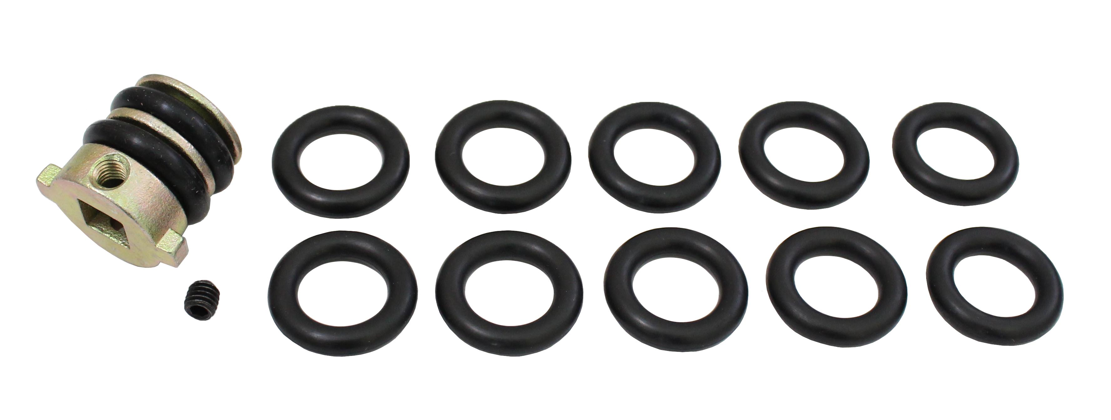

- This tool is used to remove and replace the injector cups.
- Applications: SERIES 60, Detroit Diesel
- OEM NUMBER: 46904

