
H.C.B-A1271- G
DAF TRUCK TRANSMISSION MAIN
SHAFT BEARING INSTALLER
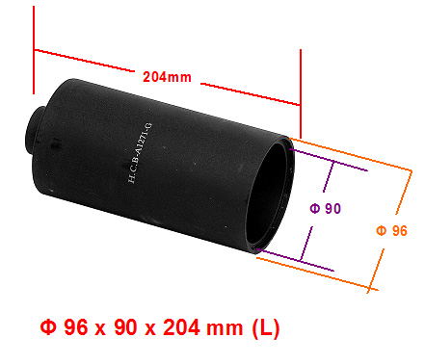

▉ H.C.B-A1271- G assist to push the bearing into main shaft.

Put this tool on the bearing seat, pushing it and forced the bearing seat move into main shaft.

