
H.C.B-A1271-F
DAF TRUCK TRANSMISSION MAIN
SHAFT BEARING INSTALLER

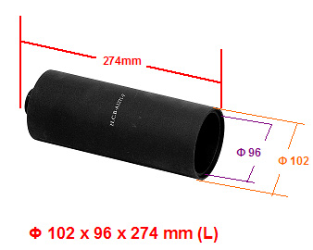

▉ H.C.B-A1271-F assist to push the bearing into main shaft.

Put this tool on the bearing seat, pushing it and forced the bearing seat move into main shaft.

