
H.C.B-A1271-E
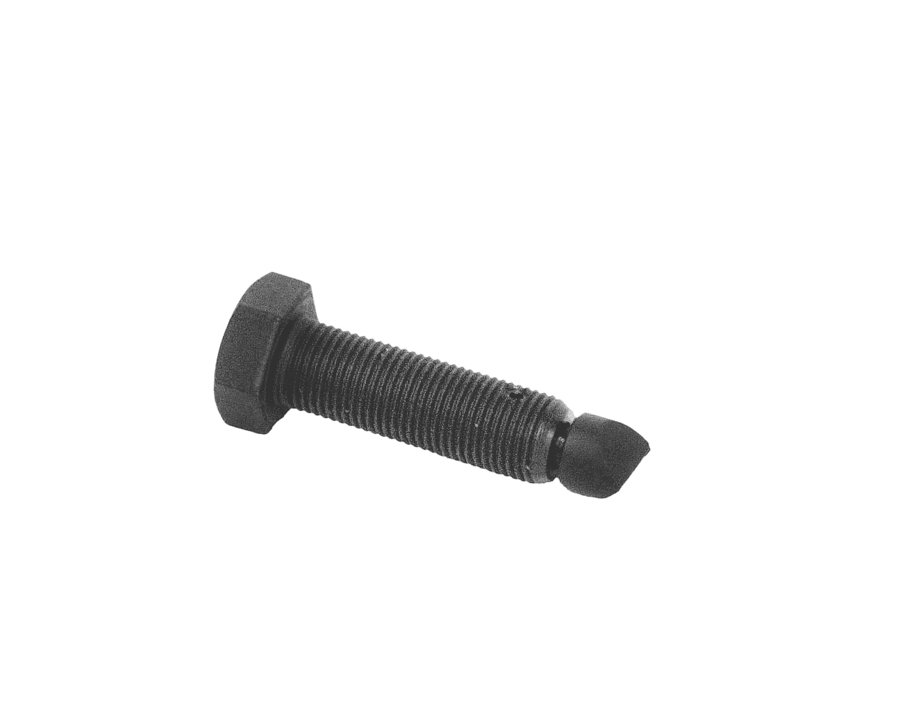
DAF TRUCK TRANSMISSION
PLANETARY GEAR RETAINING BOLT(ZF 16S)

▉ This tool helps to installing and extracting transmission main shaft smoothly.
Before dismantles planetary gear cylinder, take piston pin apart. Rotating this tool into piston hole, set the gear shift lever and tighten locked device.
▉ When assembles planetary gear to the case, this tool assists planetary gear to seat the right place.
Put this tool to piston hole. Until tighten the locked nut on the piston, take this tool out.

