
H.C.B-A1271-D
DAF TRUCK TRANSMISSION
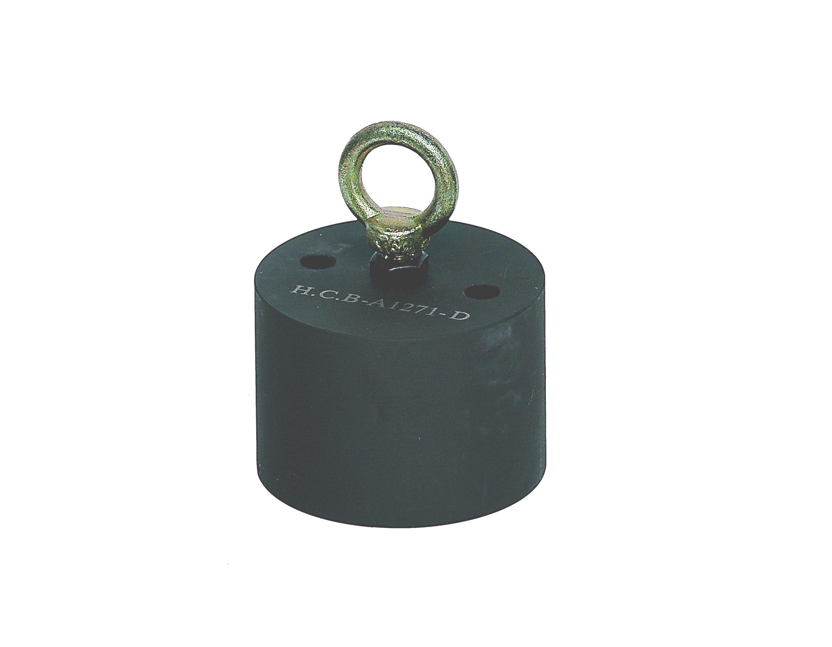
PLANETARY GEAR ASSEMBLY SLING(ZF 16S)

▉ This tool designed for helping lift the transmission planetary gear.

