
H.C.B-A1271-C
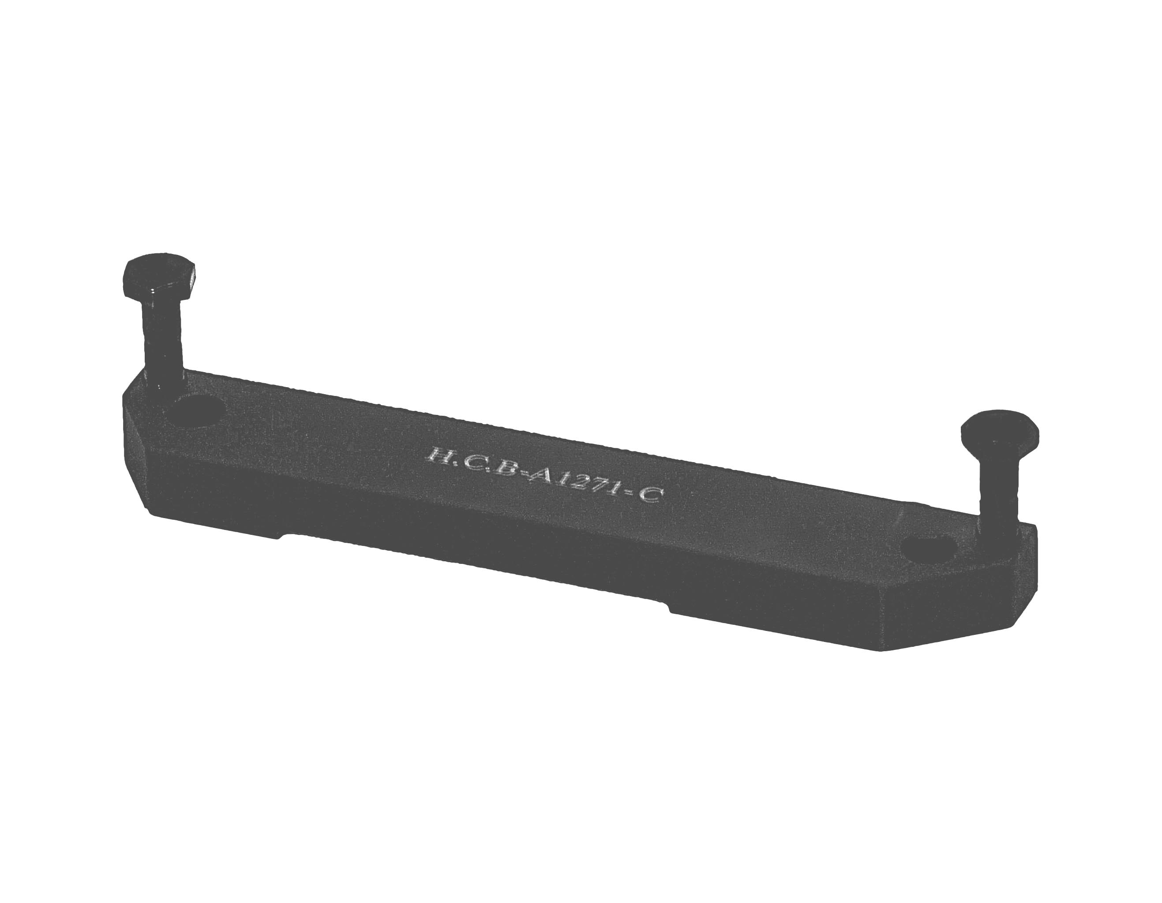
DAF TRUCK PLANETARY GEAR
GROUP SUPPORTING PLATE (ZF 16S)

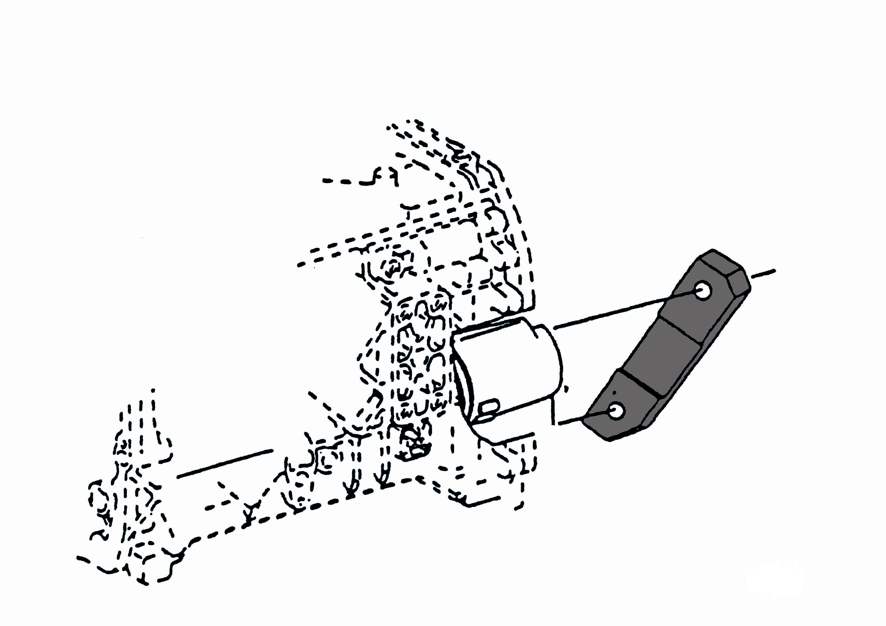

▉ Before assembles the planetary gear train, use this tool to test if the block leakage or not while the piston acting.
- Before assemble the planetary gear train, fasten this tool and piston together. Shifting to half gear, spraying the air into planetary gear block and testing if piston working smoothly or air-leakage. Assembles the planetary gear system, after confirmed there is no air-leakage.

