
H.C.B-A1271-B
DAF TRUCK TRANSMISSION MAIN SHAFT AND COUNTER SHAFT FIXED SEAT (ZF 16S)

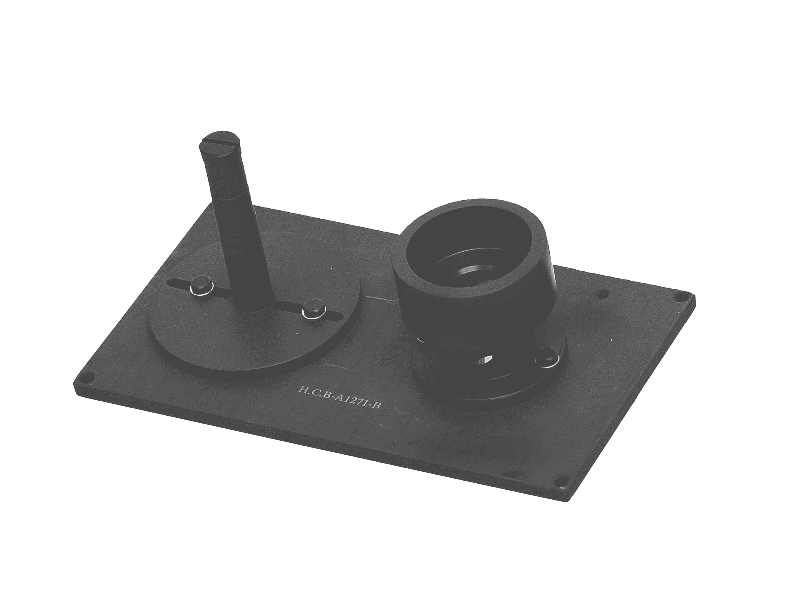
Counter Shaft Placed Seat
Main Shaft Placed Seat
▉ Put main shaft, counter shaft and gear shift lever on this fixation to prevent damage.
▉ Re-assembles main shaft, and placed it on the fixed seat. Set counter shaft and lever to this seat step by step. Tighten the fixed screw of sling with main shaft, counter shaft and install lever, lift and remove them to the correct position.

