
H.C.B-A1271-A
DAF TRUCK TRANSMISSION ASSEMBLY REMOVAL/INSTALL SLING (ZF 16S)
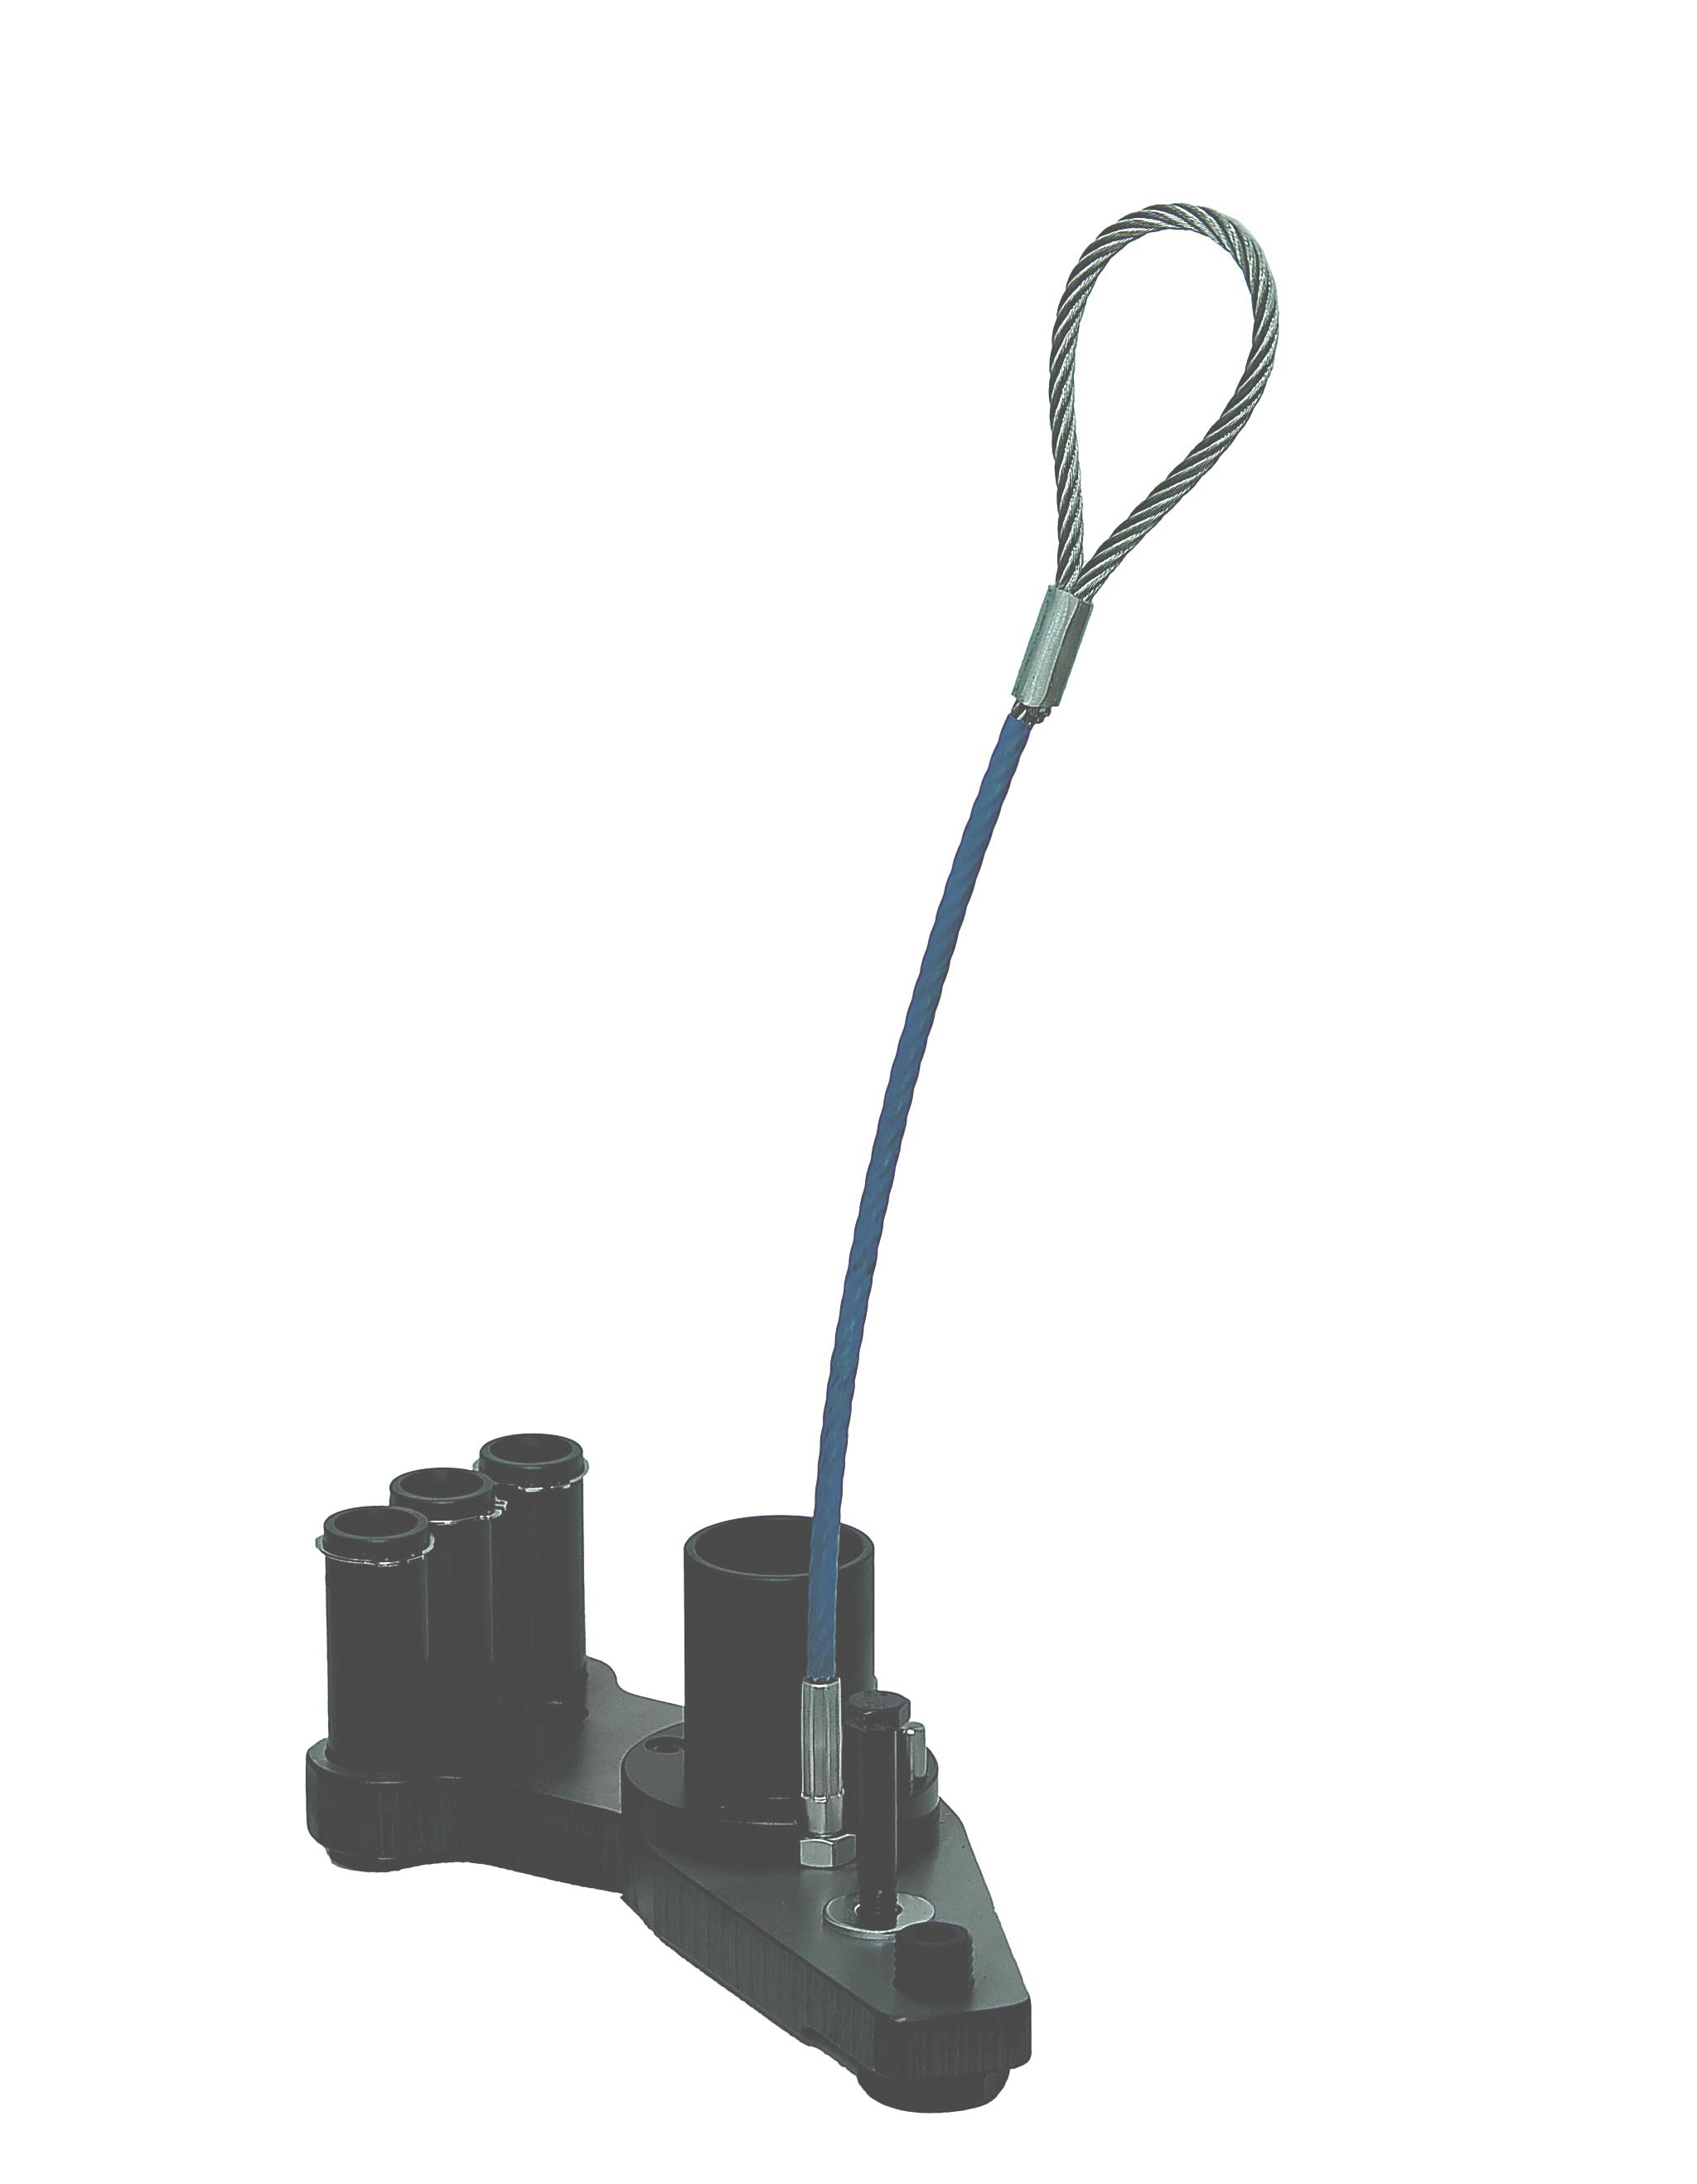
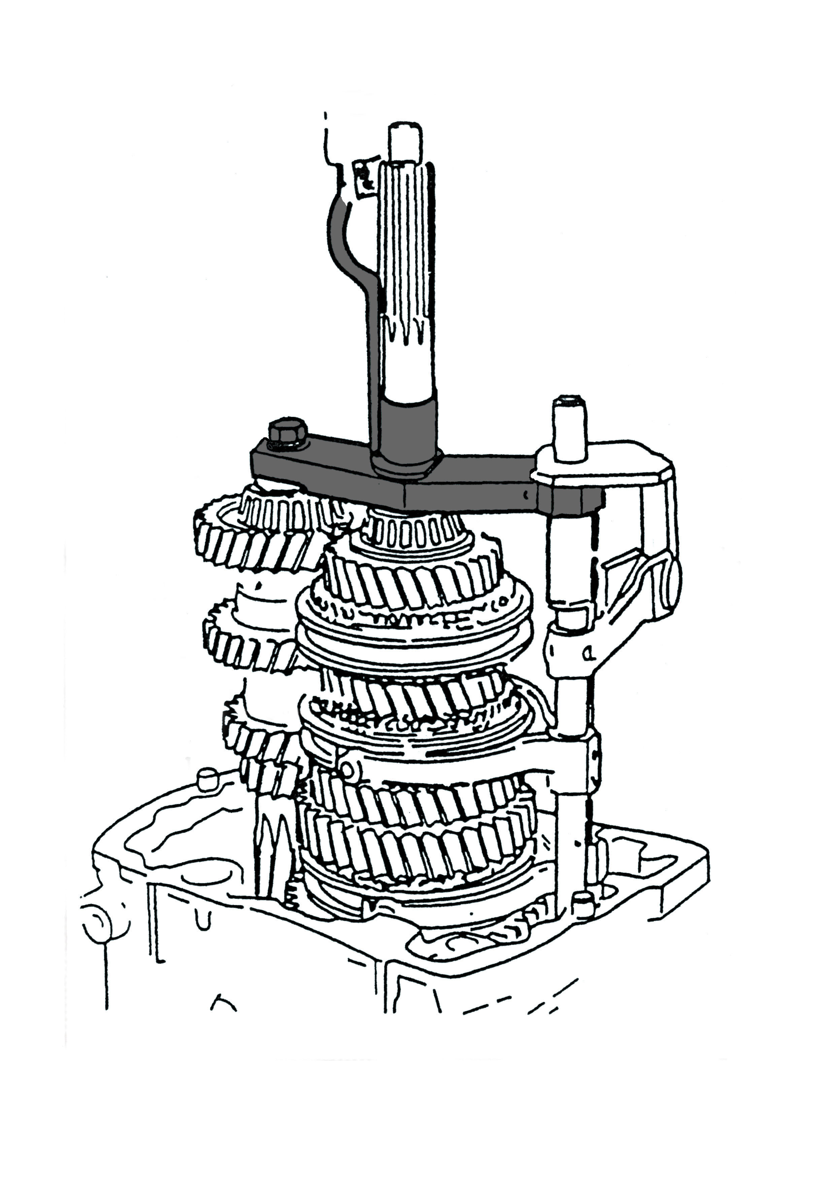

▉ Assist to take transmission main shaft, counter shaft and gear shift lever apart all together.
- Tighten H.C.B-A1271-E into transmission assembly, loosen gear shift lever. Take off main shaft, counter shaft and gear shift lever, put them on H.C.B-A1271-B steady.
- After shifting this tool step by step, separates counter shaft and gear shift lever.
- Get main shaft off from H.C.B-A1271-B, disassemble it.
- Applicable: European truck---DAF, Japanese truck---HINO.

