
H.C.B-A1903
FORD 6-SPEED POWERSHIFT TRANSMISSION ACTUATOR SOCKET
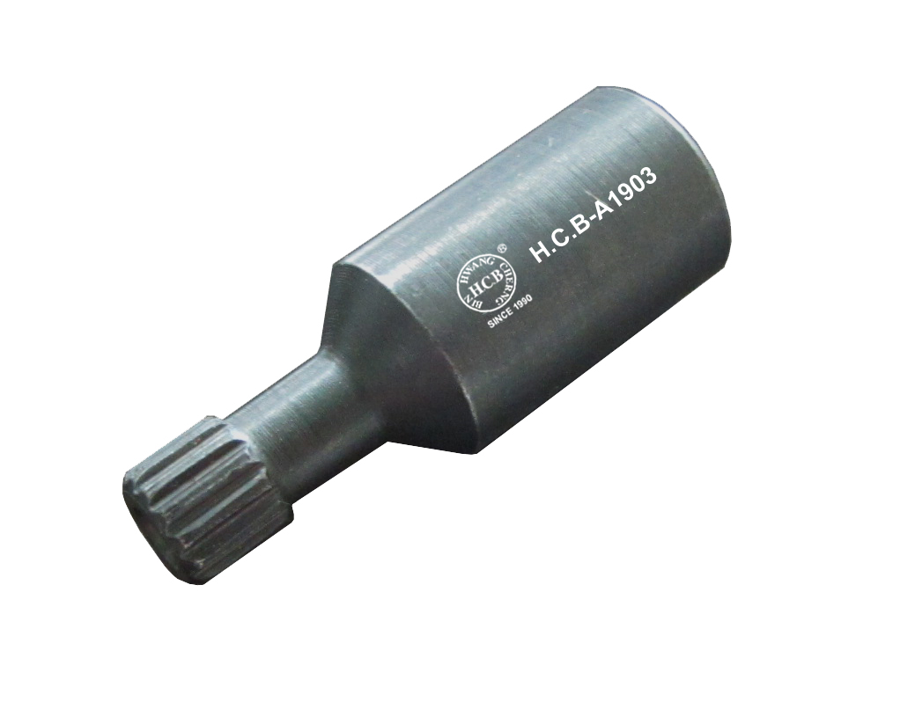

- Automatic Shifting Manual Transmission/Transaxle : Fiesta : 2011
- Automatic Transmission - Vehicles With: 6-Speed PowerShift Transmission - DPS6/6DCT250 : Focus : 2010/2011
- Automatic Transmission - Vehicles With: 6-Speed Automatic Transmission - 6DCT250 : Fiesta : 2010/2011
- Automatic Shifting Manual Transmission/Transaxle : Fiesta : 2012
- Automatic Transmission - Vehicles With: 6-Speed Automatic Transmission - 6DCT250 : Fiesta : 2012
- Automatic Transmission - Vehicles With: 6-Speed PowerShift Transmission - DPS6/6DCT250 : Focus : 2012
- Automatic Shifting Manual Transmission/Transaxle : Fiesta : 2013
- Automatic Transmission - Vehicles With: 6-Speed Automatic Transmission - 6DCT250 : Fiesta : 2013
- Automatic Transmission - Vehicles With: 6-Speed PowerShift Transmission - DPS6/6DCT250 : Fiesta : 2013 : Focus : 2013
- FORD OEM no. ref.: 307-677

