
H.C.B-A1900
FORD 6-SPEED POWERSHIFT TRANSMISSION TOOL
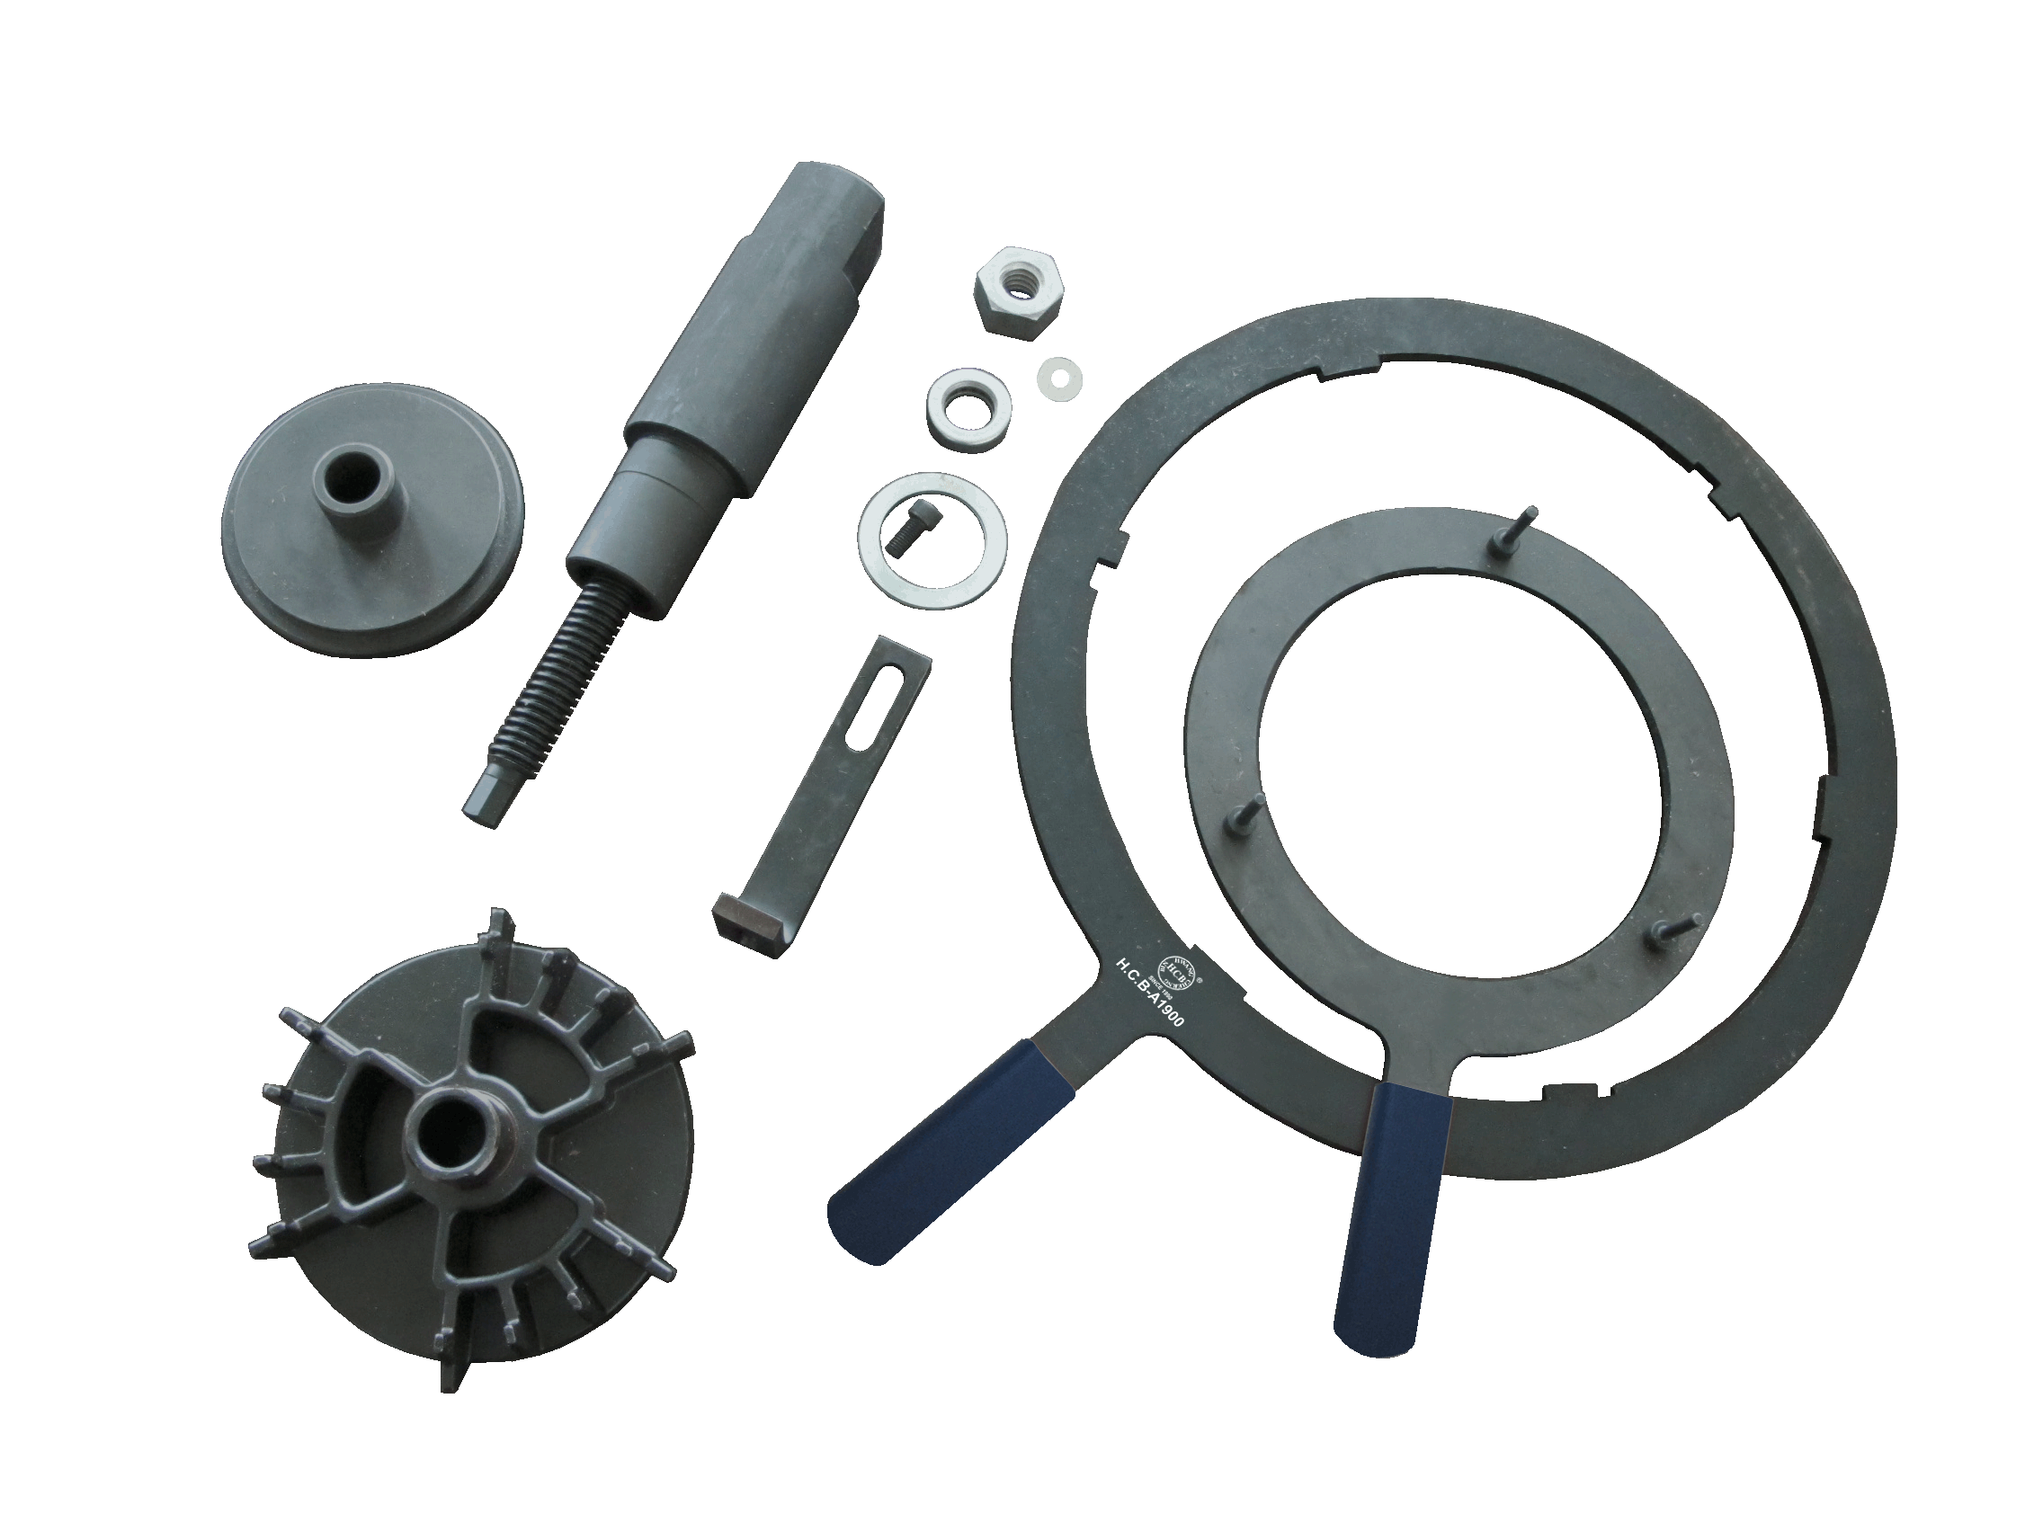

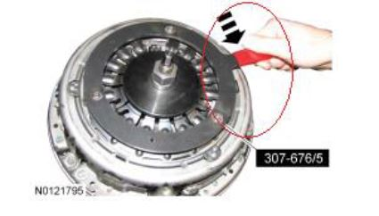

Application:
Automatic Shifting Manual Transmission/Transaxle : Fiesta : 2011, 2012, 2013
Automatic Transmission - Vehicles With: 6-Speed Automatic Transmission - 6DCT250 :
Fiesta : 2010, 2011, 2012, 2013
Automatic Transmission - Vehicles With: 6-Speed PowerShift Transmission - DPS6/6DCT250 : Fiesta : 2013
Automatic Transmission - Vehicles With: 6-Speed PowerShift Transmission - DPS6/6DCT250 : Focus : 2010, 2011, 2012, 2013
OEM: 307-676

