
H.C.B-A1894
SITRAK OIL SEAL INSTALLER

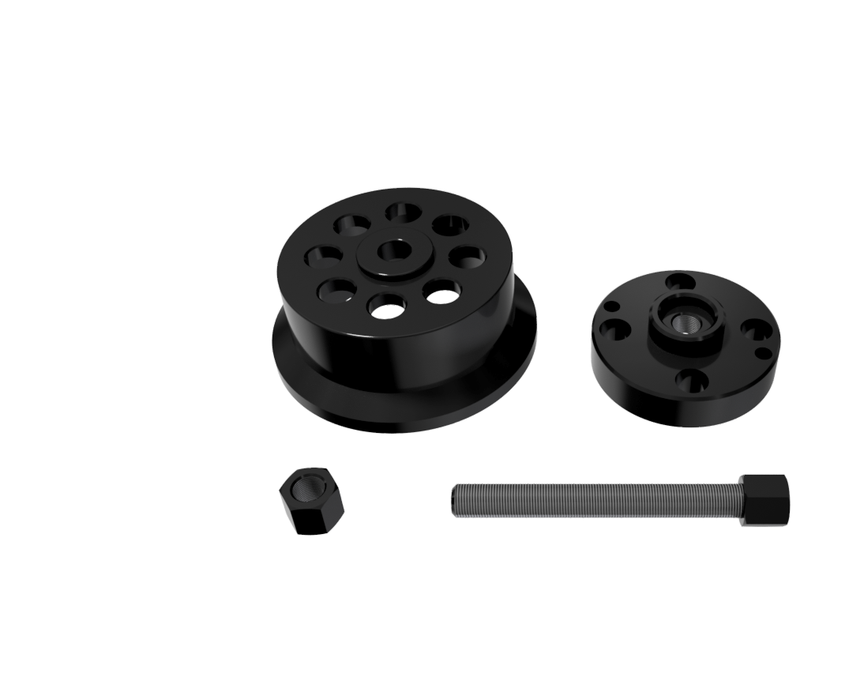

- To prevent the oil seal from damaged when installing it.
- Application: SITRAK 35TONS

