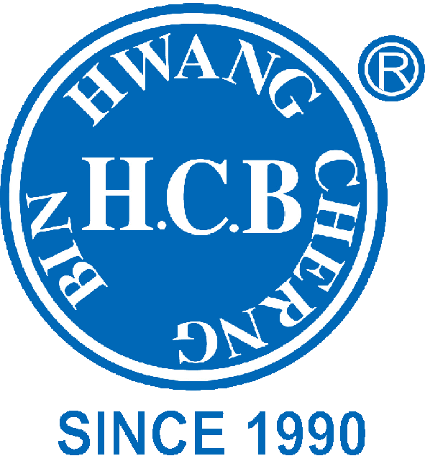
H.C.B-A1871-60
BENZ TRUCK FRAME RAIL NUT SOCKET
(Dr. 3/4”, E30, 60 mm)
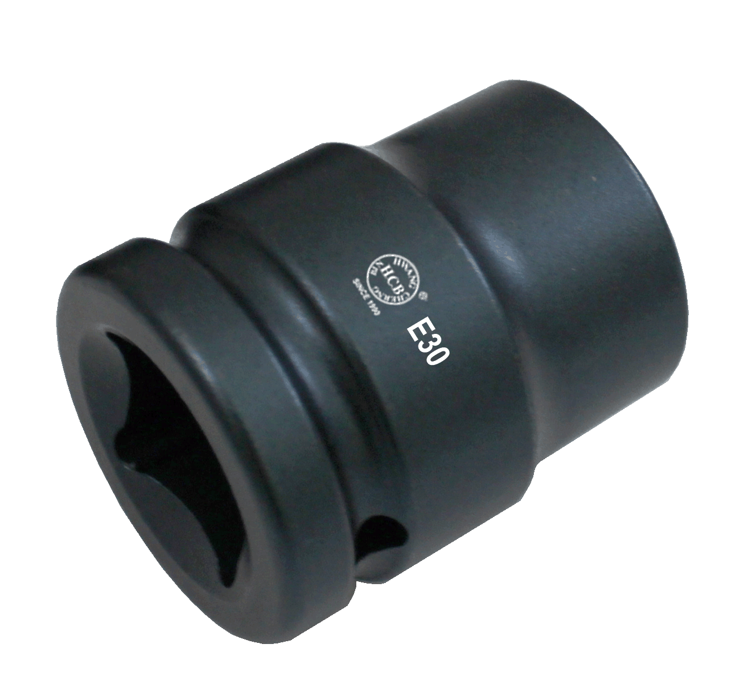

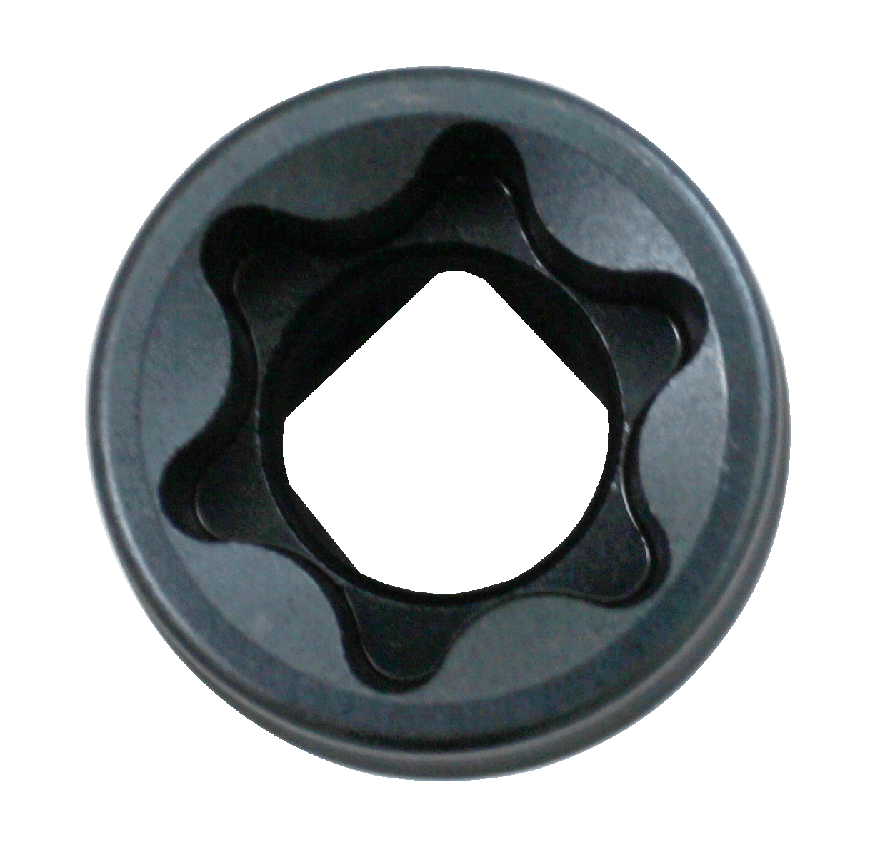
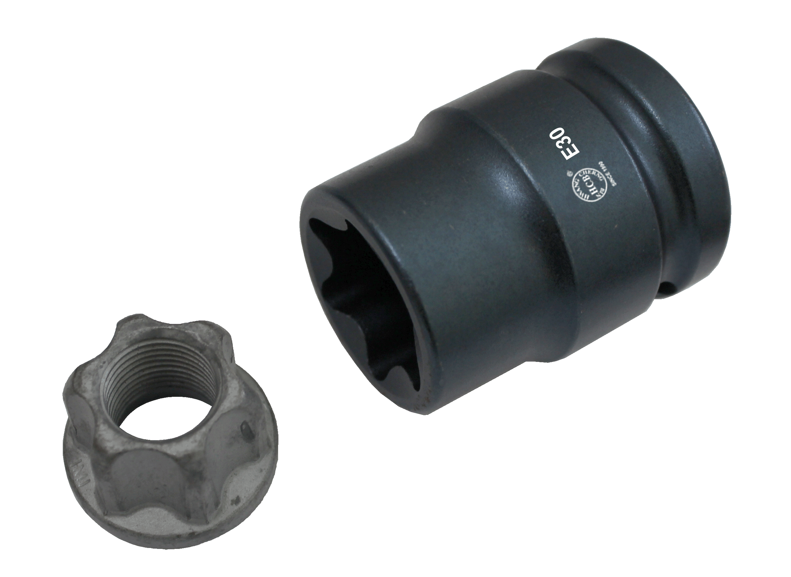

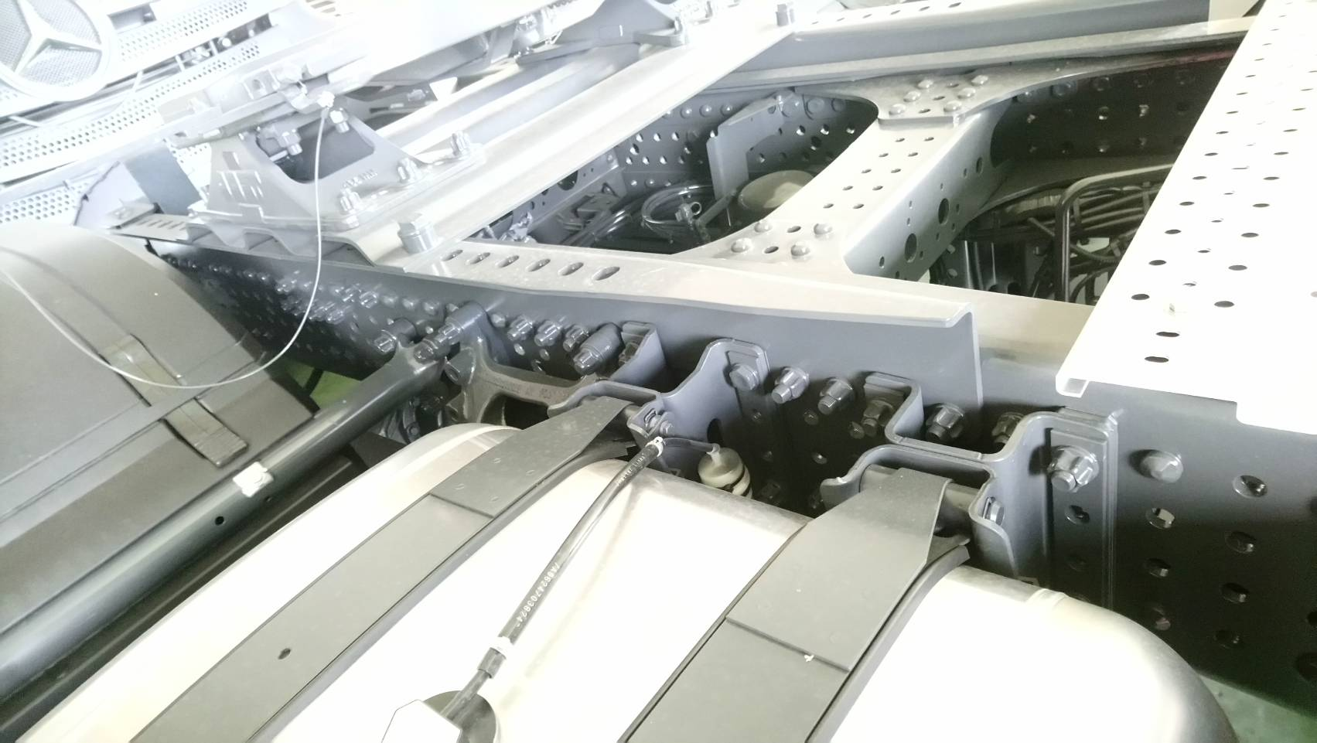

- Special E-TORX socket for lightweight E30 nuts which can be found in the chassis area of Benz truck.
- Dr.3/4”, Head Ø 40 mm, Total length: 60 mm, E-TORX E30.
- Application: BENZ EURO 6 Truck/Mercedes Bus (405), Unimog(437), Econic (956), Actros (963),Arocs(964), Atego(967), Zetros(949).
H.C.B-A1871-60
BENZ TRUCK FRAME RAIL NUT SOCKET
(Dr. 3/4”, E30, 60 mm)

- Special E-TORX socket for lightweight E30 nuts which can be found in the chassis area of Benz truck.
- Dr.3/4”, Head Ø 40 mm, Total length: 60 mm, E-TORX E30.
- Application: BENZ EURO 6 Truck/Mercedes Bus (405), Unimog(437), Econic (956), Actros (963),Arocs(964), Atego(967), Zetros(949).

