
H.C.B-A1868
SAF AXLE BRAKE DISC NUT SOCKET
(Dr. 1/2", 12 POINTS, 13 mm)
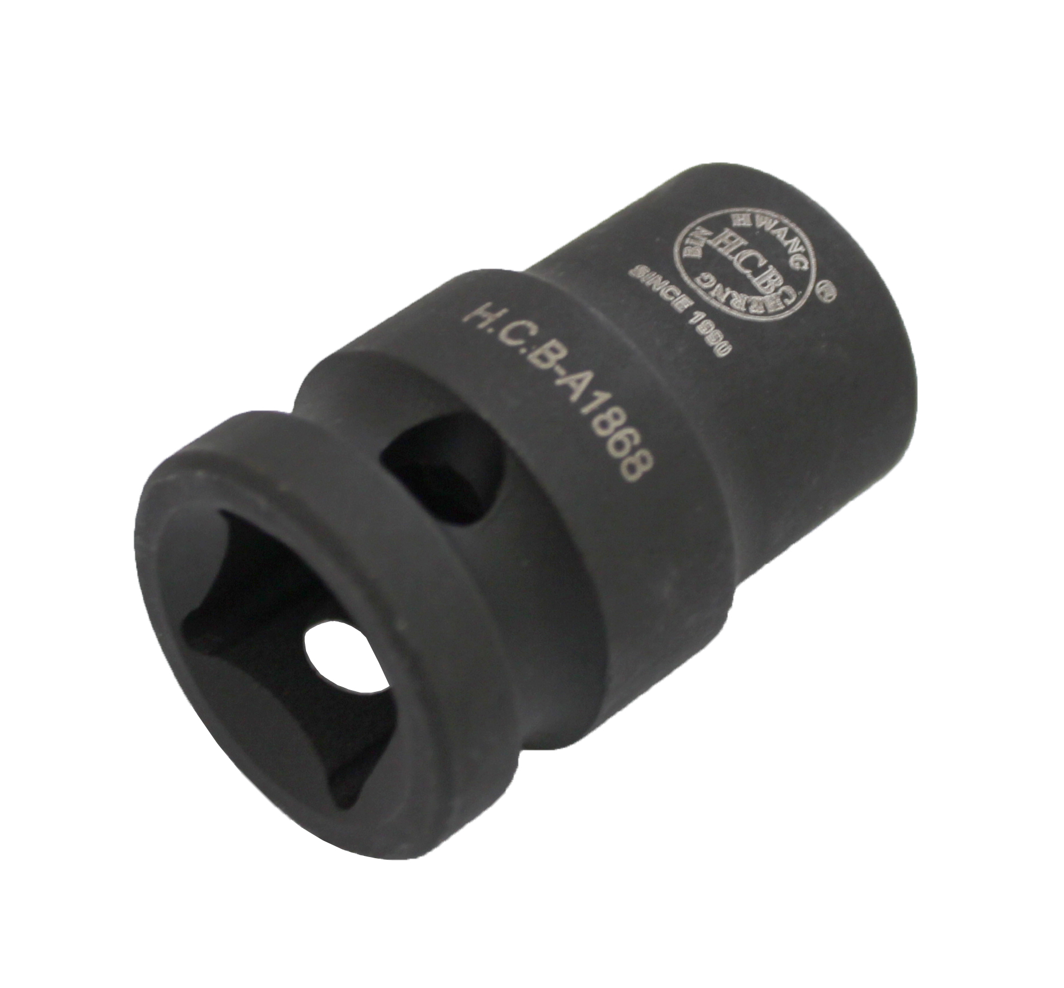

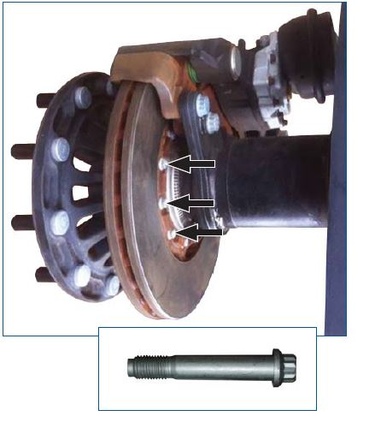
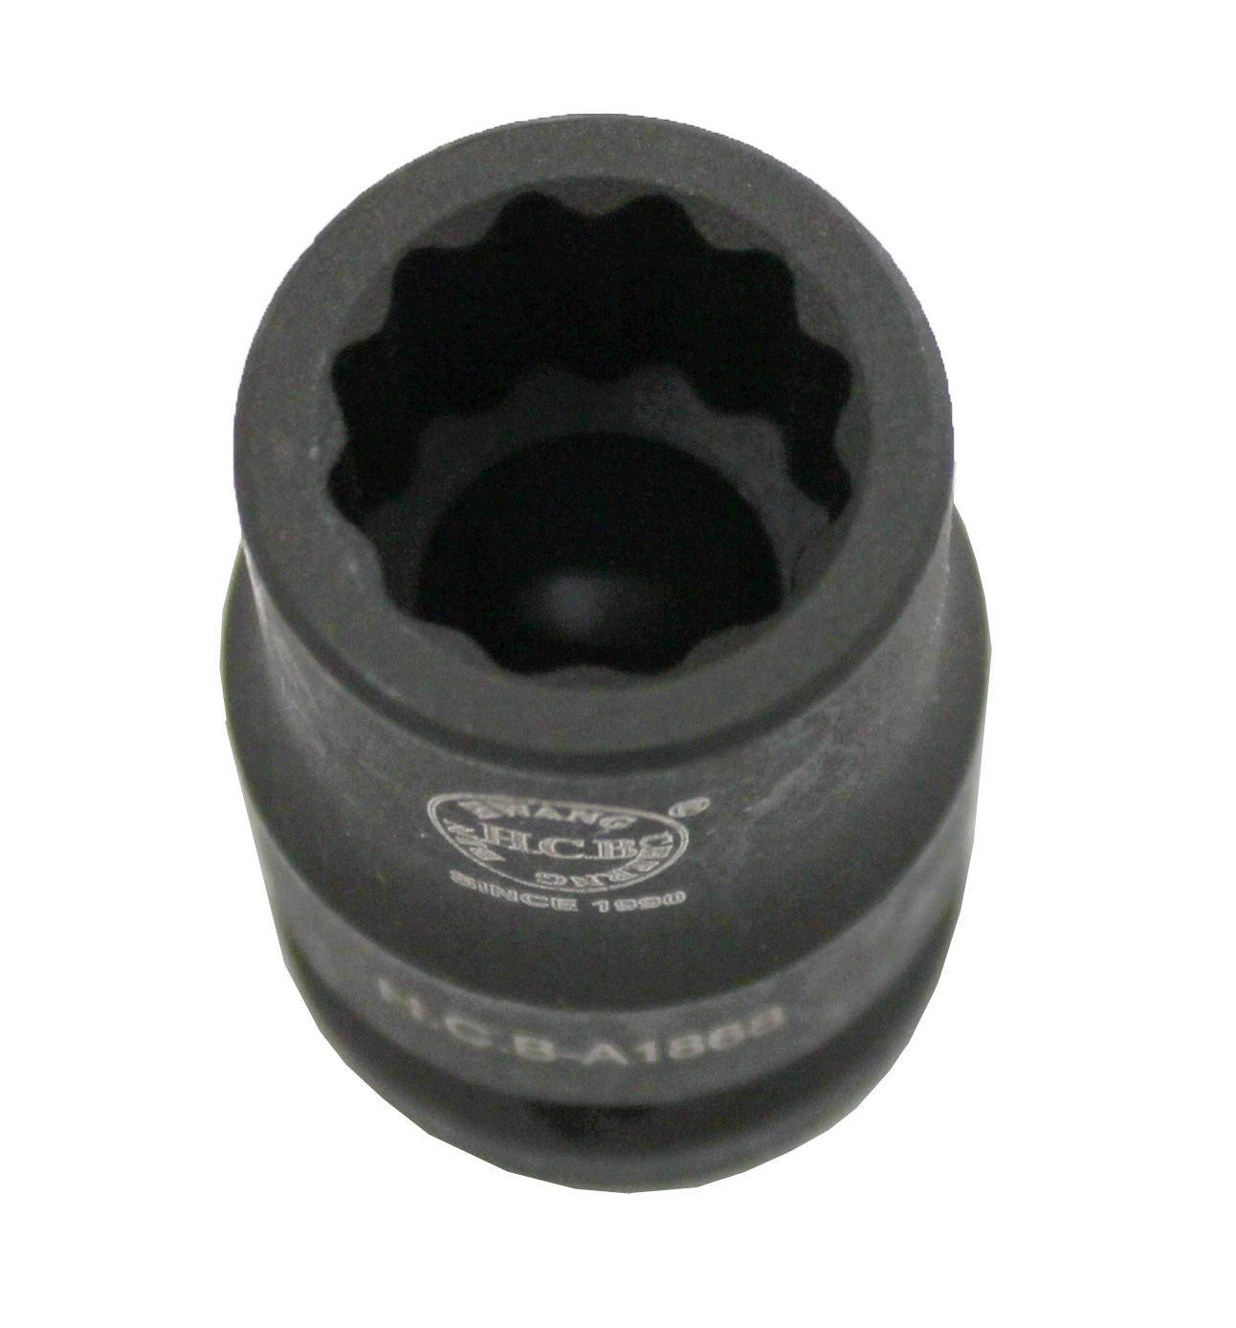

- Designed for loosening and tightening the brake disc nuts on SAF axles.
- Size: Dr. 1/2", 12 points, 13 mm ,Length: 38 mm
- Application: HGVs with SAF axle.

H.C.B-A1868
SAF AXLE BRAKE DISC NUT SOCKET
(Dr. 1/2", 12 POINTS, 13 mm)

- Designed for loosening and tightening the brake disc nuts on SAF axles.
- Size: Dr. 1/2", 12 points, 13 mm ,Length: 38 mm
- Application: HGVs with SAF axle.

