
H.C.B-A1866
VW GEARBOX SHAFT SPACER

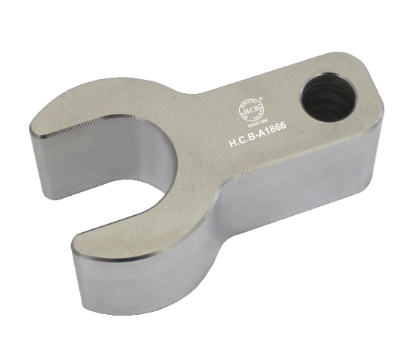

- For adjusting gear shift mechanism.
- Application: Transporter 2004 >,6-speed manual gearbox 0A5
- VW OEM no. ref.: T10216

H.C.B-A1866
VW GEARBOX SHAFT SPACER

- For adjusting gear shift mechanism.
- Application: Transporter 2004 >,6-speed manual gearbox 0A5
- VW OEM no. ref.: T10216

