
H.C.B-A1865
VW GEARBOX SHAFT SPACER

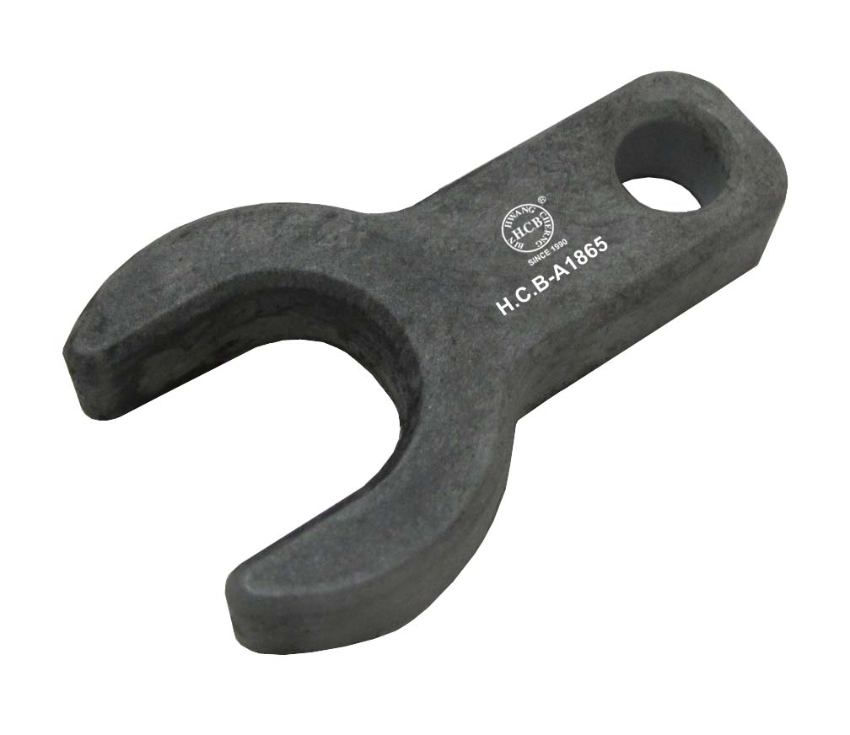

- For adjusting gear shift mechanism.
- Application: Transporter 2004 >,5-speed manual gearbox 02Z
- VW OEM no. ref.: T10217

H.C.B-A1865
VW GEARBOX SHAFT SPACER

- For adjusting gear shift mechanism.
- Application: Transporter 2004 >,5-speed manual gearbox 02Z
- VW OEM no. ref.: T10217

