
H.C.B-A1850
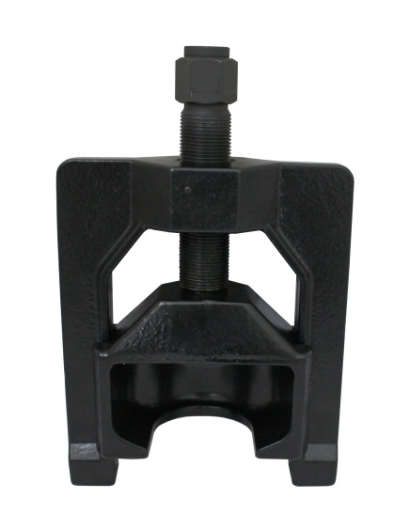
HEAVY DUTY U-JOINT PULLER

Safety Warning
Read all instructions and safety warnings prior to operation. Failure to do so could result in equipment damage, personal injury or even death.
NOTE: hammering this tool will void your warranty.
- Remove all fasteners from bearing cups.
- Slip the U-Joint Puller over the yoke of the drive line.
- Turn the tool’s forcing screw clockwise with up to a 1" impact wrench.
Note: Reverse threads, bottoming out forcing screw on frame may cause unwarrantable damage to threads.
Provides ultimate brute strength for disassembling even the most seized u-joints in minutes on virtually all Class 7 and 8 trucks and machinery.
Eliminates dangerous vice-and-socket or hammering methods
Reduces the risk of damage to driveshaft, yokes, joints or bearing cups
Engineered for use with a 1” impact tool
under even the most extreme conditions, commonly found in seized u-joints on class 7 and 8 trucks.
- Application
U-Joints with bearing cups 1.5″ to 2.2″ O.D.
Spicer 1610, 1710, 1760, 1810, 1880 Series
Spicer SPL 140, 170, & 250 Life Series
Meritor (Rockwell) 16N, 17N, 18N, 1710 Series
Meritor RPL 20, 25 Permalube Series

