
H.C.B-A1836
DAF 12-SPEED TRANSMISSION DISASSEMBLE BASE
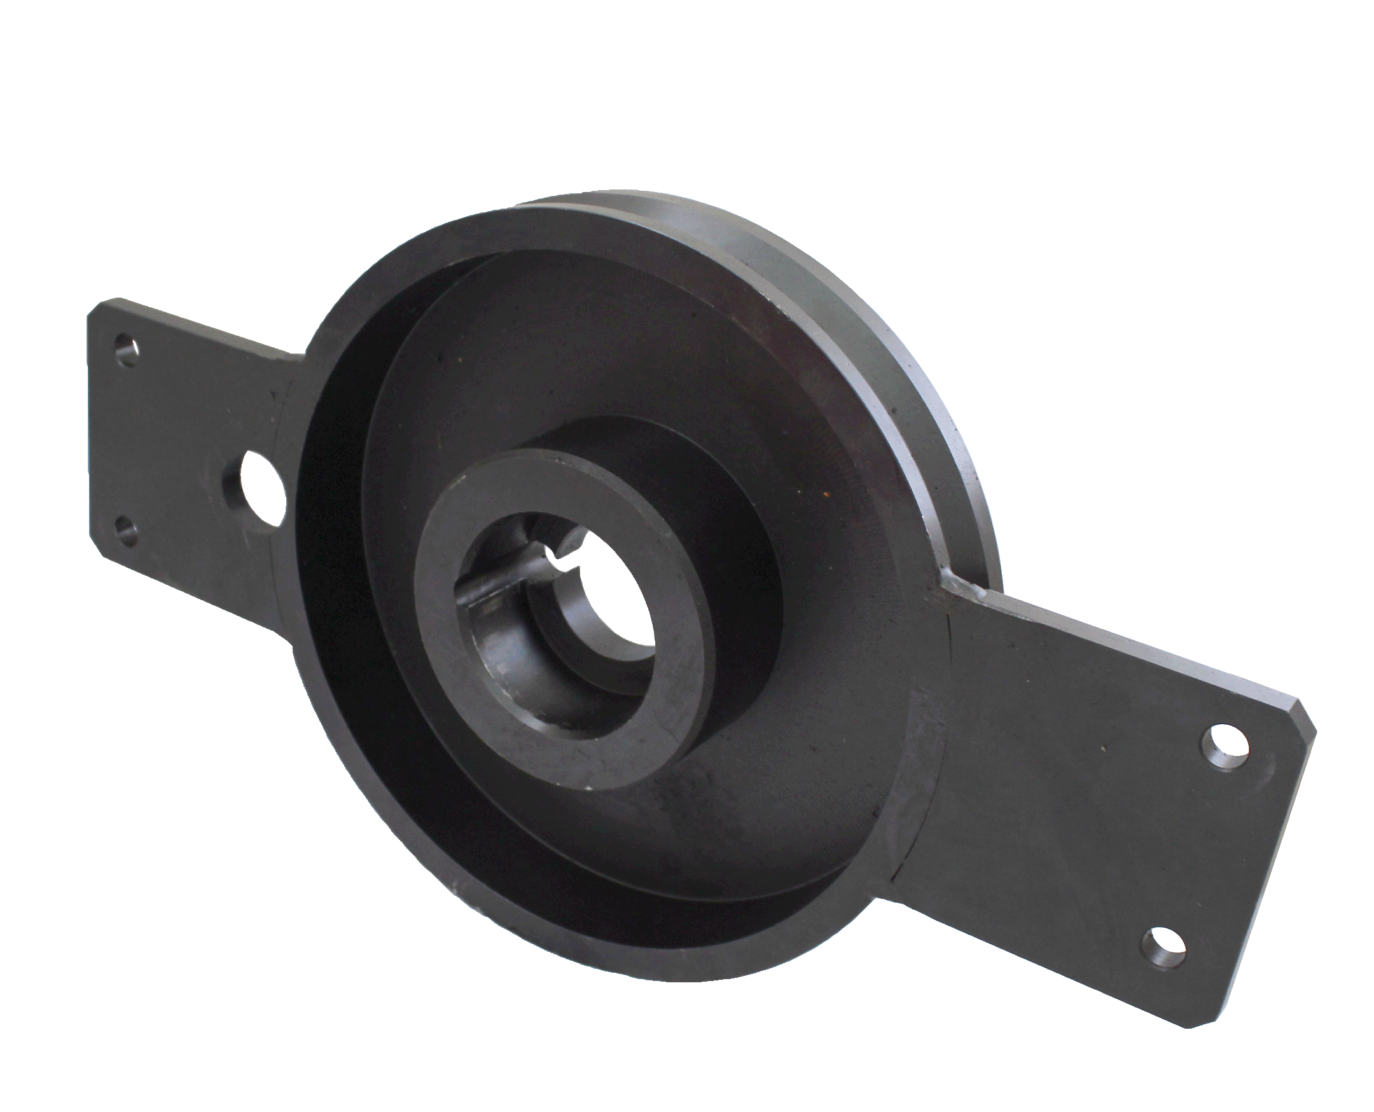

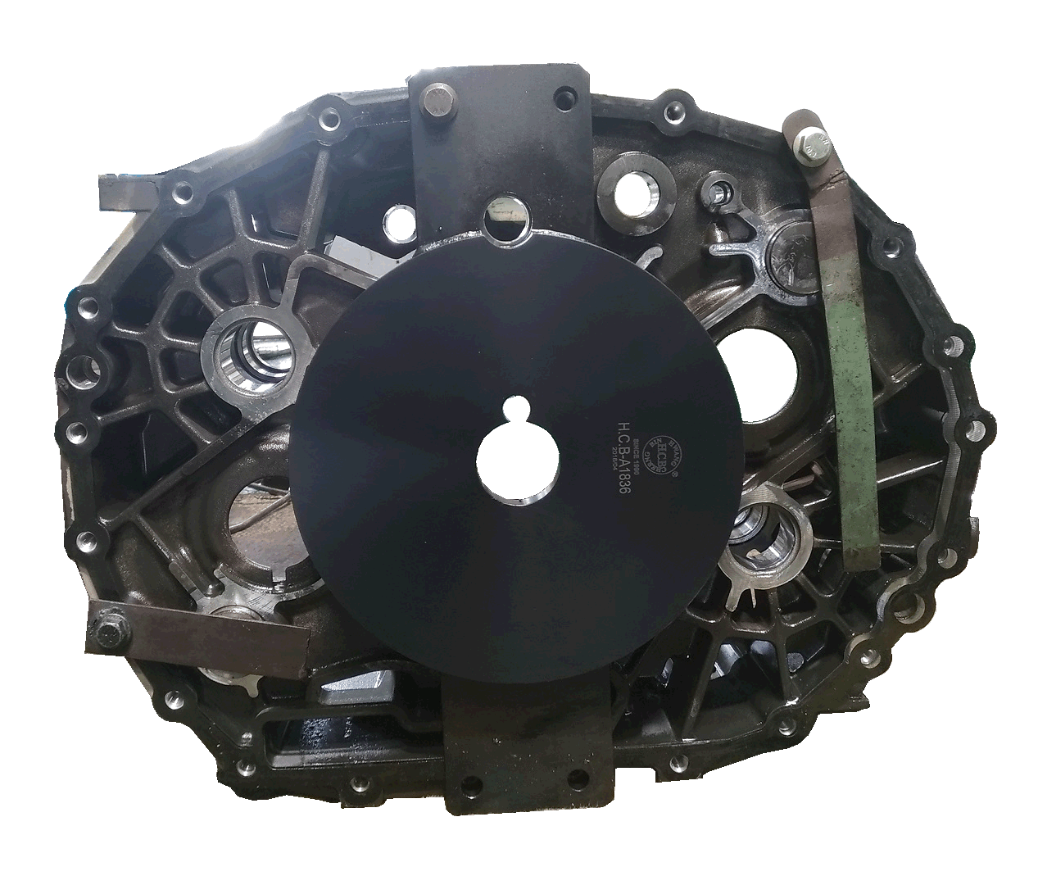

■ Use H.C.B-A1836 to disassemble the transmission will save time and labor.
■ Application: DAF 12-speed transmission

