
H.C.B-A1833
VOLVO (FM) TRUCK INPUT SHAFT BEARING REMOVER

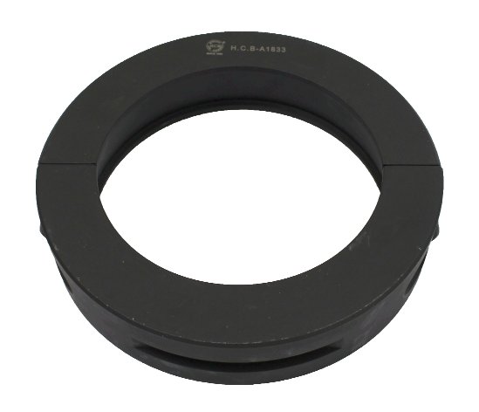

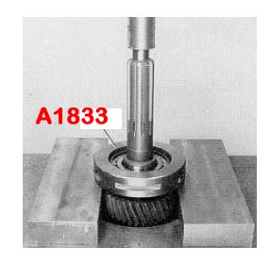

- Fix H.C.B-A1833 onto the bearing, use the vise to resist A1833. Press down the tool.
- Application: Volvo F10, F12, FH12, FL10, FL12, FL7, FM10, FM12, FM7, NH12, NL10, NL12.
- Volvo OEM number: 9998192

