
H.C.B-A1832
BENZ (2845/ 2846/ 2858) TRUCK AUTOMATIC TRANSMISSION ADJUSTER

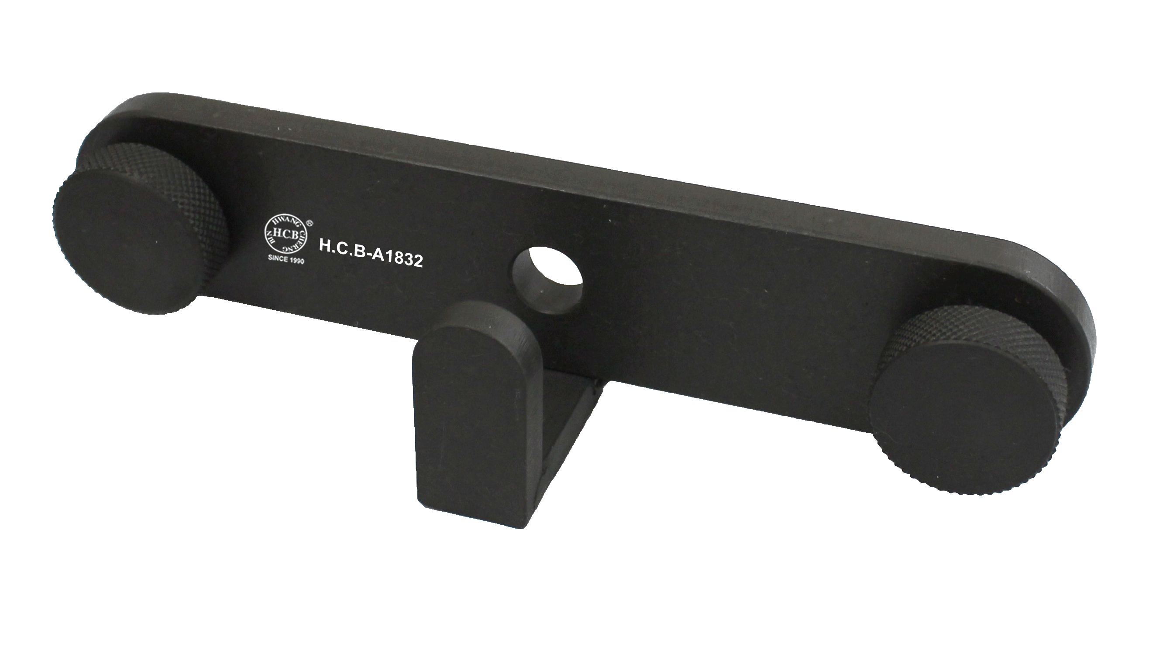

- Designed to maintain Benz (2845/ 2846/ 2858) truck automatic transmission.

