
H.C.B-A1831
VOLVO (FM) TRUCK INPUT SHAFT BEARING REMOVER
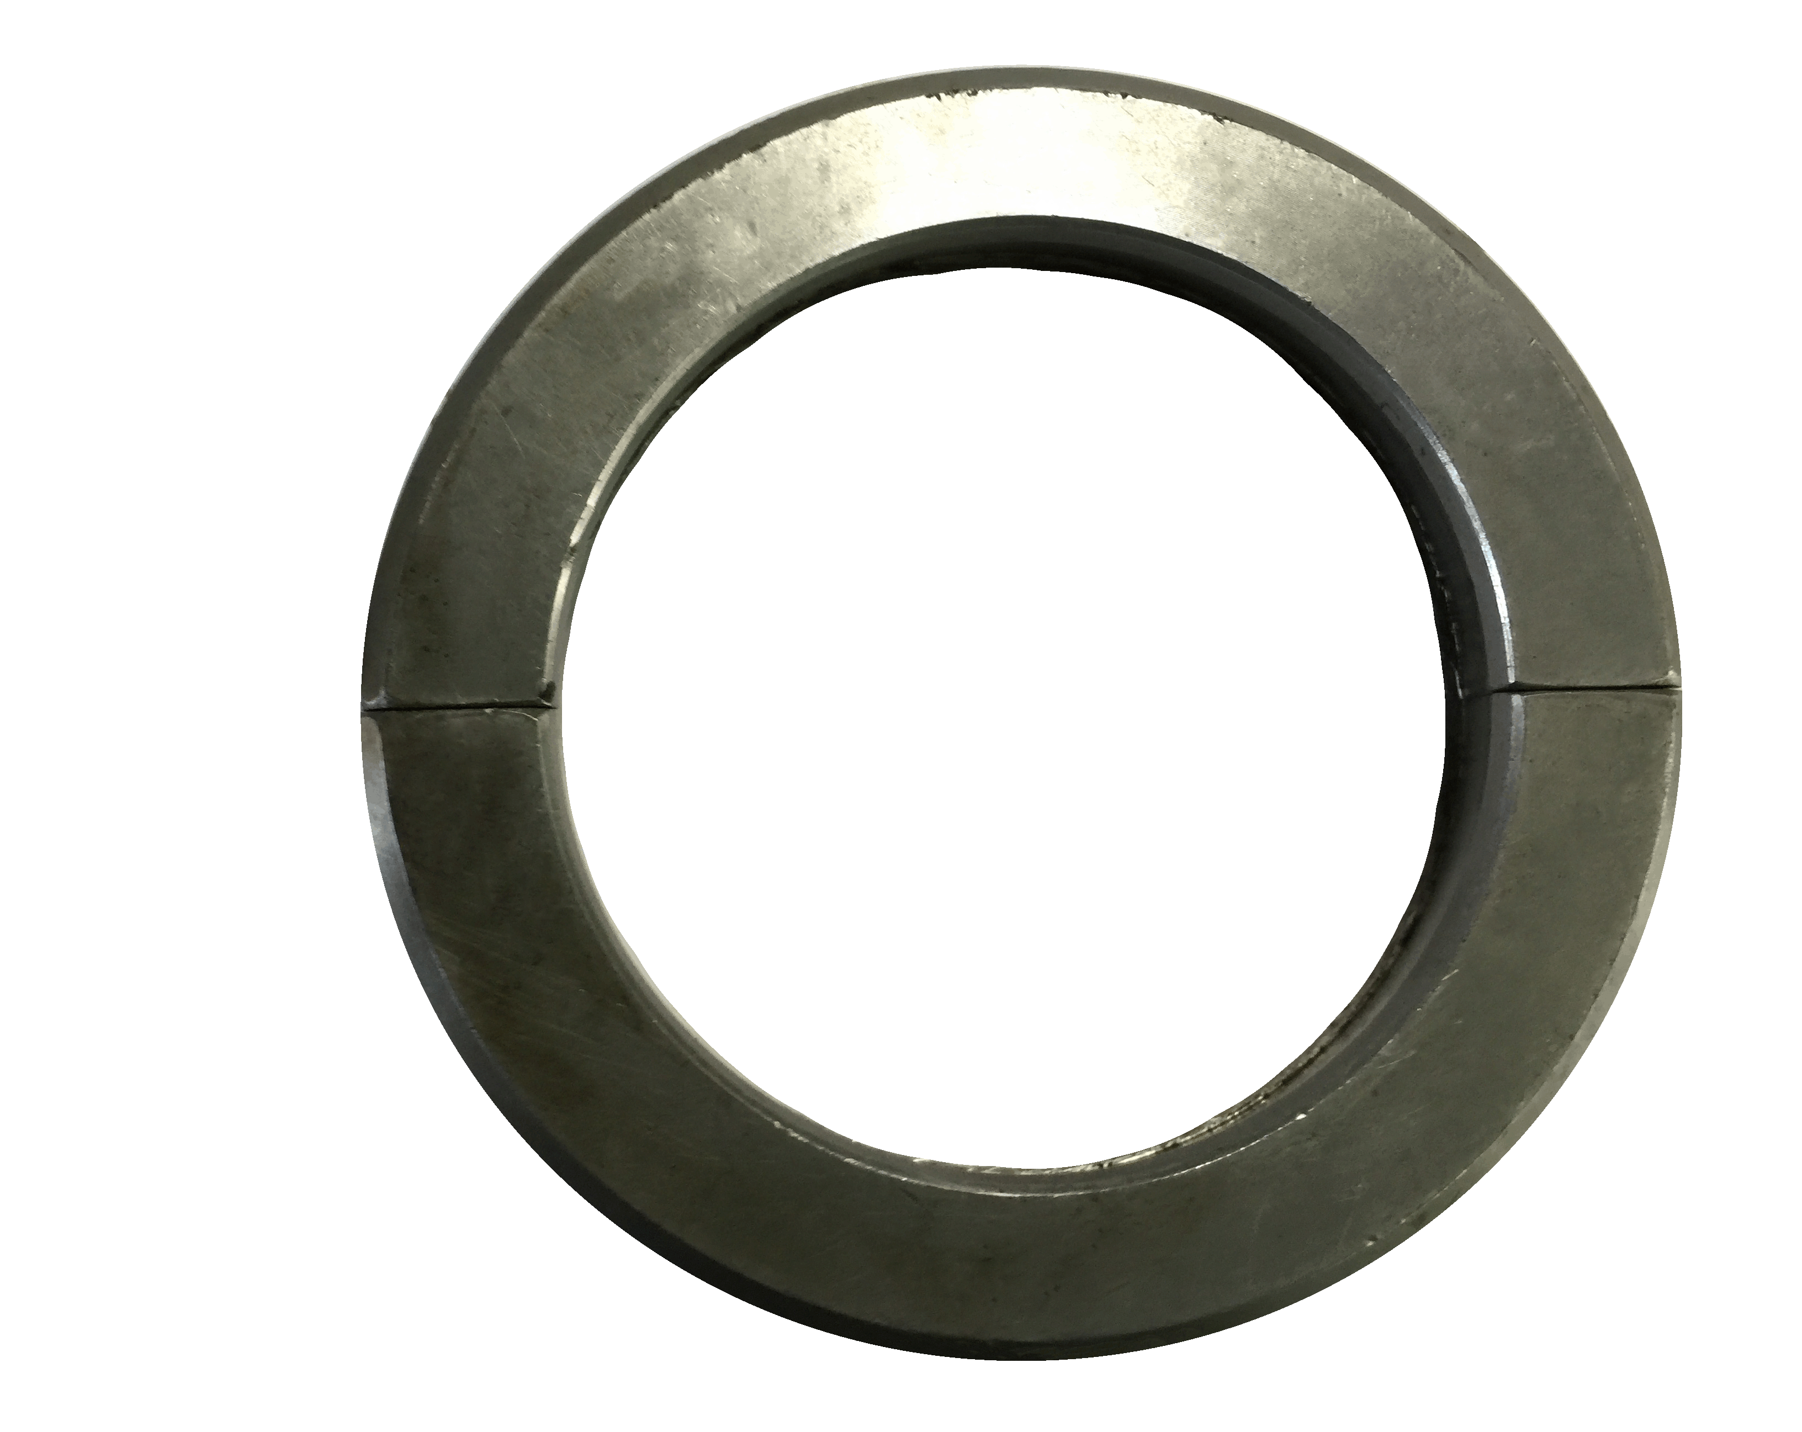

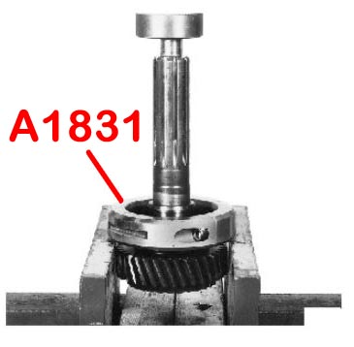

- Fixing H.C.B-A1831 onto the bearing, then use vise to resist A1831.Press the hydraulic press to press down the input shaft until the bearing is removed.
- Application: Volvo FM, B12B, B12M, B7R, B9R
- OEM number: 9998022

