
H.C.B-A1828

VOLVO (FM) TRUCK MAIN SHAFT BEARING REMOVER
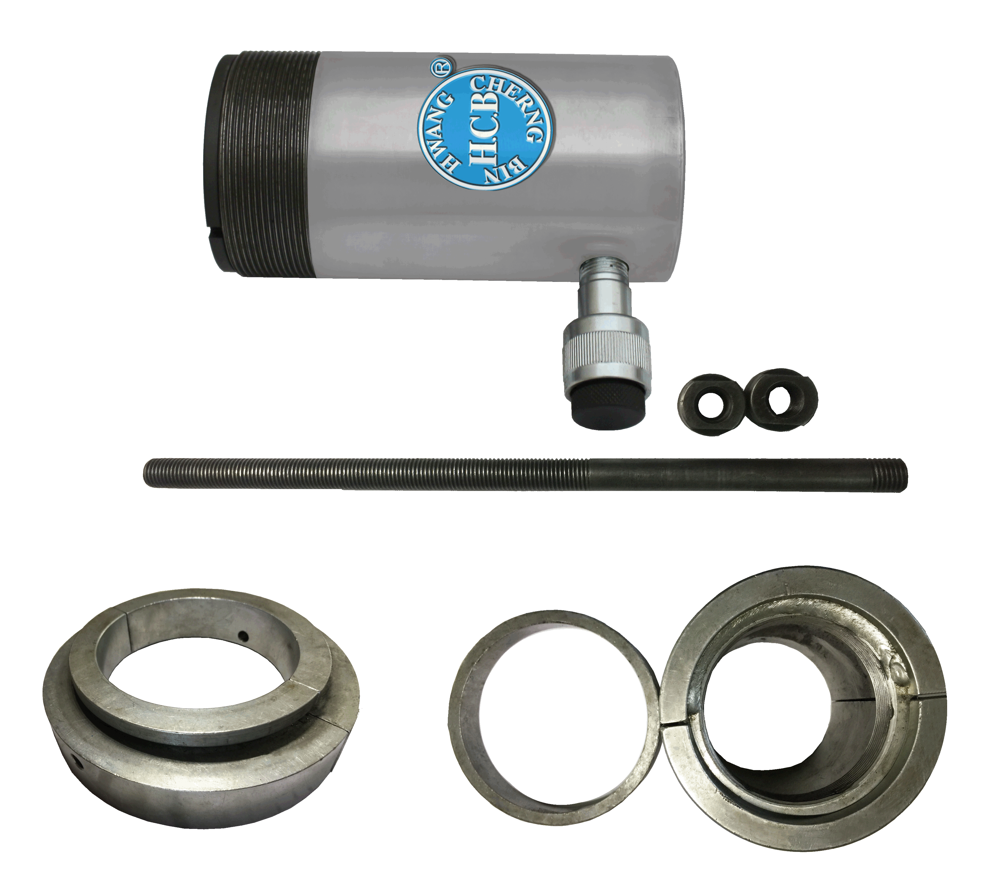
7/₈”-9UNC

3 ⁵/₁₆”-12UNF

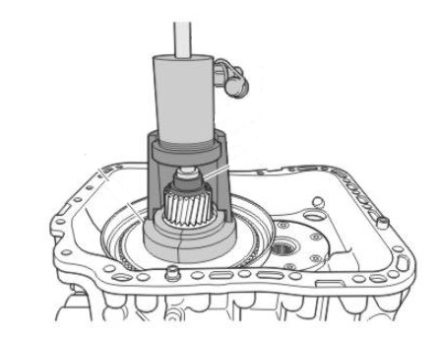

- A hydraulic kit for quick and easy removal of main shaft bearing.
- Stroke: 53 mm, D: Ø 90mm, L: 175mm
- Application: Volvo FM truck
- VOLVO OEM number: 88800015.9998542

