
H.C.B-A1827

VOLVO (FM) TRUCK REAR AXLE BEARING INSTALLER
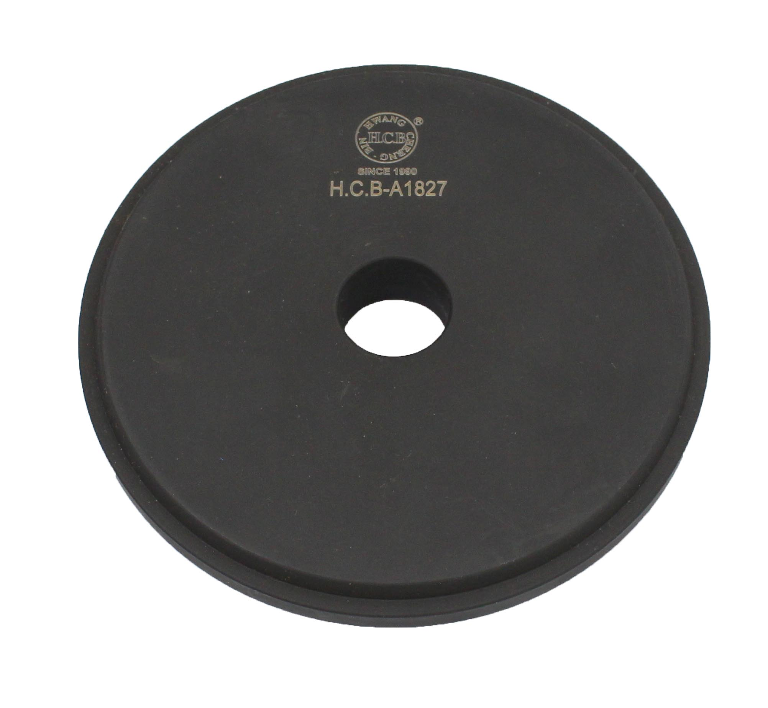

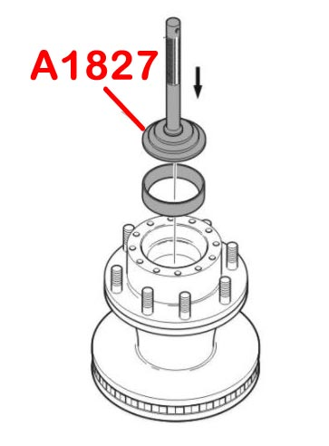

- This tool can help you install the rear axle bearing with even force. Avoid incorrect installation.
- Application: Volvo FM truck
- Volvo OEM number: 9992633

