
H.C.B-A1826
VOLVO (FM) TRUCK GEAR FIXING SCREW
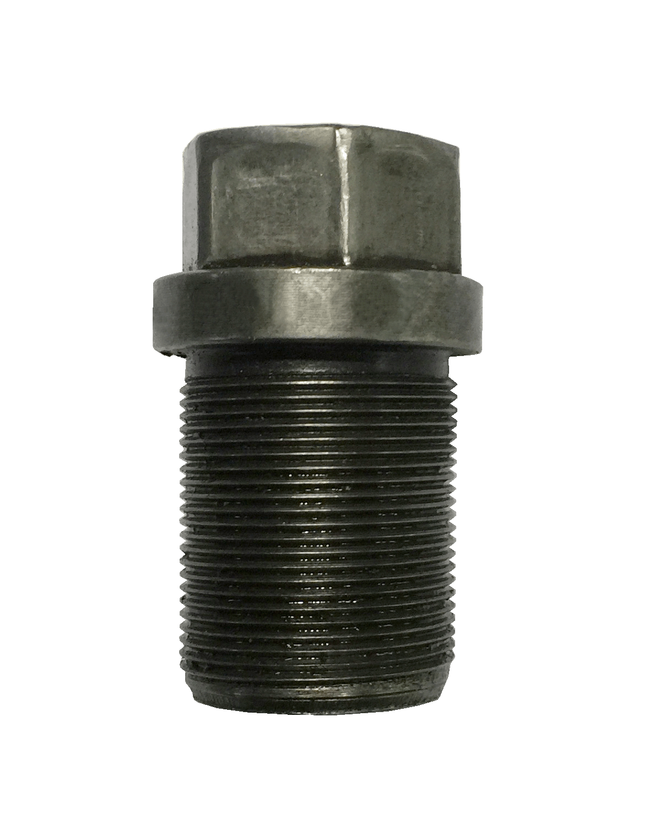
O

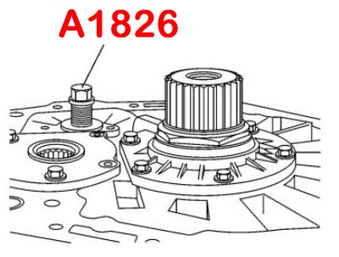
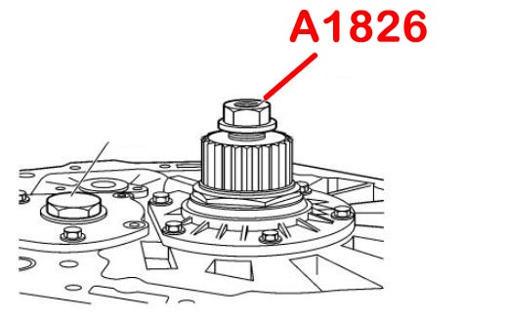

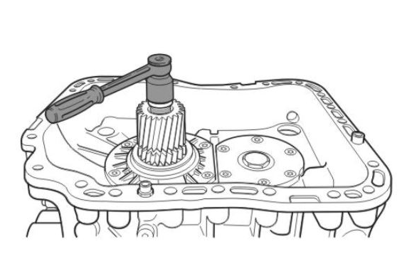

轉動約20圈

- This tool can fix the gearwheel.
- Application: Volvo FM, B12B, B12M truck
- VOLVO OEM number: 9996917

