
H.C.B-A1825
VOLVO (FM) TRUCK INPUT SHAFT BEARING INSTALLER

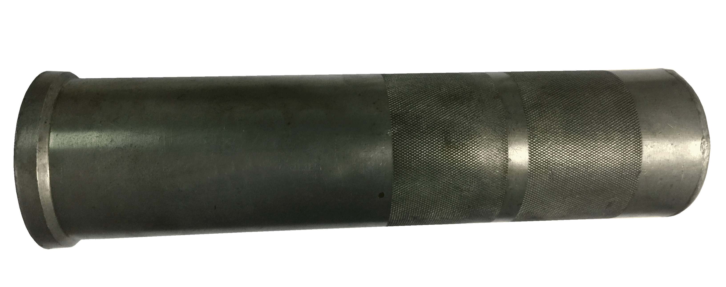

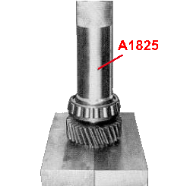

- This tool can help you install the bearing to input shaft with even force. Avoid incorrect installation.
- Deminsion: d: Ø 76 mm, D : Ø 94 mm, 350mmL
- Application: Volvo FM truck

