
H.C.B-A1823
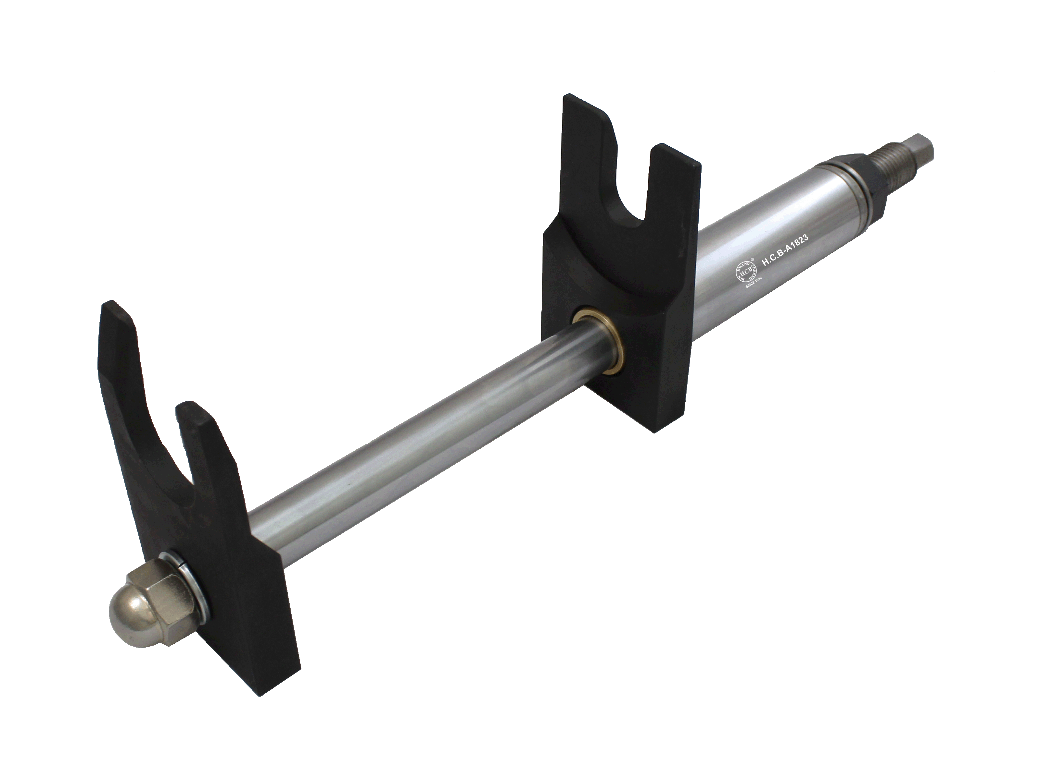
BENZ ACTROS TRUCK CABIN SHOCK ABSORBER SPRING COMPRESSOR

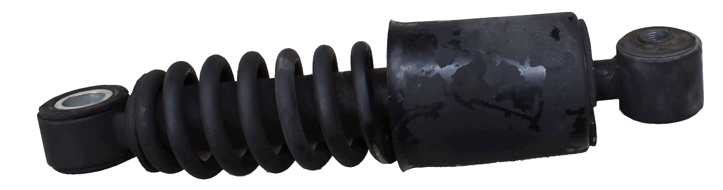
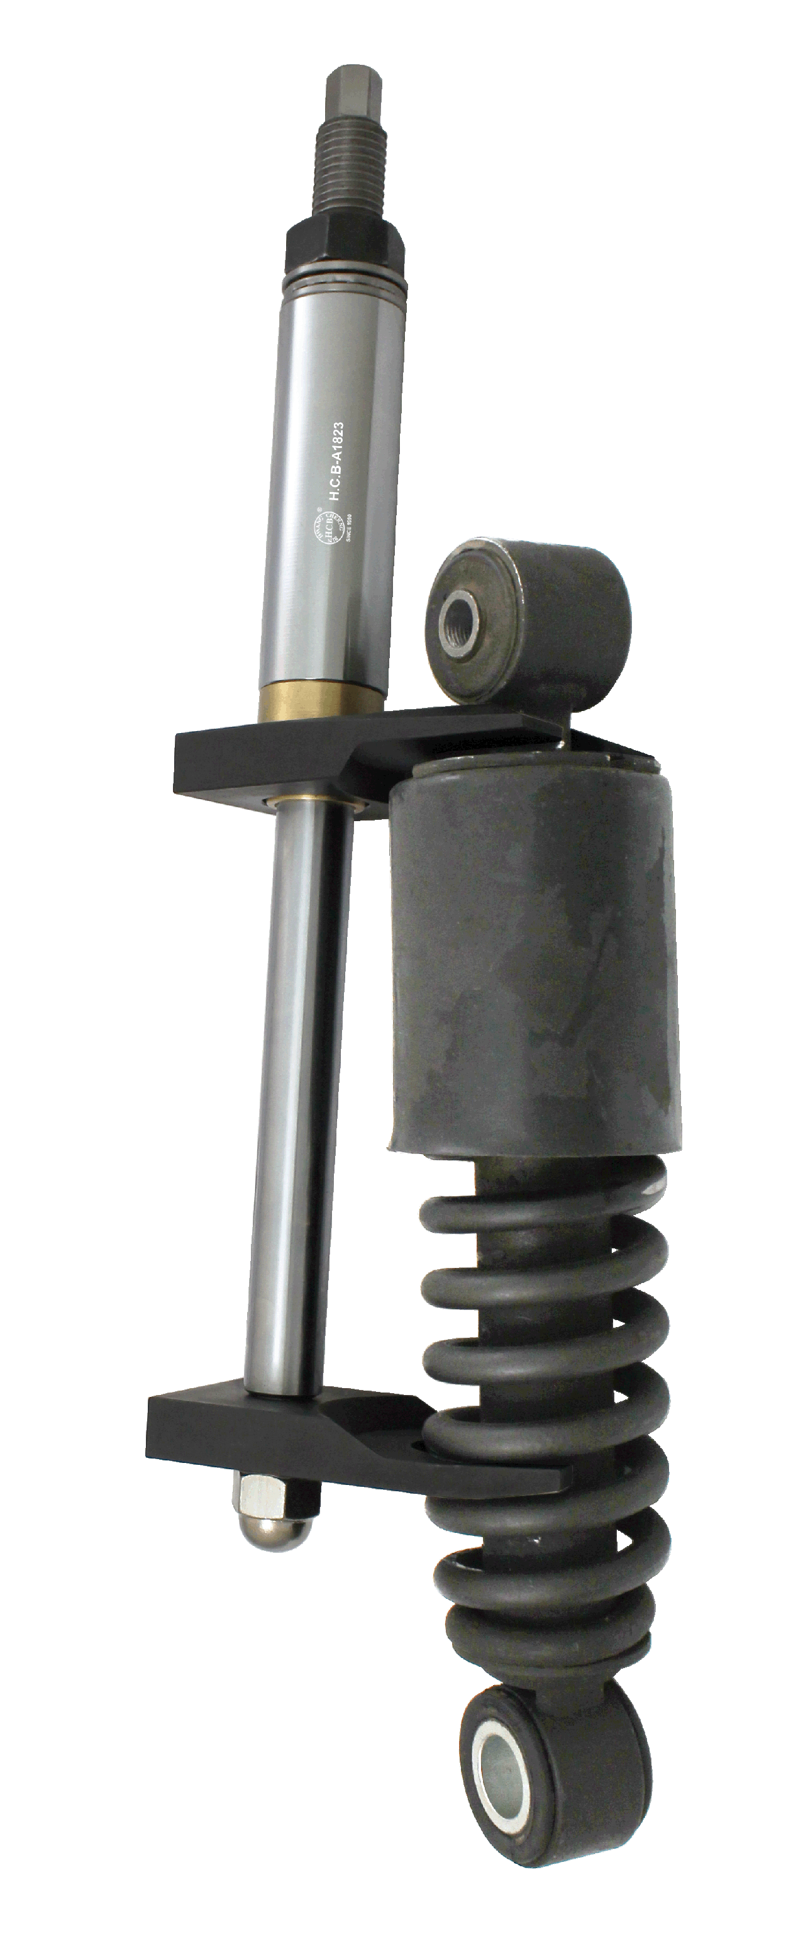
Part OEM number:A 943 890 03 19

- Instruction: When the shock absorber leaks, you will need this tool to remove the spring absorber to service the shock absorber.
- Application: BENZ ACTROS truck

H.C.B-A1823
BENZ ACTROS TRUCK CABIN SHOCK ABSORBER SPRING COMPRESSOR

Part OEM number:A 943 890 03 19

- Instruction: When the shock absorber leaks, you will need this tool to remove the spring absorber to service the shock absorber.
- Application: BENZ ACTROS truck

