
H.C.B-A1821
VAG DSG TRANSMISSION OIL FILLING TOOL
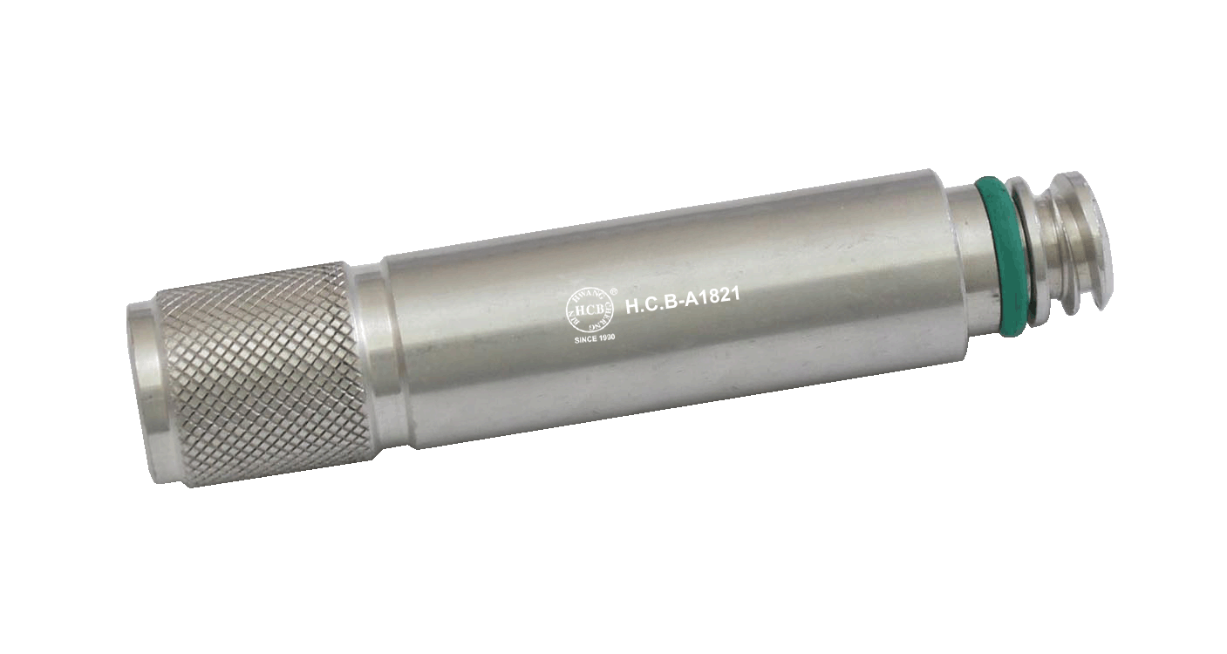

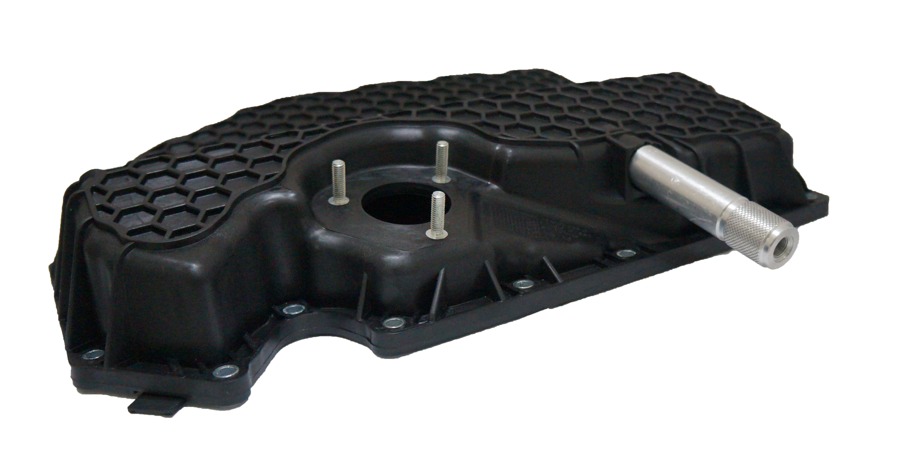

- The adapter VAS 6617/12 is required in conjunction with hand pump for gear oil VAS 6617 for filling 7-speed dual clutch gearboxes.
- Initial use: Audi A6 2011>

H.C.B-A1821
VAG DSG TRANSMISSION OIL FILLING TOOL

- The adapter VAS 6617/12 is required in conjunction with hand pump for gear oil VAS 6617 for filling 7-speed dual clutch gearboxes.
- Initial use: Audi A6 2011>

