
H.C.B-A1810
VOLVO TRUCK THERMOSTAT SEAL INSTALLER

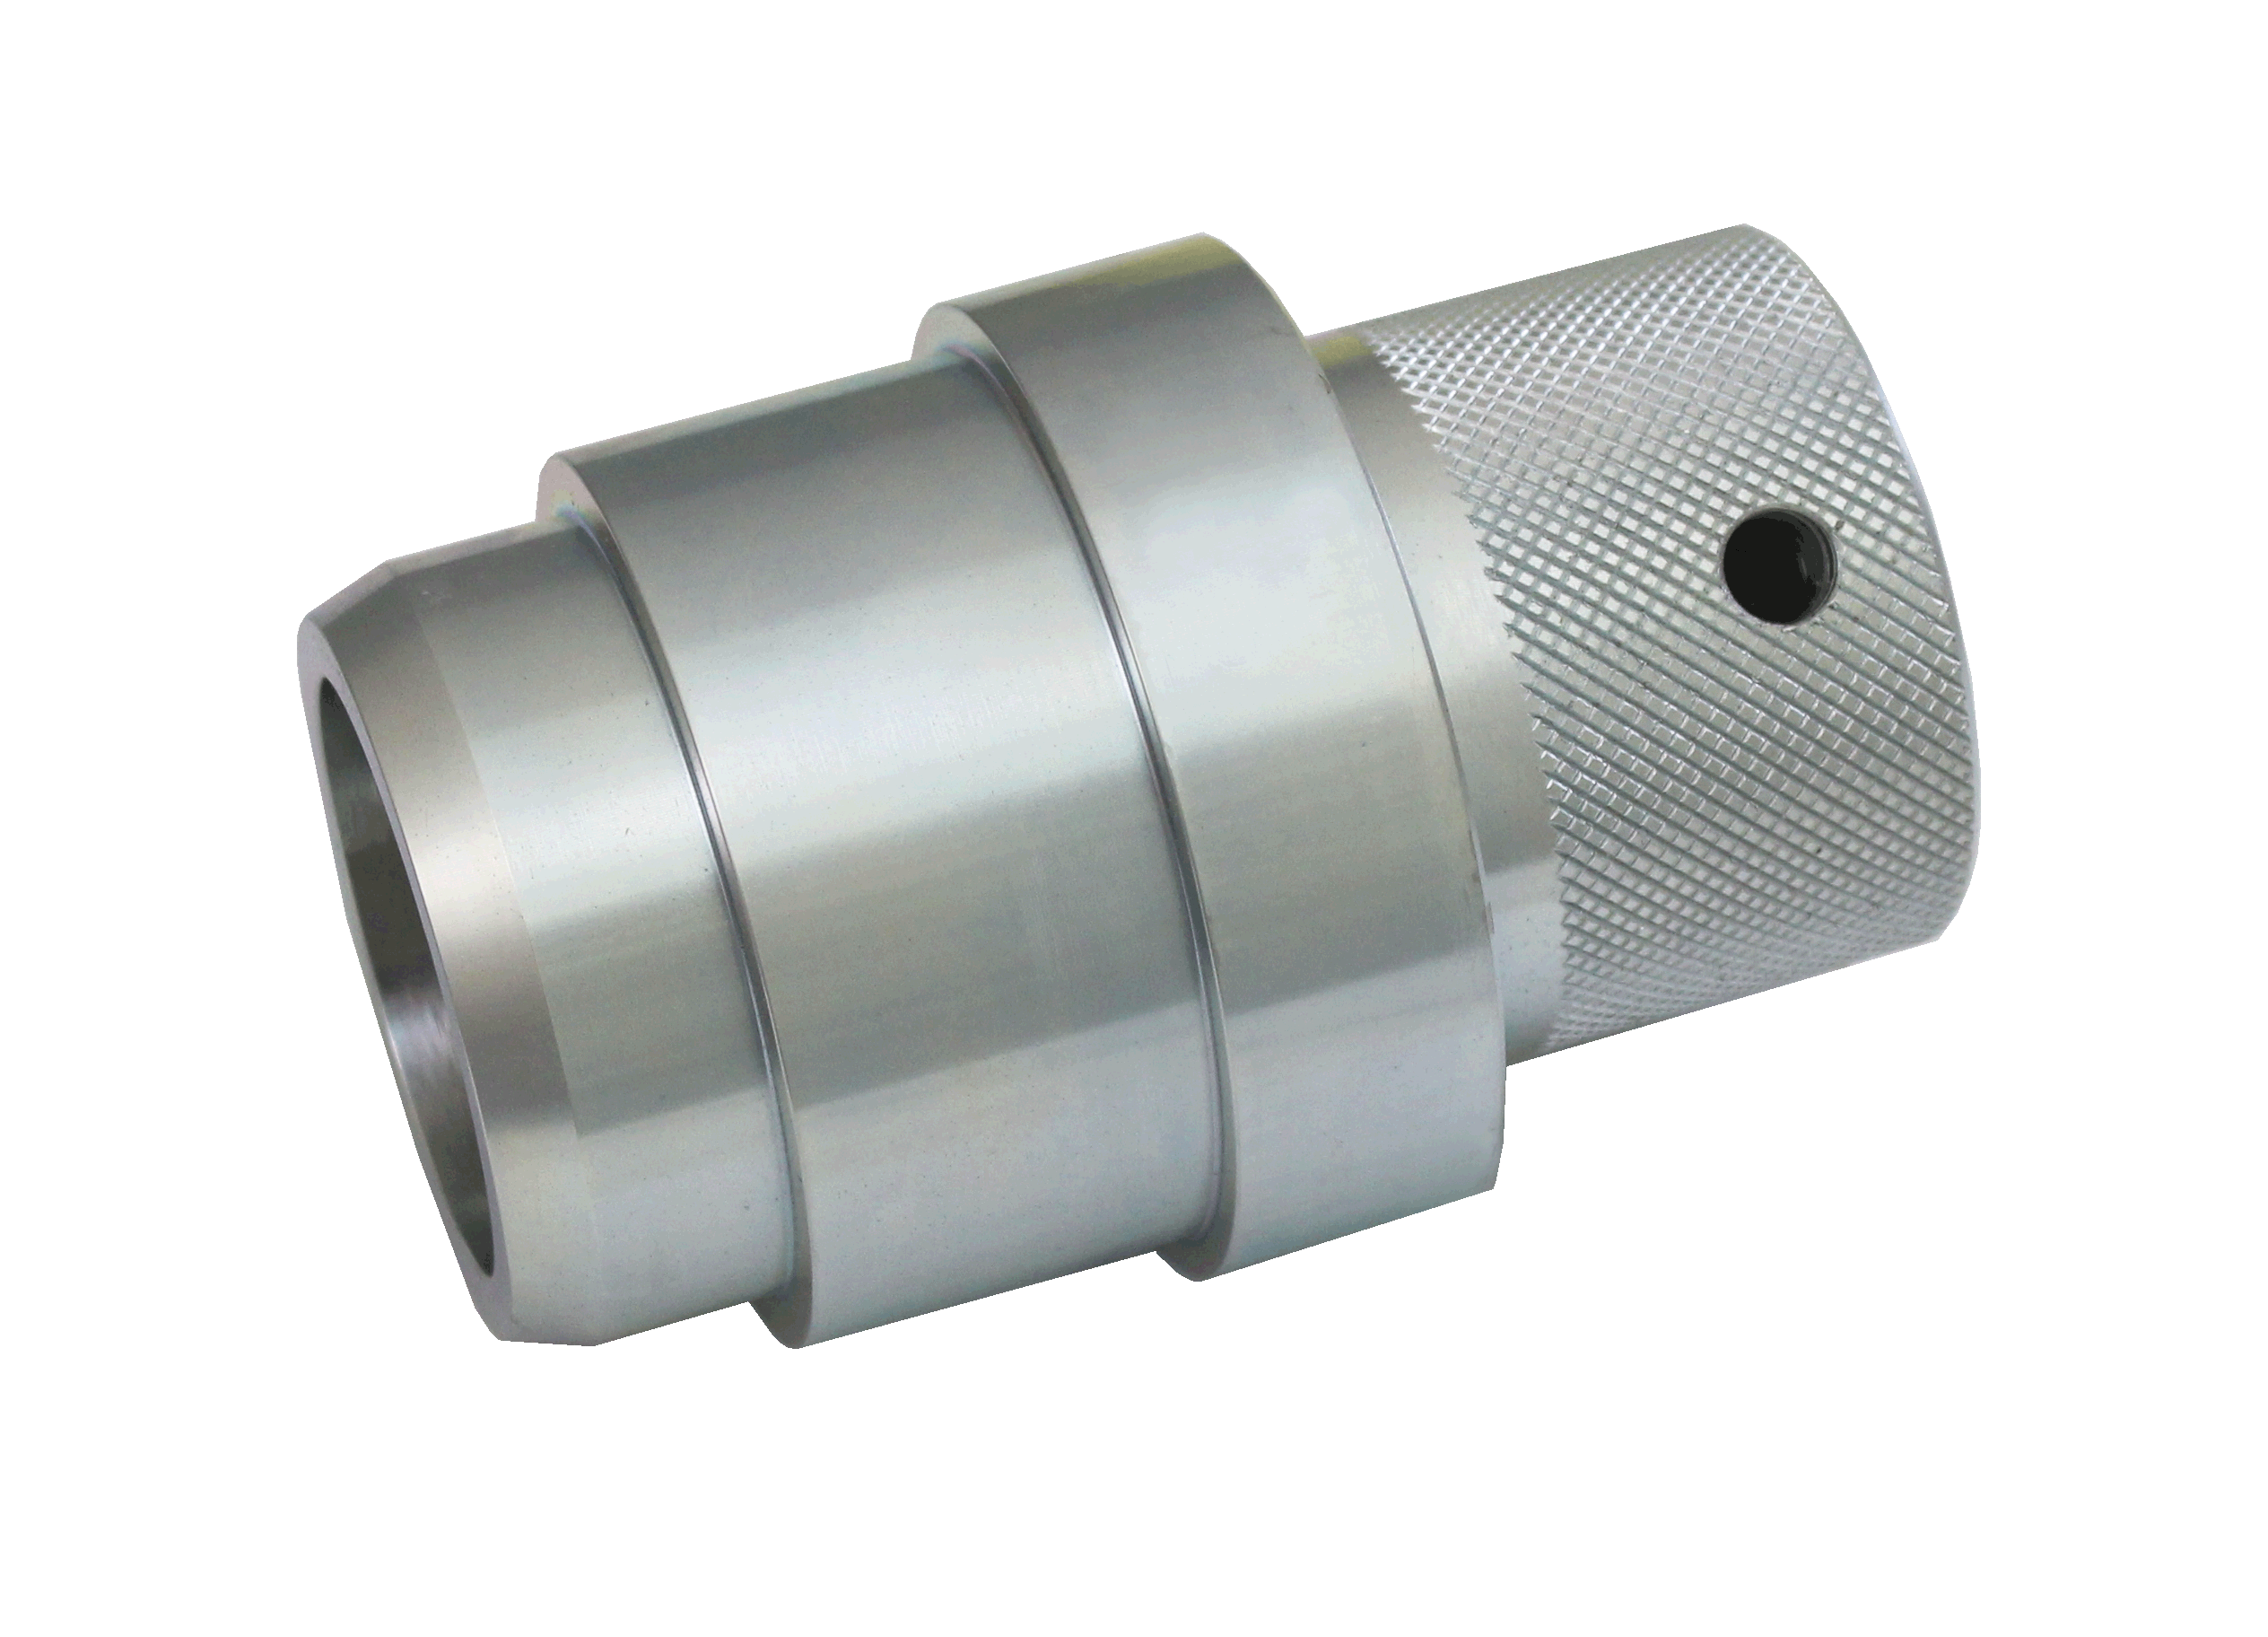

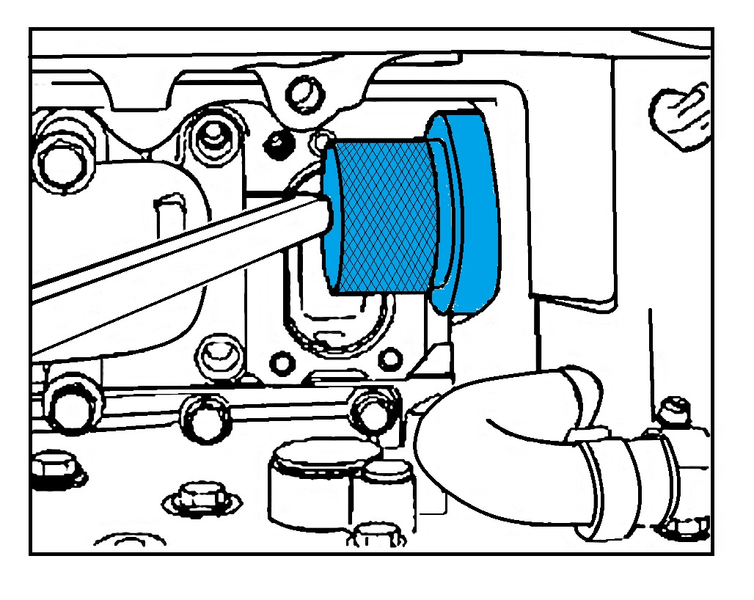

- Tool for installing thermostat sealing ring on the D12C engine.
- Application: VOLVO D12C ENGINE
- VOLVO OEM no.ref.:9998619

