
H.C.B-A1805
VOLVO TRUCK ENGINE HOUSING SEPARATOR

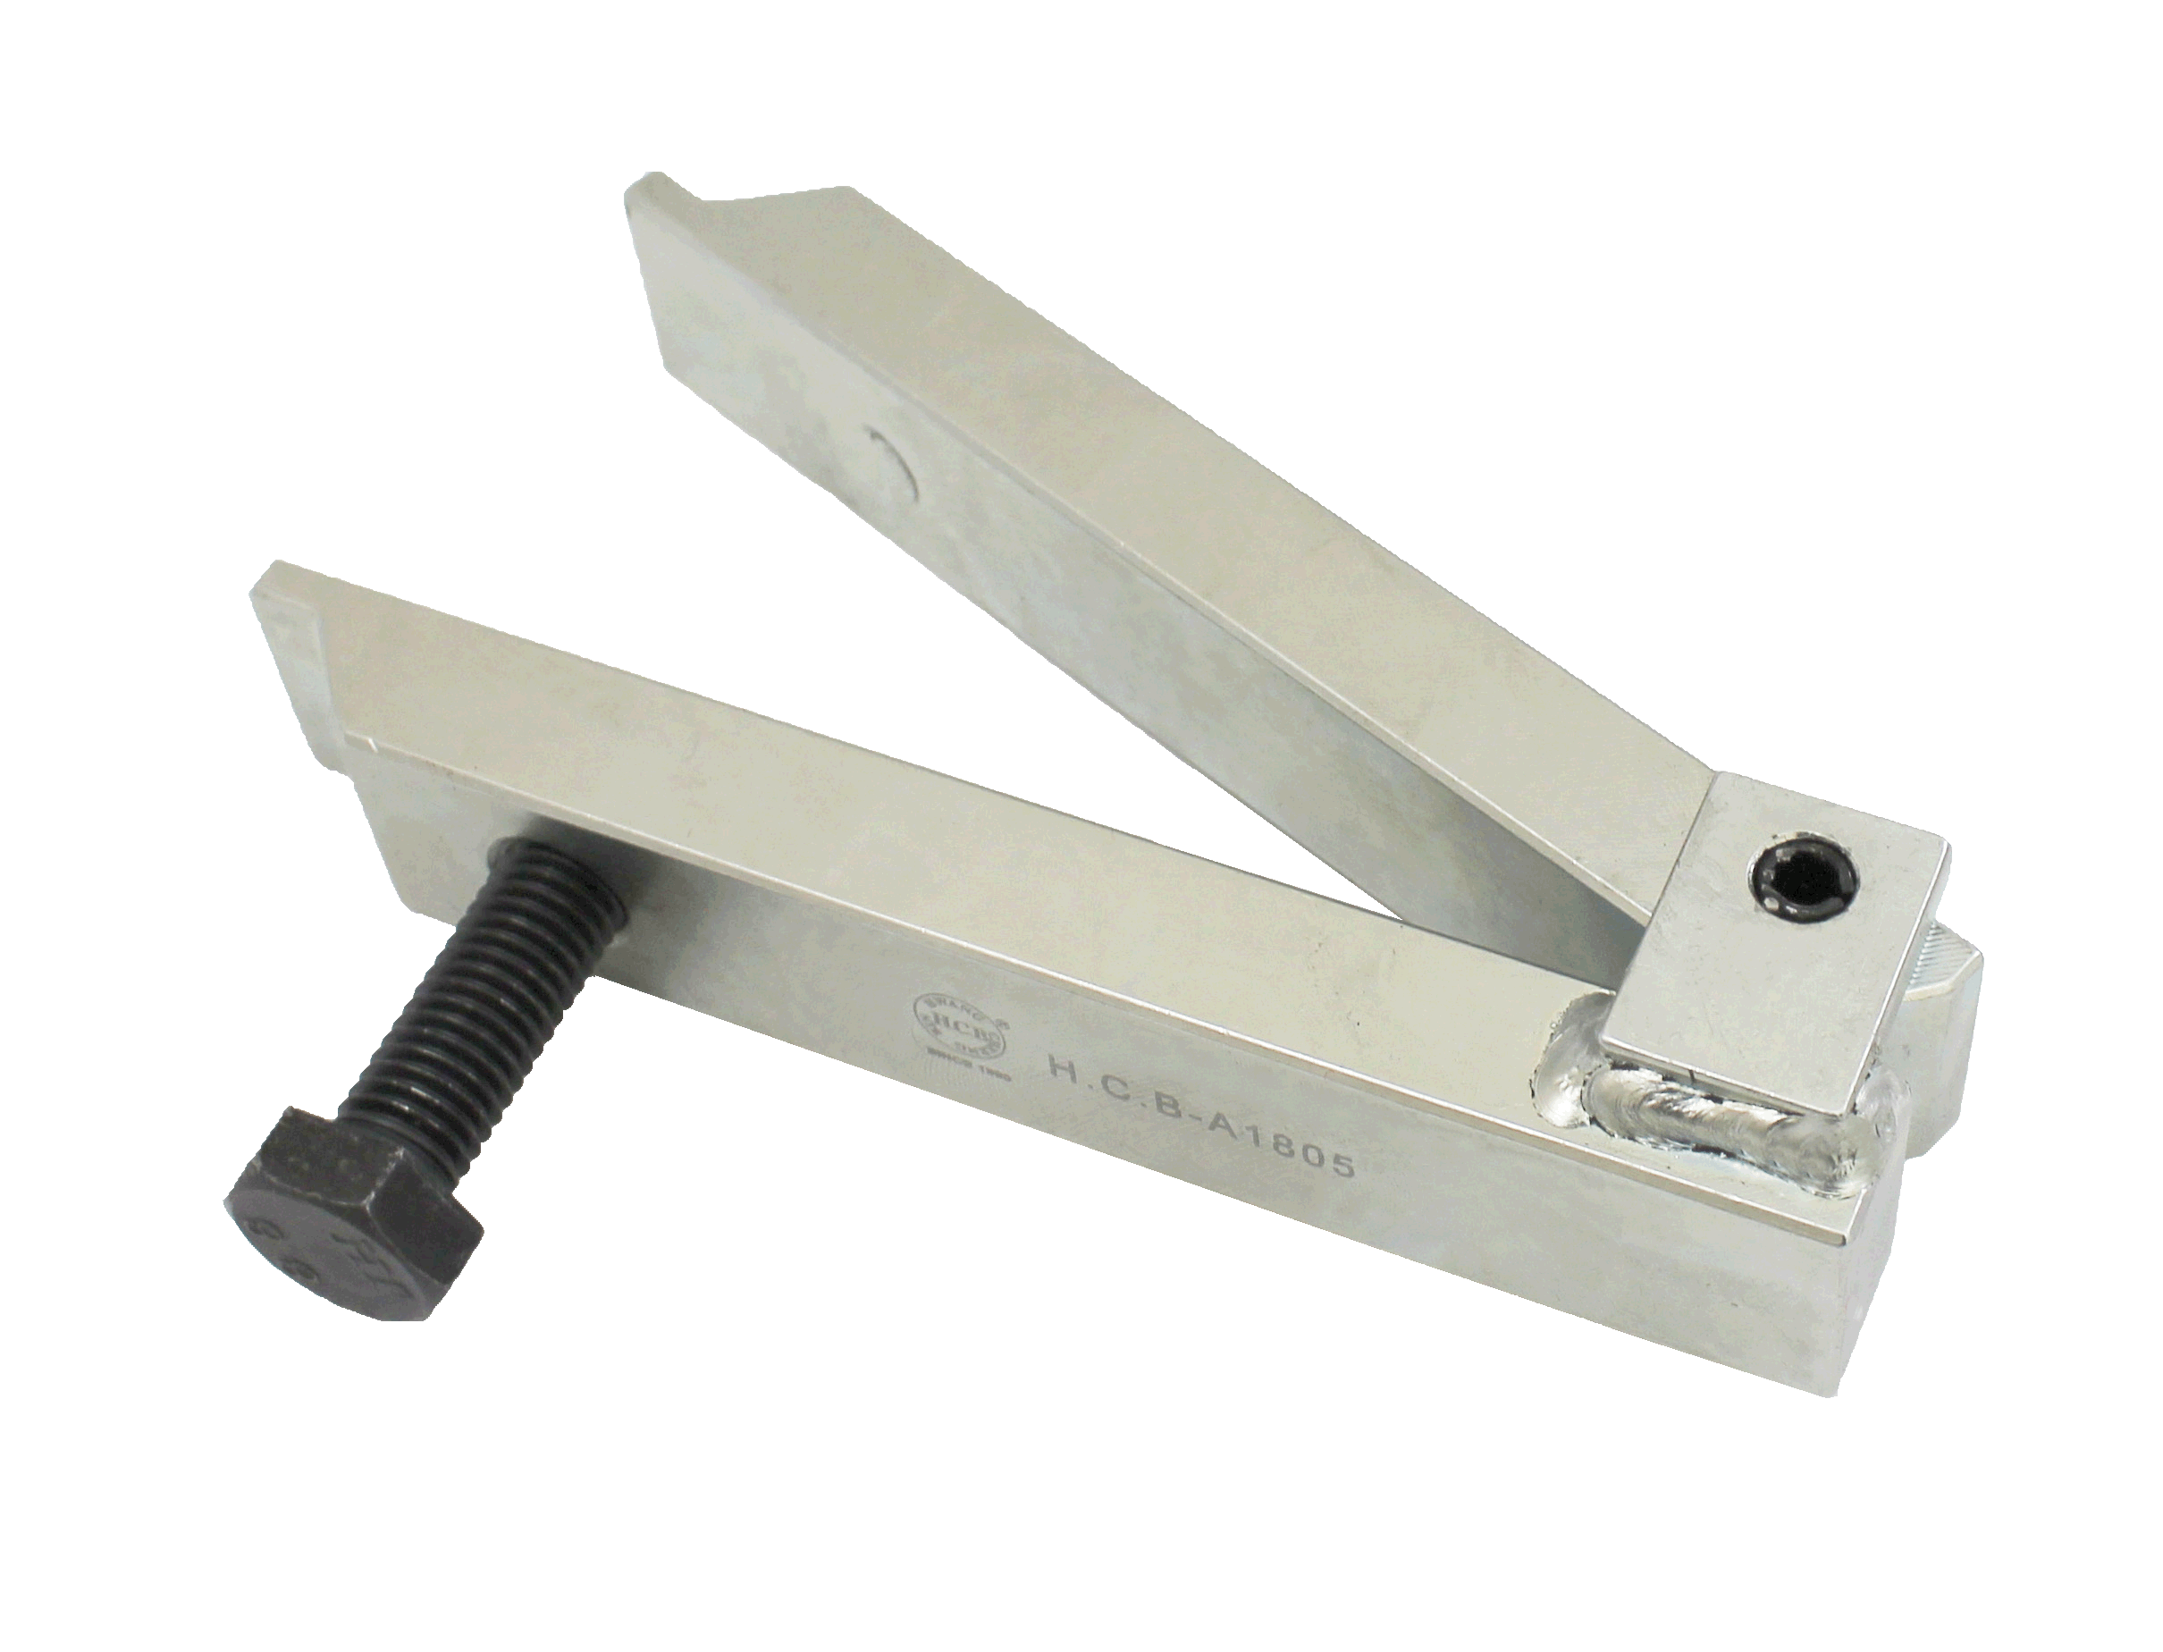

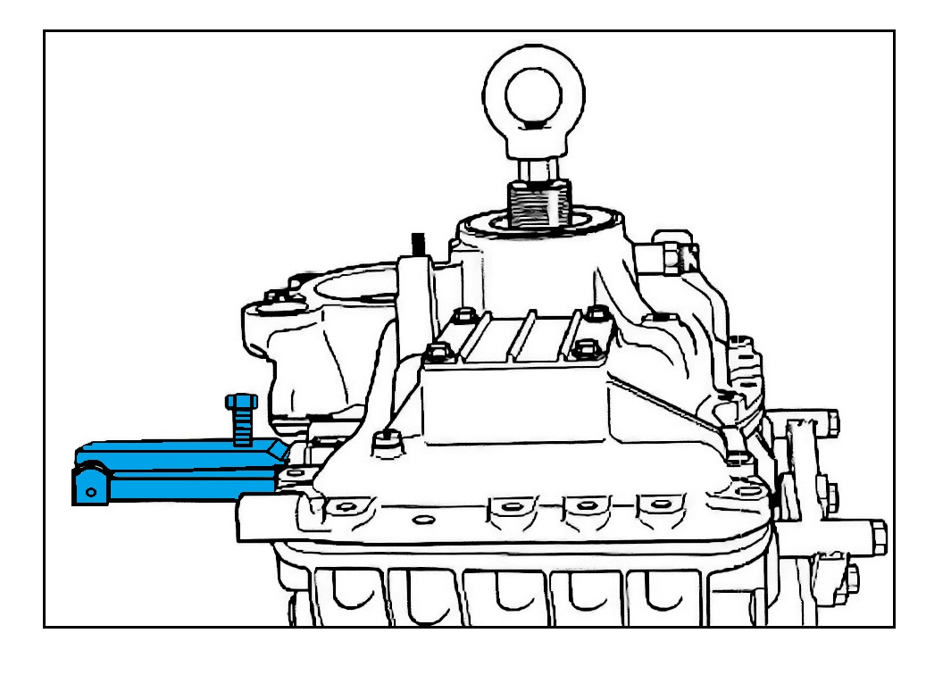

- This tool is to split the main housing and range housing.
- Application: VOLVO FM AT2512C
- VOLVO OEM no. ref.: 9998051

