
H.C.B-A1804
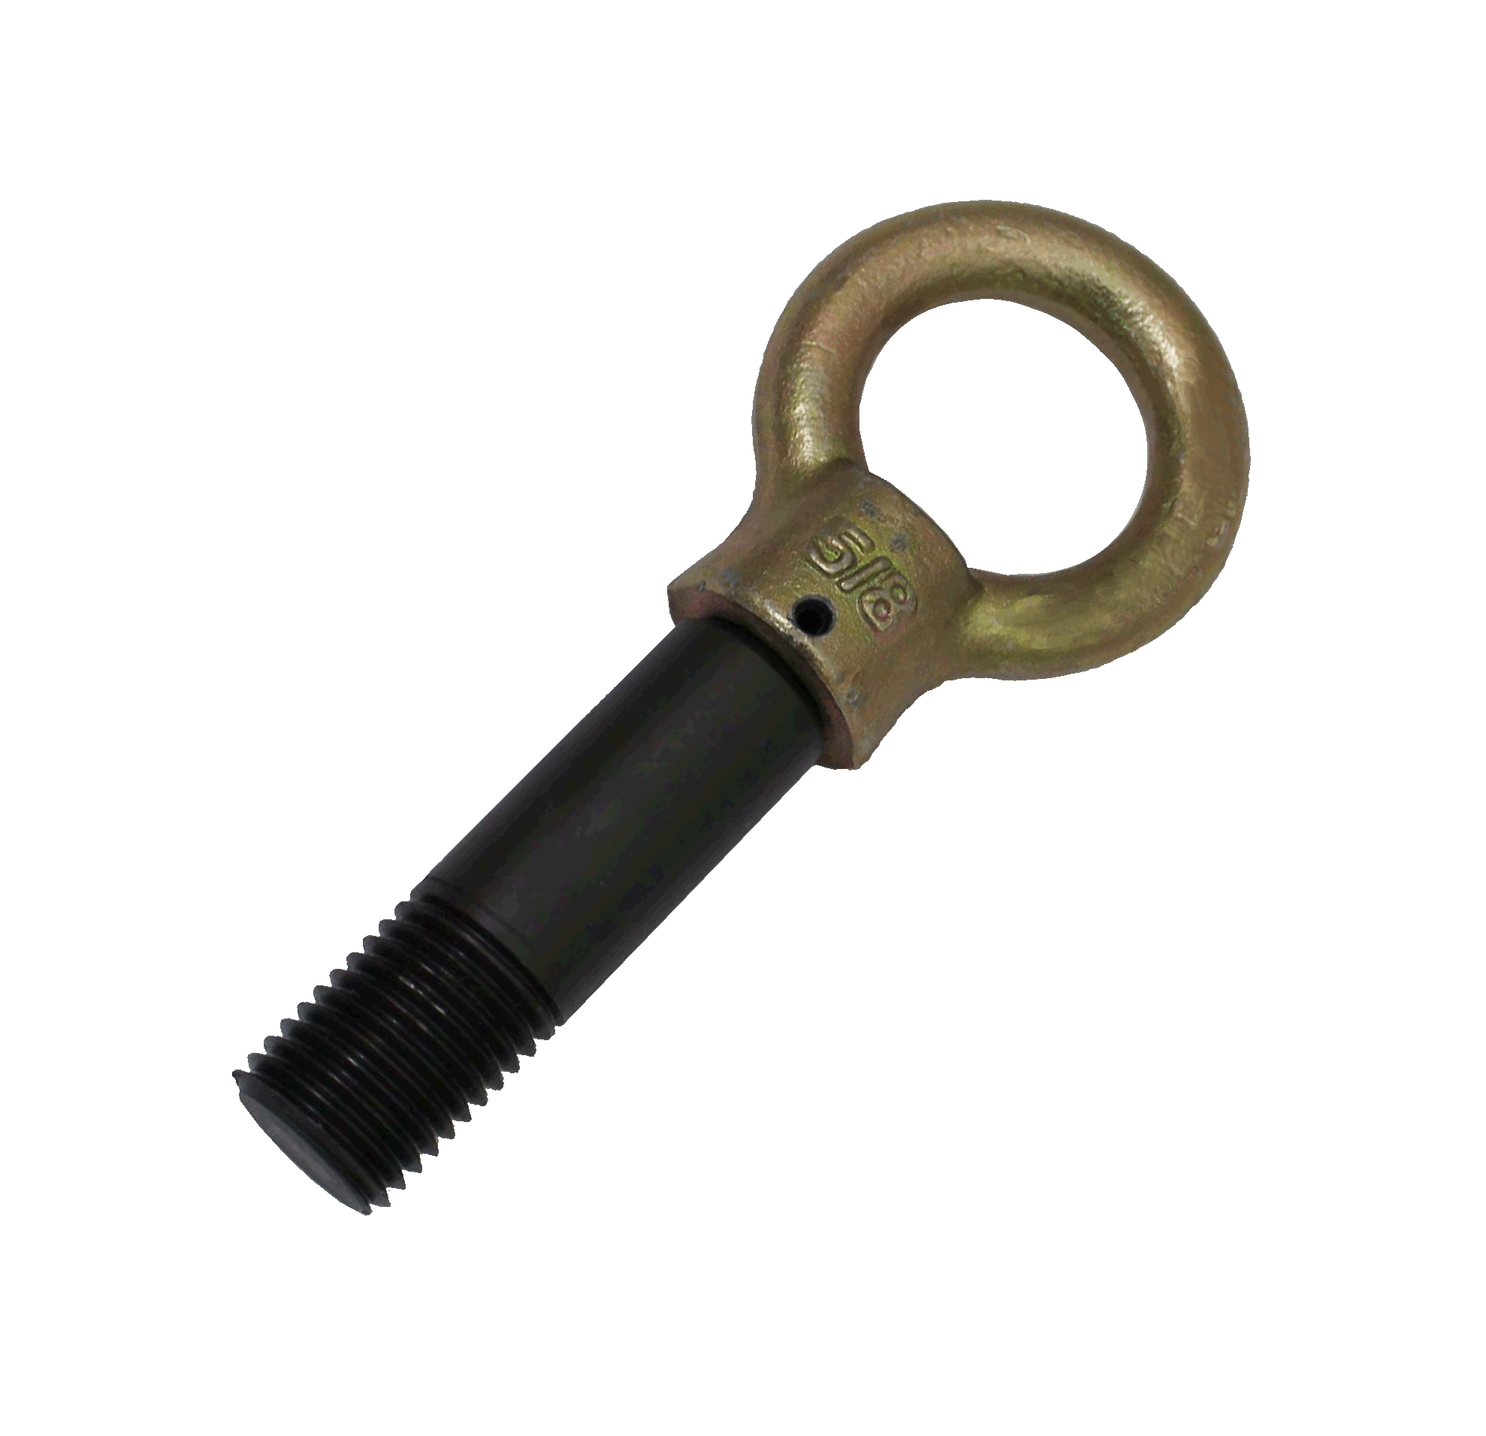
VOLVO TRUCK LIFTING EYE TOOL

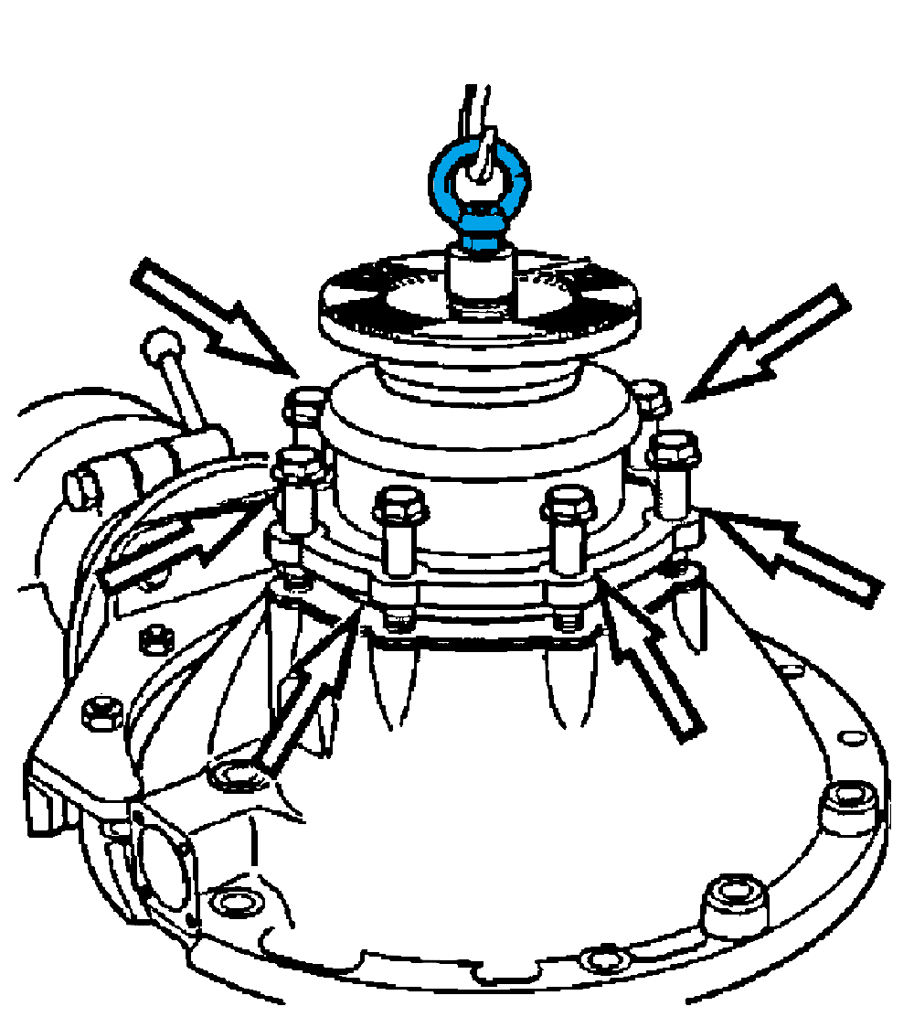

- Install on the output shaft to separate the gearbox housing.
- Application: VOLVO truck

