**H.C.B-A1797**



**IVECO DUAL GEAR ENGINE FLYWHEEL ROTATOR (WITH 2 GEARS)**

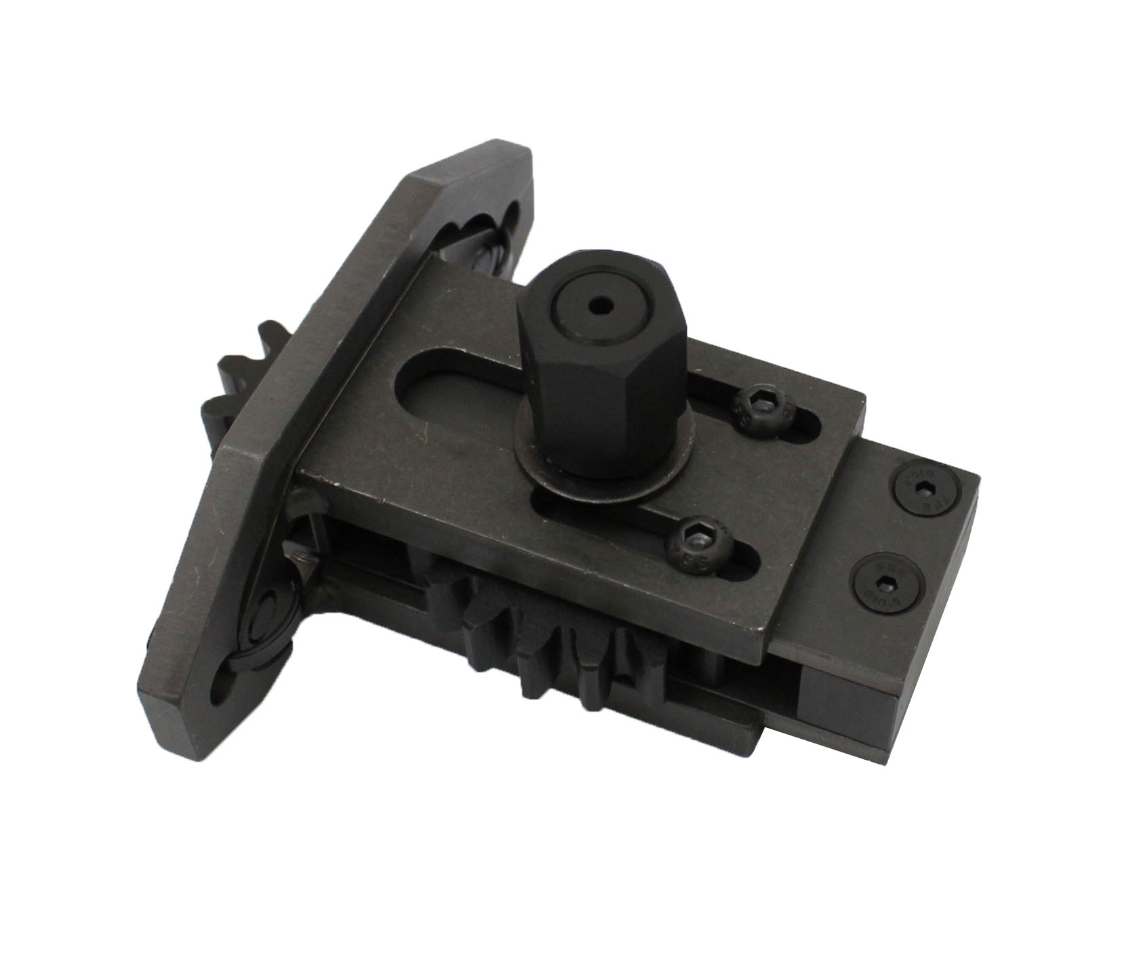

94mm

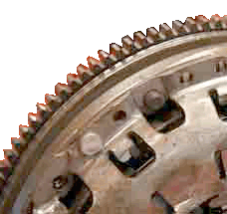

■ Designed for dual gear engine flywheel rotation for timing.

■ **Suitable for**Euro Cargo/ Cargo Eurotech/ Heavyon/ Off Road/ Bus models.

■ **Engine models**: 8040-25-45/ 8060-25-45/ 8460/ 8260/ 8280/ 8210.42/ 190.38/ 190.42

**H.C.B-A1797**



**IVECO DUAL GEAR ENGINE FLYWHEEL ROTATOR (WITH 2 GEARS)**



94mm



■ Designed for dual gear engine flywheel rotation for timing.

■ **Suitable for**Euro Cargo/ Cargo Eurotech/ Heavyon/ Off Road/ Bus models.

■ **Engine models**: 8040-25-45/ 8060-25-45/ 8460/ 8260/ 8280/ 8210.42/ 190.38/ 190.42