
H.C.B-A1794
RENAULT TRUCK HUB SOCKET
(Dr. 1”, 6 POINTS, 77 mm)

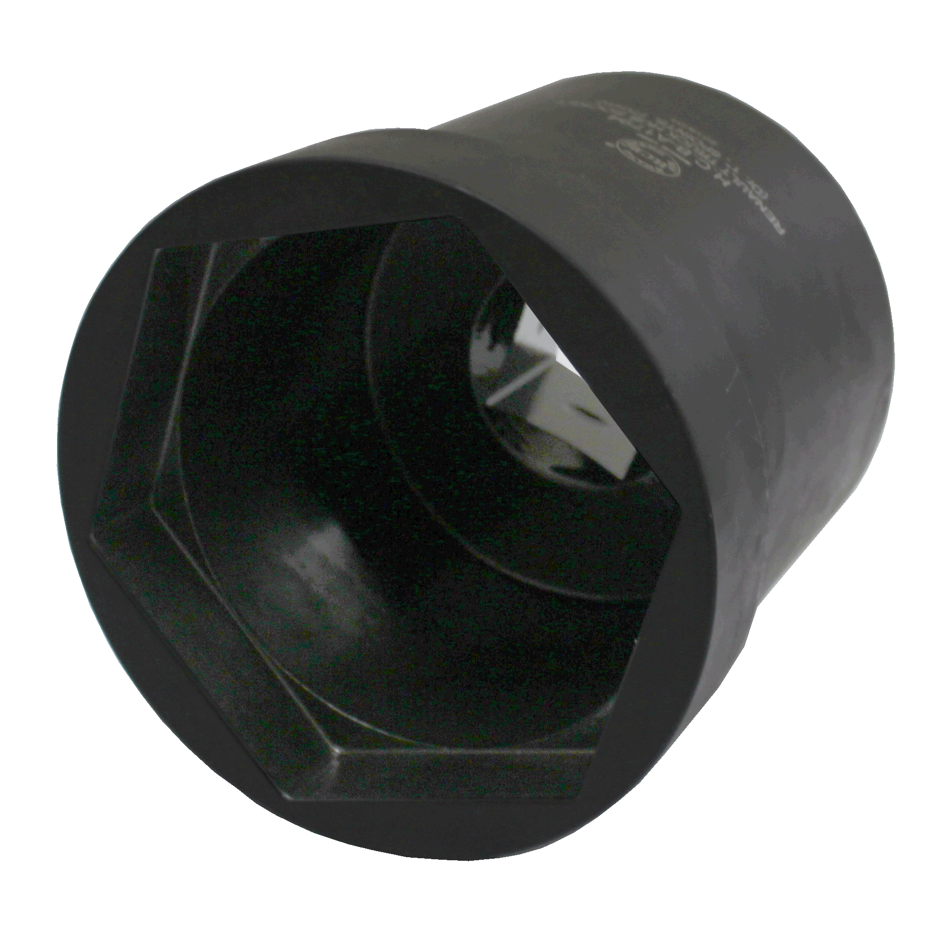
Dr. 1”

- Socket for HUB of Renault trucks.
- Size: Dr.1”, 6 POINTS, 77mm
- Application: Renault

H.C.B-A1794
RENAULT TRUCK HUB SOCKET
(Dr. 1”, 6 POINTS, 77 mm)

Dr. 1”

- Socket for HUB of Renault trucks.
- Size: Dr.1”, 6 POINTS, 77mm
- Application: Renault

